

WRITING THROUGH THE COMPETENCE BASED APPROACH

Writing : Process and Product

Elaborated by

Souad Belbachir

TABLE OF CONTENTS

Introduction

I-Definition : Writing

II- Process versus Product
III- Composition
IV- Managing Writing Activities

A. Pre-Writing
- Brainstorming
- Discussion
- Quickwriting
- Journal writing
- Debating
- Reading
- Wordmapping
- Interviewing
- Free Association
- Conferencing

B.While Writing Activities
- Drafting
- Revising
- Peer response
- Collaborative Writing
- The editing process

Conclusion

Bibliography

To the student
Writing is like carrying things up steps. If you try to jump to the top with every-thing…
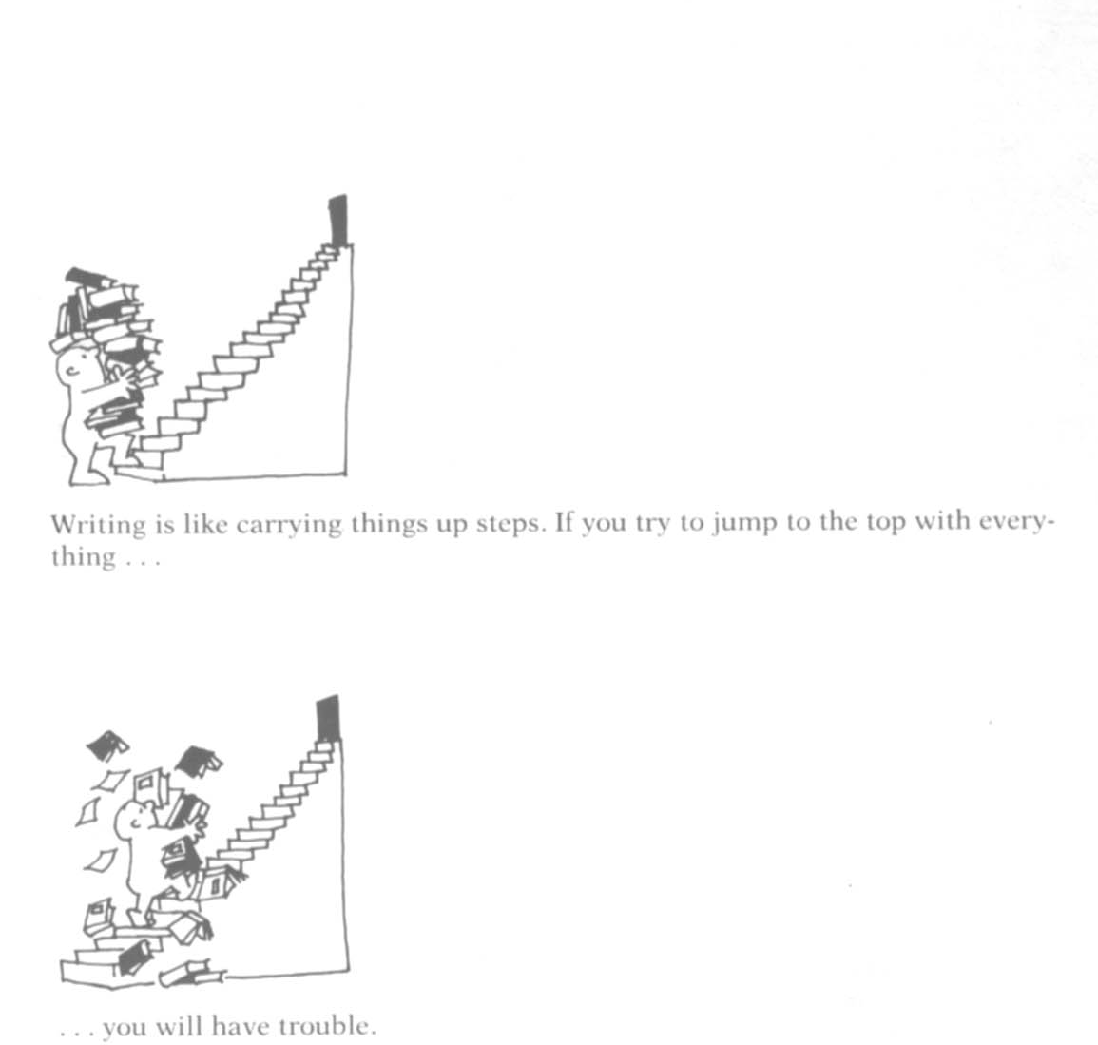
…you will have trouble.

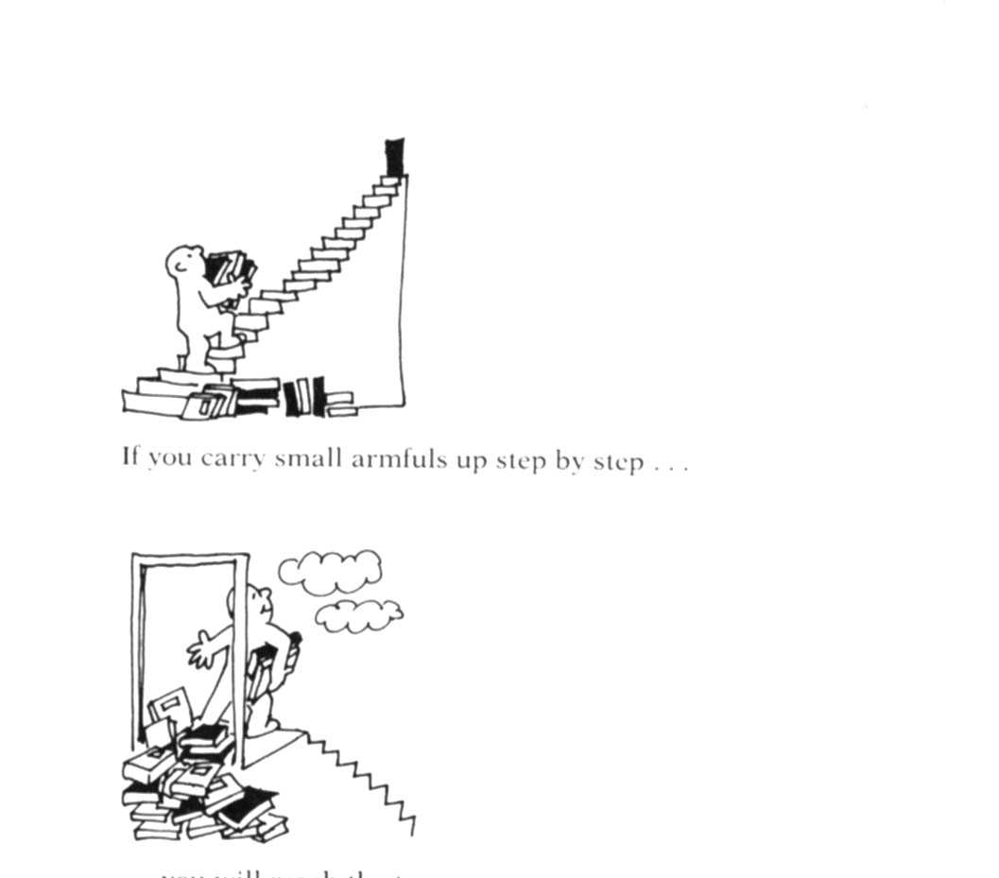
If you carry small armfuls up step by step…
you will reach the top.

INTRODUCTION

This modest work shows how the students are encouraged and given opportunities to produce written texts. Years ago, writing was characterized by an approach that put emphasis on linguistic forms. Speech was primary, and writing served to reinforce oral patterns of the language. Writing took the form of sentence drills, transformations, completions, imitations and substitutions. It tested the exact application of grammatical rules, and focussed on the written products composed by the students.

Researchers and teachers realized that the focus on the product did not take into consideration the act of writing. Moreover the students were not allowed freedom to create their own compositions. In other words, content was neglected. Researchers noticed that emphasis was put in the form and structure of writing rather than on how writers create a written piece.

Now, the students in the English language classroom, no longer do the same types of activities that they did in the past. The attention to the writer as language learner and creator of a text, has led to a process approach with new classroom tasks and projects characterized by the use of journals, drafts, collaborative writing, revision and attention to content as much as form, and we should keep in mind that with the reform of the Algerian Educational system, the final objective is that, at the end of the Secondary Education (3rd year ), the student should be able to produce a piece of writing of about 20 lines through the Competence based approach. And we all know that writing skills are essential for succeeding in high school, college, and at a job. And as our President said during the settling session of the C.N.R.S.E.:

“We want to equip
our kids (the learners) with necessary assets to succeed in tomorrow’s world.”

Therefore , our students should be familiar with the competency-based teaching and the learner- centered approach. ( 1AM, 2AM, 3AM, 4AM 1AS, 2AS, 3AS Programs the approach is competency based.)

« Competency-based learning is motivated by the idea that the classroom should prepare learners for real life. Learners acquire the language, but they also develop skills and strategies that will help them complete the kind of tasks they would do in real life. »

Alison Oswald

The Power of Writing, the Writing of Power ( By Elsa Auerbach )

If you had walked into an adult English for speakers of other languages (ESOL) class 20 years ago, you might have seen students doing little writing other than completing short exercises designed to reinforce particular grammar points or language functions. The teacher may have evaluated this writing on the basis of formal correctness; students may have had little opportunity to write extended pieces in which they expressed their own ideas. Today, you may see exactly the same kind of writing in some adult ESOL classes; in many others, however, you're likely to see students filling out job applications, writing notes to their children's teachers, or practising taking phone messages. They may be writing journal entries, doing free writing, composing stories about their lives, or writing down folktales from their homelands. Some may be revising their work for publication. Others may be working together to draft letters to the editor of a newspaper about a community problem or to craft a petition to the local school board. The teacher may be writing alongside students, responding to their writing by asking questions and sharing experiences, or giving mini-lessons about a particular grammar point.

Behavioral and Functional approaches:
Writing for Assimilation
One of the first departures from grammar-oriented writing instruction for adult ESOL students in nonacademic contexts was the functional or competency-based approach (Savage, 1993). This approach, which evolved in the late 1970s, is based on the view that, for immigrants or refugees, the priority is survival; according to this view, their needs for writing focus primarily on very functionally-oriented, context-specific writing tasks. Thus, where grammar-based approaches value what students know about language, this view emphasizes what students can do with language. It is concerned with the behaviors and performance demanded in particular domains or roles rather than with grammar per se. For example, workplace educators may develop an inventory of writing tasks required for a specific job and base writing instruction on that inventory. As such, this approach is parallel to the English for special purposes (ESP) approach used in academic contexts. Often writing tasks are integrated into thematic life skills modules along with reading and oral language skills: reading want ads, filling out job applications, and preparing for interviews may go hand in hand as tasks associated with finding a job. Assessment is based on the ability to demonstrate competence; this approach is congruent with outcomes-based models currently being mandated through federal policy initiatives.
Proponents of this approach argue that it will enable learners to participate in the contexts of their daily lives competently and meet the practical demands of work, family, and community life. It will, they say, prepare new immigrants and refugees to succeed according to the expectations of American society. The message here is that being able to perform the writing tasks associated with specific contexts, norms, and societally defined roles will results in assimilation into the American mainstream.

Cognitive Approaches: Writing for Self-Expression and Meaning-Making.
As second language acquisition and composition theories have developed, an emphasis on writing as a cognitive, meaning-making process has become increasingly popular. Critiquing behavioral and functional approaches, believers in this approach argue that writing should be much more than filling out forms or responding to externally defined norms. All too often, they claim, the functional approach limits both the kinds of writing students can do and the roles for which it prepares them. It trains students to fit into the social order as it exists, which, for refugees and immigrants, often means filling menial roles or dead-end jobs that require little thinking or extended writing (Tollefson, 1989).
In the cognitive view, often called the "process" approach to writing, the focus on meaningful communication for learner-defined purposes derives from second language acquisition theory. The focus on the process of writing as a vehicle for reflection and exploration of ideas comes from composition theory. The content, practices, and purposes of ESOL writing inspired by this approach differ from those in functional classes: writing becomes a way of making sense of experience or discovering what one thinks rather than performing functionally useful tasks. Thus, writing often starts with personal narratives, as titles such as Writing Our Lives (Peyton & Staton, 1996) suggest. Literary forms such as poetry are also often incorporated (Kazemek & Rigg, 1995). While instruction focuses primarily on writing to create meaning, form is addressed both implicitly and explicitly: advocates of this approach argue that increasing accuracy evolves through drafting, revision, and editing; in addition, teachers often incorporate mini-lessons about relevant linguistic points.

Common practices in the process approach include free writing in journals, writing extended narratives through a cyclical process, and publishing student writing. In dialogue journals, students write about thoughts, experiences, reactions to texts, or issues of importance to them, and teachers respond to the content of students' entries by sharing experiences, ideas, and reactions as well as modeling correct usage (see Peyton & Staton, 1993). The cyclical process of composing extended narratives involves generating ideas through free writing and brainstorming, drafting, conferencing with peers and teachers, revising organization and content, editing for form, and, in some cases, publishing writing for a broader audience. These publications give writers real audiences and purposes for their writing, as well as becoming the impetus for building curriculum around learner writing and serving as models for student writers (Peyton, 1993). The message this approach sends is that learners' lives and voices have value and can become the vehicle for language acquisition as well as self-discovery.

The Socio-Cultural Practices Approach: Writing for Affirmation

A third perspective coming from the field of literacy studies focuses on socio-cultural practices rather than functional behaviors or cognitive processes. Literacy ethnographers argue that cognitive views of literacy and process approaches assume a universality to writing that is not borne out by research into actual literacy uses (Street, 1984). Their research shows that ways of acquiring and using writing vary from culture to culture, from context to context, and always depend on who is using it, under what conditions, and for what purposes (Barton & Ivanic, 1991). According to this view, people are informally socialized into the local, culture-specific literacy practices of the communities in which they are immersed. Because the out-of-school literacy practices of people from "mainstream" backgrounds are most congruent with school literacy practices, they are at an advantage when they encounter literacy instruction in school.
To value the range of practices that students bring and utilize them as resources, advocates of this view propose starting with what people know and do, by investigating how people actually use and acquire writing within specific families and communities (see, for example, Klassen, 1991). The point is to build on what people know, and to incorporate their local cultural knowledge into schooling, drawing on what Luis Moll (1992) calls their funds of knowledge. Thus, pedagogical practices may encourage the use of culture-specific genres, purposes, and content. Examples include a book about the many uses of aloe vera and other natural remedies produced by a class of Latino elders (Costanzo & Paxton, 1999) and a literacy text based on Creole proverbs developed in a Creole literacy project (Auerbach et al., 1996). Along with this goal of cultural affirmation, promoting the first language as a vehicle for cultural maintenance is often emphasized. Students in a Hmong project in California decided to learn to read and write in Hmong to preserve their first language and pass along oral histories to their children (Kang et al., 1996). The message in this approach is that learners' cultural knowledge and ways of using literacy are valuable and can become a bridge to new learning. Writing is a vehicle of social and cultural affirmation.

The Genre Approach: Writing for Access to Powerful Discourses.

A fourth approach argues that both the cognitive and socio-cultural approaches to writing instruction, despite claiming to empower learners, assure their continued exclusion. They argue that because certain literacies yield more power than others, it's not enough for learners to share their stories, find their voices, and celebrate their cultures. Process writing and immersion in meaningful usage may be fine for people who come from the dominant culture, but they obscure the rules of the game for everyone else. Delpit (1995), for example, argues that what's important is not voice in itself but teaching the discourses of power. She favors explicit instruction in the rules and standards that are valued in the dominant culture. The genre approach, popular in England and Australia, proposes deconstructing dominant genres, analyzing them from a linguistic point of view, and reproducing them (Hasan & Williams, 1996). Through overt instruction students learn to identify specific text types (narrative, factual, procedural, and persuasive), analyze their structural and linguistic features, and generate their own texts that conform to the conventions of each genre (see Spiegal & Sunderland, 1999). For example, students might be given two different texts, such as a news report about the housing crisis and a letter to the editor about housing discrimination. They would be invited to compare what the texts are about, why they were written, when one would read each, where they would be published, and how the language and structure of the texts differ (USWE, 1997). The students might then use this information to produce their own parallel texts. The message sent by this approach is that mastery of the genres of power will yield access to power.

The Critical Approach: Writing for Social Change

A fifth view argues that neither the socio-cultural practices view nor the genre view actually delivers what it promises: where the socio-cultural practices folks focus on writing practices, and the genre folks focus on text structures, the social change folks focus on social issues and action for change. They argue that it's not enough to affirm learners' cultures and celebrate their voices; they say that it is crucial to look at literacy within the context of larger institutional forces. As Giroux says, "Student experience has to be understood as part of an interlocking web of power relations" (1987, p.177). Social change advocates say that the genre approach makes the mistake of claiming that acquiring the discourse of power will actually lead to gaining power (Luke, 1996). In fact, they say, experience, history, and research show that other factors such as gender, ethnicity, and race are equally important in determining access. This approach argues that all writing pedagogy has an implicit political stance, whether or not it is acknowledged (Severino, 1998).
So within the critical approach, writing pedagogy is tied to analyzing student experience in relation to broader economic and political relations. Writing focuses on content drawn from the social context of learners' lives (connecting the word and the world, as Paulo Freire would say) and is used in the service of action for change (Freire & Macedo, 1987). For example, a parents' group in Los Angeles that began meeting the week after the L.A. riots used their classes to explore their fears and concerns about what was happening in their communities. They then wrote a book not only describing their experiences but also analyzing what was happening and why, and distributed the book in their community to prompt further dialogue (Orellana, 1996). In a Boston ESOL class, students compared and analyzed incidents of police harassment after one received an unjust traffic ticket. They then wrote a letter to the editor of a local paper about police discrimination (Nash et al., 1992). The message this approach sends is that writing can become a context for exploring critical social issues and a tool for taking action to improve the conditions of one's life.
My hope is that this article has shown how the practices described in the opening paragraph reflect different approaches to ESOL writing. I hope it is also clear that certain common elements underlie current approaches and that, in practice, writing instruction often draws elements from each of them. There is widespread consensus within the field of ESOL writing about several points:

- that a focus on meaning rather than form (grammatical correctness) encourages writing development;
- that instruction should stress writing for real reasons, to real audiences in order to promote authentic communication;
- that writing should be contextualized and that content should be meaningful and relevant to learners;
- that learners need some degree of overt instruction, which includes talk about writing, substantive, specific feedback, and multiple opportunities for revision;
- that social and cultural variation in writing practices and genres needs to be taken into account;
- that all writing pedagogy reflects a stance about the learner in relation to the social order. The most important point is that teachers need to be conscious of implications of their practices and of the power of the messages that their pedagogical practices convey.

Updated 1/02/06 Copyright © 2005 NCSALL

The following chapter gives definitions of writing. It also defines the process of writing versus product, and composition writing. It puts emphasis on the process of writing and on the different strategies writers use in the process. Moreover, it shows how the students are encouraged and given opportunities to produce written texts. Years ago, writing was characterized by an approach that put emphasis on linguistic forms. Speech was primary, and writing served to reinforce oral patterns of the language. Writing took the form of sentence drills, transformations, completions, imitations and substitutions. It tested the exact application of grammatical rules, and focussed on the written products composed by the students.

Researchers discovered that writing was a highly complex process made up of different sub-processes which occurred not one after the other in a linear sequence, but cyclically in varying patterns.

They started to recommend that students explore ideas first, be allowed time and opportunities to choose topics of interest, use personal experience to write about what concerns them, generate ideas, get feedback, share their writing with peers, revise and finally edit their work. Linguistic accuracy is no longer emphasized from the start, but is delayed until the writer has explored ideas.
The diagram below, gives the reader an idea about the drastic changes that occurred in the teaching and studying writing :

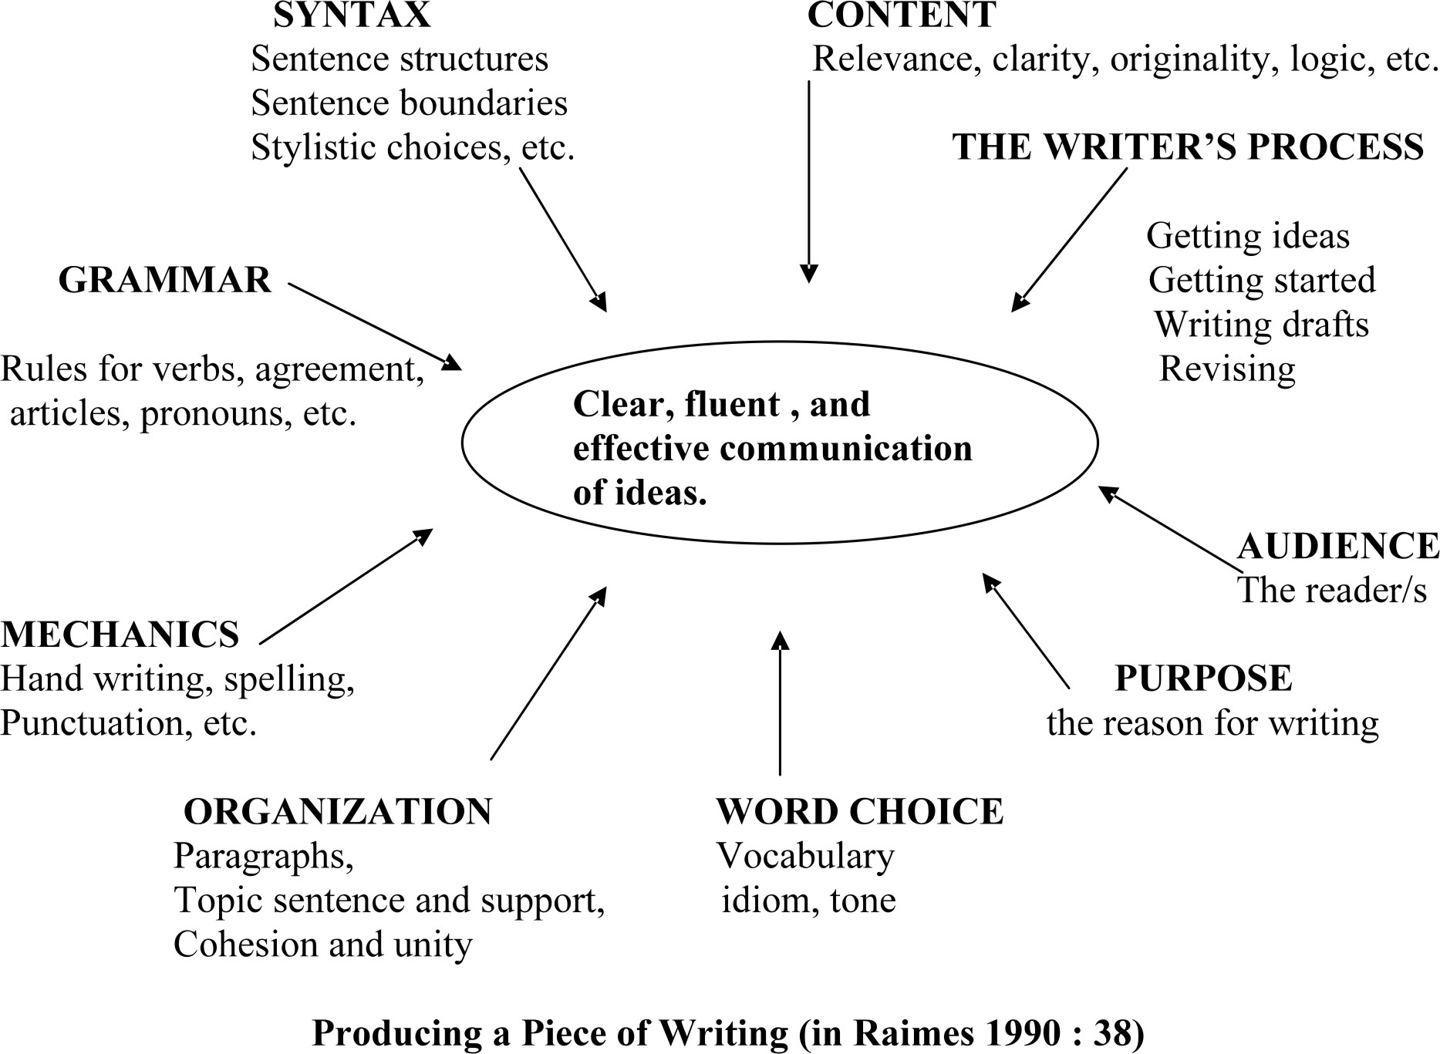

I. Definition of writing :

Writing has been defined as using graphic symbols : letters or combination of letters related to the sounds one makes when he speaks. The symbols are set to form words which in their turn, are arranged to make a coherent whole : a text. In fact, writing is not merely a way of recording language by means of visible marks as Bloomfield (1990: 101) remarked, but a communicative activity, and a process through which meaning is created, just as Wilson (1994 : 16 ) views writing.

“A creative process of immense perceptual linguistic
and cognitive complexity in which meanings are made through the
active and continued involvement of the writer and the unfolding text.”

Writing is not a simple activity, for it requires a control of the mind. It forces the writer to explore the world, to enhance his capacity to think, feel and perceive. It is a means to promote thinking, a rational activity that the mind solves by thinking. Byrne (1979 :14) states that writing is :

“Transforming our thoughts into language. It is a very complex
skill that requires both physical and mental activity on the part of the writer.”

Before the 1970’s, the teaching of writing was focussed on language forms and structures. Students used to get good marks only if they wrote texts with few errors and mistakes. Writing was considered as an inferior skill compared to speaking, and it used to reinforce language which has been dealt with in speaking. Under the Audio-lingual method, speech was primary and writing served just to reinforce oral patterns of the language. As Raimes (1983: 6) puts it, writing :

“Served to reinforce speech in that it stressed the
mastery of grammatical and syntactic forms.”

Students used to be tested just on how accurate their grammar was. Writing consisted in transforming texts from present to past simple tense, for instance, in changing all the masculine pronouns to feminine ones, and the students did not create. Widdowson (1978:116) points out that they

“Need to pay no attention whatever to what the sentences
mean or the manner in which they relate to each other.”

In fact, the teaching of writing is not a means of reinforcing language that has been dealt with in the spoken form ; it does not consist in transforming texts written by others, and it involves more than producing words and sentences : Writing is a process of discovery, a process of communicating ideas on paper to an audience. As Shaughnessy (1977 : 234) points out, writing is

“The record of an idea developing. It is a process whereby an initial idea
gets extended and refined.”

Writing is a purposeful selection and organization of ideas, for when writing, one expresses his thoughts, feelings, and experiences. Judy (1986 : 39) and Laver (1980 : 56) say

“ Students’ writing should be motivated by their feelings
about and responses to a topic with which they have some experience.”

Besides it is a cyclical, recursive process which involves : brainstorming, drafting, editing, rewriting, writing. In fact, a good writer thinks, writes, rewrites and writes again. As Boileau, the French writer said,

“ Bring your work to the workshop twenty times.
Polish it continuously, and polish it again.”

Writing is now seen as a communicative process. It represents

“ an interactive process of negotiation of meaning.”
As Widdowson (1983 : 4 ) puts it.

It is not a private matter. The reaction of other people to what one writes helps to discover ideas, correct and find a better way to arrange sentences. In fact, the collaboration of other people will help to have a good text : the final product.

Writing consists in generating ideas, organising them, then finding the language and writing conventions (i.e. : grammar, vocabulary, spelling, punctuation ) which are tools to help the writer convey his message. Pre-writing, activities for instance, such as brainstorming, word-mapping, journal writing, free association, quick writing, reading, discussing, debating, help the students get started. D’Aoust (1986: 7) said,

“Prewriting activities generate ideas, they encourage a free flow of thoughts
and help students to discover what they want to say and how to say it on paper.
In other words, prewriting activities facilitate the planning for both
the product and the process.”

Everything the students write is the product of a step-by-step process. The process means pre-writing activities, and the students are supposed to write drafts, make revisions, then come up with a final product. The process oriented approach includes multiple stages such as : pre-writing, writing and rewriting. Once the rough draft is created, it is polished into other drafts with the help of other readers (the teacher, peers….), then final editing is followed. Writing activities help the students to be familiar with patterns of language they need for effective communication. i.e : features such as linking devices, forms of language and vocabulary.

e.g : coordinating and subordinating conjunctions.

Ben travelled to London, but his wife stayed in Liverpool.
Wait for me until 6 o’clock.(Book At the Crossroads Reminder Unit 1 1AS)
Although he tried hard, he did not manage to open the safe.(Unit 4 1AS )

The teacher develops an approach to writing for communication. Gradual explanations and exercises enable the students to accomplish, with a sense of achievement, and through the process of writing, a final product. As Perl, (1980 b : 368) points out,

“When we are successful at this process, we end up with a product that teaches us something, that clarifies what we know (or what we know at one point only implicitly)
and that lifts out or explicates or enlarges our experience.”

Thus writing is both a process and product, and the teaching of writing does not involve only the teaching of its mechanics (grammar, vocabulary, spelling) but also communication.

It has been found out that student writers need time to write and rewrite, and that drafts are needed, for the students need to play with ideas, organize them, construct, and reconstruct sentences to produce discourse which embodies correctness of form, appropriateness of style and coherence.

The students need help with grammar and sentence structure. They also need assistance to organize their work and reach the product. According to Walters (1983 :17 ) writing,

“ The last and perhaps most difficult skill students learn….if they ever do.”

Therefore, teachers who try the process approach with their students help them develop good strategies for writing, and create a stimulating atmosphere in the classroom. The students experience being writers, see models of writing, practise the forms of language, get help during the writing process, analyse the structure of given texts, practise pieces of communication. It is important for them to see that controlled exercises have their place in writing. Consequently an eclectic approach to the teaching of writing will help foreign language students in the process of writing. The diagram on page 20 illustrates what the students have to deal with when they are producing a written piece. It demonstrates that different factors are involved in good writing, and that writing is, above all, a communicative act. In fact, grammar, syntax, mechanics of writing, organization, word choice, context, the process, audience, and the purpose are all important in the composing process, for they help to communicate ideas. As Savignon (1993 :43) points out,

“Grammar is important : and learners seem to focus best
on grammar when it relates to their communicative needs and experiences.”

II-Process versus Product

Teachers who advocate the process approach to writing focus on the means by which the text is created. i.e. : the product. The product approach to writing puts emphasis on the end-product of the act of composing i.e. : the essay, the letter, the paragraph, the story, and so on. The teacher who follows the product approach is interested in having a result that is readable, grammatically correct and obeys discourse conventions.

Recently, researchers in writing have noticed that the product approach to writing concentrates on ends rather than means, and does not take into consideration the act of writing itself. They studied how writers went about their work. Zamel (1988:4) for instance, discovered that the act of composing evolved through various stages. In fact, writers do not simply write linearly. They start with an idea which is then refined, expanded and transformed. As the writer writes and rewrites, he/she discovers ideas through the process. Raimes (1985:229) has studied what experienced writers do when they are writing. She points out,

“They consider purpose and audience. They consult their own background knowledge. They let ideas incubate. They plan. As they write, they read back over what they have written… Contrary to what many text books advise. Writers do not follow a neat sequence of planning, organizing, writing, and then revising. For a while a writer’s product- the finished essay, story, or novel is presented in lines, the process that produces it is not linear at all.”

In the past little or no attention was paid to the process of writing. The students used to write but ignored why and to whom they were writing. The teacher’s response was often directed to the features of punctuation, spelling, grammar and handwriting only. Such features are important, yet they need not be taught as ends in themselves but as means to help the student express ideas. As Shaughnessy (1977:222) puts it,

“Cut off from the impulse to say something, or from the sense that anything he might say is important to anyone else, he is automatically cut off from the grammatical intuitions that would serve him a truly communicative situation.”

Recently things have changed, the teacher is no longer seen as an assessor but someone interested in being communicated with. The teaching of writing no longer means asking students to manipulate texts that are alien and that have no special meaning to them. The students write about their experiences and about what they are interested in .Diaz, Moll, and Mehan (cited in Zamel 1987:704-5) point out,

“Students became engaged in their own ethnographic research, collecting data from their own community, and produced writing based on their analysis of this information. Their skills, experiences, and strengths became the basis for further instruction, and responsibility for and control of learning shifted from teacher to student. In this way students who would otherwise do little or no classroom writing because of their language difficulties were better prepared for academic work in English.”

Research in the teaching of writing has brought a great deal of controversy around the dichotomy of process and product. In the product approach, the students have no freedom to create their own composition. The product approach concentrates on ends rather than means.

In the process approach to writing, writing is seen as three major steps : prewriting, writing and rewriting. It is a recursive activity in which the writer moves backwards and forwards. As Shaughnessy (1977:222) describes it,

“One of the most important facts about the composing process that seems hidden from students is that the process that creates precision is itself messy.”

The student is shown that revising means deleting and adding sentences or even pages. There must be different transformations in their writings, ideas are jotted down, erased, changed….
In the process approach to writing, students are encouraged to use methods good writers use in writing. The research that has been done, has shown that good writers use various strategies in the process of writing. They think of the purpose of writing, they identify their audience, they gather ideas through brainstorming, talking to others, observing, reading, and taking notes. They write a first draft, they read it for content, then they write more drafts, they refine their work again then they write the final version. At the end, they proof-read for errors and mistakes.

The process of writing involves different stages which can be represented in the following figure :

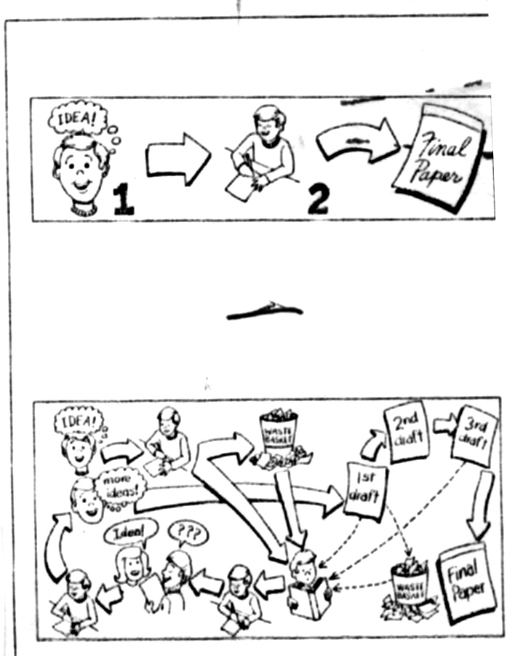

Perl, Sommers, Rose and Zamel studied skilled and unskilled writers. They noticed that unskilled writers felt easily frustrated when what they have written does not match what they have planned. These writers were also inhibited by their concern about form and content. Skilled writers viewed writing from a global perspective ; they changed whole chunks of discourse and reordered the whole, whereas unskilled writers revised in limited ways : they rarely altered ideas, their concern was with lexicon and teacher-generated rules. They paid so much attention to form, and the ongoing process of discovery was constantly interrupted. Rose noticed that unskilled writers were obsessed with the final product. Halsted (1975:82) comments,

“The obsession with the final product….is what leads to serious writing block.”

Skilled writers used reading and re-reading to move on, whereas unskilled writers paused too often, and no thread of meaning was established. Kataryn Lance (cited in Brannon et all 1980 : 380-81) points out,

“I don’t have any idea how to get something right : I just know when it is ….. the whole thing is a process of trial and error : writing and then looking at it as a reader : making changes, then rereading again.”

Writing is indeed a process of writing and reading, of re-writing and re-reading. It is this process of trial and error that leads to a more thoughtful work, and helps the writer to express himself on paper, create a good text and write better.

Stallard found out that good writers devoted time on pre-writing and did not pay attention to form and organization right at the beginning. In other words, when working on the first draft, good writers were not concerned with accuracy in fact, premature editing blocks the writer . Zamel noticed that the flow of ideas of unskilled writers was inhibited by too much attention to form. Zamel (1982: 195 ) points out,

“Less skilled writers who view composition as more mechanical land formulaic are so inhibited by their concern with correctness and form that they can not get beyond the needs and expectations of their readers.”

Researchers have tried to apply findings to student writers. Students are introduced to invention techniques. They are helped to discover and engage a topic instead of being expected to turn in a finished product. They are asked to write multiple drafts of a work, and taught that rewriting and revising are necessary to writing, and that editing is a continuing multi-level process not just a hasty check for correct grammar.

It has been discovered that some students do not know how to revise their work. What they do is change words only and correct errors instead of re-ordering lines, or asking questions about the purpose and audience ; whereas good students change larger elements in revision. It has also been discovered that, during revision, good writers try to have a conversation with their work, which helps them to react to their own piece of writing as audience. Zamel, cited in Academic Writing. Process and Product (1988 :10) notes that :

“These reactions to their texts, what Murray describes as a conversation muttering to each other seemed to enable the students to move on.”

Flower and Hayes (1980, 1981 :102) suggest that writers often start with a view of themselves as readers when composing a text. They have drawn a distinction between reader-based and writer-based prose. The first draft is writer-based . Ideas are expressed according to the cognitive map of their writer. During revision, the writer turns his writer-based prose into reader-based prose taking into consideration the reaction of the reader to what is written. Flower says that,
“as we write, our needs as readers become paramount.”

Good writers try to get feedback from other people, and this will help them illuminate the direction of their thoughts. Moreover, they spend much time on writing the first draft and on incubation to get ideas. They write several drafts and discover more ideas before submitting the final product. A student- writer, said (1982: 202)

“…..my writing seems to take the developmental process that of a fetus : it begins as an amorphous mass and slowly shapes itself. Eventually, it develops to what it supposes to be, my finished written work, my baby.”

Some strategies developed by good writers during the writing process, can be applied in the writing class. Instruction should be based on the psychological process of writing rather than on analysis of texts after they have been produced by someone else. Flowers and Hayes (1977) cited in Academic Writing : Process and Product (1988:6) point out,

“In the midst of the composition renaissance, an odd Fact stands out : our basic methods of teaching writing are the same ones English academics were using in the seventeenth century. We will undertake to teach people to write primarily by dissecting and describing a completed piece of writing. The student is
a. exposed to the formal descriptive categories of rhetoric (modes of argument, definition, cause and effect, etc. And modes of discourse-description, persuasion, etc.
- offered good examples (usually professional ones) and bad examples (usually his/her own.)
c. and encouraged to absorb the features of a socially approved style, with emphasis on grammar and usage. We help our students analyse the product, but we leave the process of writing to inspiration.”

Some strategies developed by good writers during the writing process, can be applied in the writing class. To help the students achieve the process, the teacher interferes throughout the process. He/she makes the students proceed through the following writing process : brainstorming ideas, writing, revising, rewriting, getting feedback and writing again. During feedback, the teacher or another reader gives a first response, which should be positive and only for content, Murray cited in Academic Writing : Process and Product (1988:9) sees writing as

“taking on an existence of its own, and he talks about encouraging a piece of writing to find its own meaning.”

This is done until the students feel confident in their work. The response can be from the student himself, the teacher or a peer as one student indicated, (1982 :201)

“When I write, I keep in mind the reader. The professor is not the reader because he has heard it a million times before…My reader is an imaginary person who may not know something about which I write. You have to think that you are informing somebody even though this person never sees it ….”

Once the students feel confident in themselves as writers, they start to give suggestions for revision to improve the mechanics of writing. The students are encouraged not to pay attention to form and not to insist on perfect writing from the start. As Per (1980 :22) put it,

“Premature and rigid attempts to correct and edit their work truncate the flow of composing.”

The students must be told that a linear model of writing does not help them express their ideas and that the process approach has come to replace the old traditional product that focussed only on correctness, and that the teaching of writing means invention, pre-writing exercises, negotiation of meaning, generating meaning out of experience, editing, polishing, drafting with the assistance of peers and the teacher.

The focus must be on the process of writing first then on the final product because simply pointing out what is wrong does not correspond to the process of producing writing. Students must be given opportunities to work on successive drafts before coming up with a final product.

III.COMPOSITION

Composition writing has been defined as a piece of writing about one central topic. It can consist of one or more paragraphs. If the central topic is broad and needs to be divided into different subtopics, each of these subtopics should be developed into at least one paragraph. A composition that consists of more than one paragraph usually has an introduction and a conclusion that are separate paragraphs.

A paragraph is a group of related sentences that communicates one central idea. A paragraph may be short or long depending on the complexity or simplicity of the topic. The first line of a paragraph must be indented. A composition that has one paragraph has one indentation. A composition that has two paragraphs has two indentations, and so on. When the discourse is long, a text is divided into three sections : The introduction, the body or development, conclusion.

A paragraph usually starts with a general statement which is called “the main idea sentence” or “topic sentence.” It tells the reader what a paragraph is about and limits the kind of information that is to be included in the paragraph. (Unit4 1AS)

Most researchers think that paragraphs should be between 120 and 150 words. They feel that numerous short paragraphs can be unconnected and difficult to be understood by the reader, and that long paragraphs can become boring and the reader is often tired of reading about the same idea.

The topic sentence is usually :

- The first sentence of the paragraph, but experienced writers place it
  - in the middle
  - Or at the end of the paragraph.

It is followed by major points, and these are sentences that explain the main idea sentence. It should be short and to the point. Once the topic sentence or main idea sentence has been stated, these sentences, often called detail sentences, support that idea and add example, details or support.
(See exercise 7 Unit 4 At The Crossroads 1AS)

Read the concluding paragraph below and identify the sentence which best expresses the most important idea.

In 1896 he started teaching in a black American college-Tuskegee Institute- in Alabama. While he was teaching there, he devoted some of his time to science in order to help improve agriculture in the South. He became the most famous agricultural chemist in the South. Though Thomas Edison offered him a job at a salary of $ 25,000 a year, Carver refused to accept it. He preferred to live simply and piously and amuse himself with painting and handicraft arts. He died in 1943. His story is an inspiring example to people who want to become scientists.

All paragraphs must show unity , coherence and emphasis of a topic :

A paragraph is a unit that involves a single topic, and the writer has to write only about that topic. He must not digress into irrelevant ideas. Paragraphs are related to form a unit of thought, and the following example shows how paragraphing works :

Beginnings are apt to be shadowy, and so it is with the beginnings of that great mother of life, the sea. Many people have debated how and when the earth got its ocean, and it is not surprising that their explanations do not always agree. For the plain and inescapable truth is that no one was there to see, and in the absence of eyewitness accounts there is bound to be a certain amount of disagreement. So if I tell here a story of how the young planet Earth acquired an ocean, it must be a story pieced together from many sources and containing many whole chapters the details of which we can only imagine. The story is founded on the testimony of the earth’s most ancient rocks, which were young when the earth was young; on other evidence written on the face of the earth’s satellite, the mean, and on hints contained in the history of the sun and whole universe of star-filled space. For although no man was there to witness this cosmic birth, the stars and the moon and the rocks were there, and indeed, had much to do with the fact that there is an ocean.
(Carson 1978 :2)

In the paragraph above, the author starts to admit the uncertainty of knowledge about the beginning of the earth because there are no eye witnesses yet ; in the next part, she shows that there is still evidence to support her story. There are no irrelevant sentences since each detail links to every other detail.

A paragraph is coherent when relevance among the sentence units is maintained. In a long discourse, each paragraph carries one idea and relates to the others to form a coherent sequence of ideas. To create a connected whole, like links in a chain, transitional devices are used. Without transitions, a paragraph does not read smoothly.

Transitional devices :

1. Coordinating conjunctions such as : and, to, yet, but …….

e.g. : - He is a fine director, and he is a leader member of the community.

- She tried hard, yet she failed.

2. Subordinating conjunctions :

Example 1 : In ancient times, men used drums to send and receive messages; however, communication through drums was not satisfactory. (UNIT4 At The Crossroads Discover the Language 1AS)

example 2. : - She is a liberal; however, her husband is a conservative.
- Although he is old, he is still strong.

3. Transitional devices that introduce an example :
e. g. : For example….
For instance…..

- I think she is not punctual; for example, she kept me waiting for two hours last Monday.

Transitional devices to introduce a conclusion :
e. g. : In summary
Finally
To sum up
In conclusion
In short
Mary did not get up when her mother woke her up; she did not wash her face before she went to school, at dinner time she did not go to the kitchen to help her mother. In short, she behaved uncharacteristically all day.

Transitional devices to show a sequence : (Unit 1 Listening and speaking At The Crossroads Activity 3. 1AS)
First, second, third…..
Next…..

e.g. : If you want to get a good grade, you have to follow these directions. First, you must preview what you will study tomorrow. Second, you must do your homework. Third you must review what you have learnt after school.

Composition is not a mere reproduction of grammatically correct sentences. Pincas (1963 a : 10) says,

“Since a free composition relies on inventiveness, on creativeness,
it is in direct opposition to the expressed ideas of scientific habit.
Forming teaching methods which strive to prevent errors from occurring.”

The act of writing is by its nature creative. Raimes (1983 : 561) points out,
“The very act of writing itself has a creative function.”

Ideas are discovered as the process of creation goes on, and the creation starts to take form. The writer does not get it right the first time, and a satisfactory product is obtained at the end of a process, after the writer has created and invented. In fact, the writer decides to write with a definite idea in mind. But as he writes, new ideas develop.

In the writing class, the students should be assigned kinds of writing that allow their creativity and power of imagination. And the goal of creative writing is to communicate ideas and feelings. Vivid writing consists of concrete images that can be summoned by rules before their realization and free floating parts of the writer’s own experience. Everyday experiences, for instance, are important and can be recorded accurately and imaginatively.

It is important that, when writing a composition, the students be asked to write about something they have read, listened to or spoken about. They will feel motivated since they have ideas. A class discussion, for instance, is an excellent stimulus for writing. : ideas have been discussed, points of view given and interest in the topic aroused. All these lead to a variety of writing activities such as letters, articles, reports, poems, stories, journals and so on.
Letter Writing, articles, stories, poems,…….( 1AS At the Crossroads Units 1, 2, 3, 4, 5 )

e.g. : P57 Write a poem about your country, town, village to say what you love about it.

A correct way to enable students to write a good paragraph is to teach them how sentences are related to each other. The teacher can start with brainstorming a topic in small groups. This activity helps the students, for they can get immediate feedback from the teacher or peers, which is very helpful. The most difficult part of writing is getting started. Most articles, stories, poems…. answer at last five of the questions below :
-Who did it ?
-What happened ?
-When was it done ?
-Where was it done ?
- Why was it done ?
- How was it done ?
WH questions are a motivating factor for beginning a story, for instance. They are useful in producing coherence and unity to a paragraph.

Below, is an example of a first draft paragraph.
This activity can be dealt with in Unit 5 Back to Nature. (1AS )
The smog in this city is terrible. We could solve the smog problem by keeping cars out of the city. For one thing, cars produce the worst kind of air pollution. Another reason is that cars produce a greater volume of pollutants than any other source.

Each sentence in the paragraph above generates a question. The questions that can be asked from the first sentence : “ The smog in the city is terrible.”

- What is smog ?
- Where does the word smog come from ?
- How can you tell that we have smog in this city ?
- Which city has smog ?
- Is this the only city that has smog ?
- If so, why ?
- What makes smog so terrible ?
- Where is this city located ?

Other questions can be asked from sentence three :

For one thing, cars produce the worst kinds of pollution.
- What are the worst kinds of pollution ?
- What makes them so bad ?
- How do we know cars produce the worst kinds of air pollution ?

The students learn how to formulate WH questions and apply this method in order to develop good paragraphs.

With the process approach to writing, composition de-emphasizes a focus on grammar and correctness. Concern with sentence level errors is only a vestige of the past. Raimes (1983) cited in Forum 1991 remind us :

“All teachers know how to welcome compositions that say something, even if there are some mistakes, because there communication of ideas comes first and the rest becomes peripheral.”

The students are introduced to invention techniques and helped to discover and engage a topic instead of being expected to turn a finished product.

Instead of concentrating on the writing the students produce and making critical comments only, the teacher helps them write better and overcome difficulties by giving them assistance in the actual process of writing.

Robert Gorrel says,

“ Like most of us who started teaching in the late 1930’s, I found myself facing three or four sections of freshmen in English…. with no notion of what to do except correct spelling and other errors.”

“Creative or positive approach to composition rather than the traditional red-pencil procedure.”

IV. MANAGING WRITING ACTIVITIES
Writers use different ways to find out what they want to write about and how they will organise ideas. Below, are various techniques that help the student generate ideas and recall them from their memory with the help of others or alone through writing or through discussion.

A. PRE-WRITING ACTIVITIES

The following activities are suggestions for the earliest stages in the process focussed approach to the teaching of writing. They are techniques that are intended to help the students develop ideas and make plans for writing. Moreover, they serve as an initial stimulus and enhance motivation for writing. Students are often blocked, and find writing a difficult task. The teacher can help them further by making them talk about a topic before they begin writing.

Pre-writing techniques and activities help the students participate in thinking, speaking, writing and working on the topic assigned. These activities can be done individually, in pairs or in groups. They may be oral or written, and thus stimulate the students to come up with better pieces of writing.

a. Brainstorming

It is a method that helps to generate ideas . The students are asked to come up with as many ideas as possible in a given topic. The students are helped to develop their fluency since they are provided with opportunities to express their ideas orally or on paper. During discussion, for instance, the teacher acts as a facilitator and jots down all ideas on the blackboard making the students concentrate on content. Brainstorming encourages thinking and increases mental flexibility and imagination. It lets an idea lead to another through free association and quick-follow up of words, thoughts and opinions that are related. It is a group activity and allows the students to share ideas, learn from one another and produce new ideas.

Example
Topic : A childhood memory (can be dealt with 1AS Unit 2 Narration )

1. The teacher can tell the students about a memory of his own from his childhood.

2. He can ask if someone in the class remembers something vivid and let him describe the sensations he remembers. This can be done with different students.

3. Ask the students to write down as many memories as possible and tell them not to worry about clarity, mistakes or language as no one else will look at their notes. The teacher can suggest a five minutes time limit for such an activity.

4. If the students are blocked, the teacher can suggest that they close their eyes and think of a scene from childhood, remembering the sounds, smells, sights….

5. Ask the students to work in pairs. They should discuss selected memories with their partners, and talk about the ideas in their notes.

6. The teacher allows the students to make notes of any ideas which the discussion generated.

7. He can ask them to choose one of the memories they have jotted down and to consider the circumstances associated with it. i.e : the season, the time, the setting, the people, the incident, and to write notes down.

8. Once again, the students talk about the experience with their partners.

9. Now, they have ideas for writing a composition on ‘A childhood memory’ and can start the process of writing.

b. Discussion

Discussing a topic in groups is useful, for it helps the weak students to get ideas to write. It is a technique that should precede writing. It helps the teacher to know what vocabulary, expressions and language structures his/her students need before they start writing. Moreover, it helps the students exchange and get ideas from one another.

Discussion is a source of inspiration for writing. The teacher gives a topic to the students :

e.g. : What makes a place memorable ? 1AS describing places Unit 1: At the Crossroads

Then, they are asked to discuss, to give their opinions including vivid details. They might be asked to describe a place they really lived in, and in which they had good or bad memories. In fact, moments of joy, pain, fear, love, or peace are the seeds of memories. The students might talk about : the view, the climate, the happy time they spent there, the frightening experience they have had, new friends they made, painful memories they had….

c. Quick writing

It is a technique that aims at generating ideas. It is also called ‘speed writing’ because its characteristic is to write as quickly as possible without stopping.

The students write as much as they can on a topic without worrying about the form of what they are writing. The emphasis is put on getting as many ideas on paper as possible, which makes a writer concentrate on content rather than on form. The aim is for students to jot down their ideas quickly. Moreover, quick writing helps them organize the content of their work, and paves the way to writing. It contributes to the achievement of two goals : It makes the distance between the thoughts and the written word short, and it gives the students the opportunity to free their minds from the load they bring with them to class. They want to keep on writing because they have found something interesting.

The students, during this activity, gather strength as writers and discover ideas as they write. They keep writing for a given time without stopping or going back to correct mistakes. As Perl (1979) cited in Academic Writing (1988 :10 ) concludes,

“Editing intrudes so often and to such a degree that it breaks down the rhythms generated by thinking and writing. Premature editing can result in the writer losing track of ideas.”

Thus, in speed writing, the student writes without stopping to think about the effect on the reader, or accuracy because new ideas emerge as they write.

After the students have tried out and discovered ideas in writing, they re-write again. They get feedback from a classmate or from the teacher because the reaction of other people to what has been written will help generate more ideas and arrange sentences in a better way.

Quick writing is like free thinking or day-dreaming on paper. The pen follows wherever the mind takes it, and writing is no longer a boring exercise but a motivating activity that makes the student express his ideas, experiences, fear, joy into words, as Judy (1980 : 39) says,

“Students need opportunity to talk about, to expand, and even relearn and re-examine their experiences prior to writing.”

After having had a glance at their quick writing samples, the students see that they not only have in their heads grammatical structures, but also experiences, memories, ideas, and dreams about life. Any writer first concern is to discover and invent, for writing itself produces ideas.

In quick writing, any written page is messy; in fact, ideas flow from the mind in disorder.
After ten minutes or more, a writer has a messy page or pages of thoughts jotted down. Shaughnessy (1977 : 222 ) points out that :

“One of the most important facts about the composing process that seems hidden from the students is that the process that creates precision is itself messy.”

Very often the writer does not get it right the first time. Several drafts are needed before the final product is reached. The student should become aware that a satisfactory product occurs at the end of the process. During revision, the writer deletes, adds, expands, erases words, sentences, paragraphs, or even pages.

Quick writing is a technique to advance and develop ideas on a theme ; it is useful for any kind of writing. The students can be asked to write about anything that comes to their minds as a result of what they have just read.

d. Journal writing

Quick writing can be a means for introducing journal writing in class. Journal writing is a very useful and stimulating activity. The writing in this activity is a natural exchange of reflections, reactions and opinions related to the course of reading and writing. In writing about what they read, the students can discuss a writer’s ideas, and react to those ideas. Journal comments lead the students to develop a point of view or experience. They can also write about class discussions, writing activities and exercises, or the process of writing itself. By sharing a journal with the teacher, the students will inform the teacher of any success or difficulties they encounter. Journals are not corrected or graded. They only receive the reader’s response. They are meant to be exploratory in nature, and to develop speed and fluency. They are read for ideas only, thus the writer concentrates on meaning rather than form. Such an approach allows the students to write without being afraid of red marks and to experiment with ideas and words without the pressure of grades. The purpose of journal writing is to give the students the opportunity to use written language to explore, develop and communicate their thoughts. The students can express their feelings, emotions, fears, joy. They can also criticize the teacher or write something about the things they liked or disliked during courses. The journal helps them to reflect, react and give opinions about the teaching. They are encouraged to write for communication, and the teacher becomes a participant. It is a very stimulating activity, the students know that writing is not evaluated or marked, thus they write with confidence.

e. Debating

It consists of an oral presentation of a topic. It is used to help the students generate ideas, thoughts and give their opinion about a topic assigned.

When language is used orally, it paves the way for writing, which helps the students to improve their writing skills. Wells and Chang (1986 : 30) point out :

“Oral monologue provides an opportunity to develop some of the skills of composing; planning, selecting, marshalling and organizing ideas. Skills that are necessary for writing, and it does so in a medium in which learners feel more likely to be successful.”

f. Reading

Reading and writing are related to each other. Smith (1982) says,

“Reading and writing are two skills that mirror each other, and they ought to be taught in such a way as to complement each other.”

Stotsky (1983) noticed that better writers were better readers, better writers read more, better readers wrote more syntactically nature prose, and reading experiences improved writing more than grammar instruction or further writing exercises (cf.Carson and Eisterhold, 1990, Krashen, 1995).

Reading is an important tool for generating ideas. It could be used as a pre-writing activity that exposes the writer to vocabulary, conventions, idioms…. Besides, a story, a novel, a poem, can generate ideas for a topic in the writing class.

For example, if you read Great Expectations before writing a paper your writing will probably start to sound similar to Charles Dickens'. (1AS : At the Crossroads : Unit 2 Once Upon a Time ) Or if you liked a book you read in class, ask your teachers to recommend others like it, or read more by the same author.

Pre-reading and post- reading foster critical thinking and lead students toward developing ideas for their own compositions. They start with writing from experience and move to writing from course reading.

To write compositions based on reading, the students can follow guidelines for story completion, quoting, summarizing, paraphrasing, expanding ideas, journal writing, discussing, debating, and sharing an insight based on their own experience. They relate what they have read to what they know from experience. Throughout the course of reading, the students will be exploring ideas in discussion groups, and through a variety of writing activities.

In writing about what the students have read, they can discuss an author’s ideas and react to those ideas. They may develop a deeper understanding of a reading selection. They may discover why they agree or disagree with an author’s experience or point of view.

g. Word Mapping/Clustering

It is “ a pre-writing technique that enables the writer to map out his /her thoughts on a particular topic and choose which ones to use.” (Carr 1986: 20)

Word mapping is similar to brainstorming. The difference is that the emphasis is narrowed down to a specific idea or word. Rico (1986:17 ) defines word mapping as follows : a

“non linear brainstorming process that generates ideas, images and feelings around a stimulus word until a pattern becomes discernible.”
The stimulus word is circled by the teacher, who asks the students to say all that comes to their minds when they see that word. Responses given by the students are encouraged. The teacher groups responses on the blackboard with the stimulus word in the centre. She/he tells the students that they always have plenty of ideas in their heads, and the best way to produce them is to gather them quickly on paper ; otherwise they will be forgotten. As they are listening to other students making suggestions, and to the teacher’s explanations, the students are exposed to new vocabulary for the ideas they have jotted down. The teacher elicits ideas from the students and puts a collective map on the blackboard. Branches are added since the students suggest new ideas. The result will be a kind of map with a number of subtopics originating from the central topic.

When the map is completed, a class discussion can be held, and students with the help of the teacher, will decide on the best order in which points would be presented in a written piece.

WORD MAPPING

Topic : Describe your town Unit 1 AT THE CROSSROADS 1AS

Preparation : This activity is carried out with blackboard and chalk to help the students have an idea on how such a pre-writing activity is dealt with.

Procedure :
- The teacher asks the students to close their eyes and think of their town. They are then asked to jot down all the things that are associated with “their town” that come to their mind.
- A collective map is put on the blackboard as the ideas are suggested. The students have an opportunity to see how different aspects of a topic can be drawn by the teacher. e.g. :

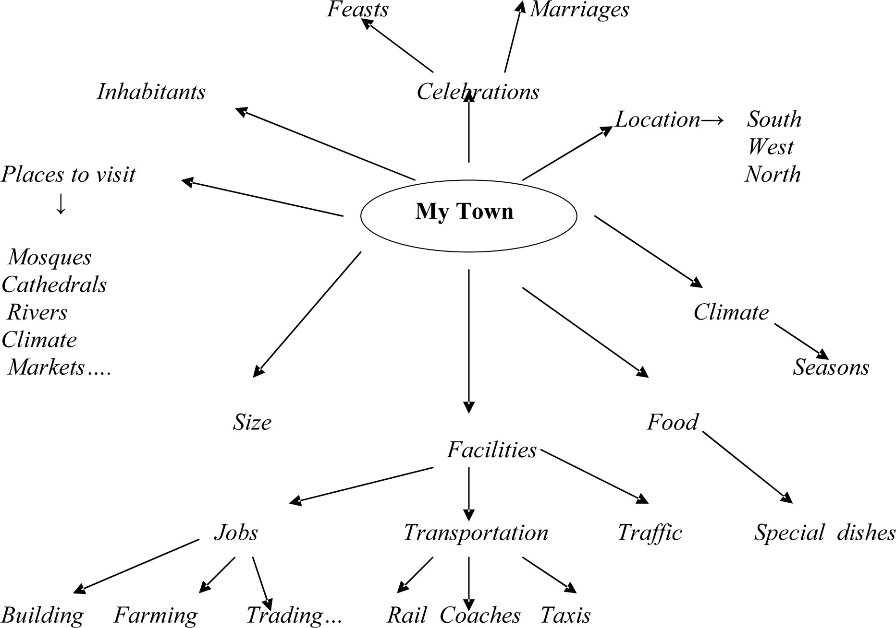

h. Interviewing

It is a prewriting activity that helps to create a relaxed atmosphere for writing. It helps to break the ice, and is very useful at the beginning of the year. The teacher tells the students that they are going to interview a member of the class to find out information of special interest about him or her. The teacher gives time to the students to generate questions for the interview.

e. g. : What’s your name ?
Where do you come from ?
Which school do you come from ?

The teacher makes the students ask their partner some fairly personal questions such as :

  - What makes you happy ?
  - Are you optimistic ?
  - Can you give me three things you are good at ?
  - Do you have a boy/girl friend ?
  - Are you interested in politics ?
  - Do you like reading ?
  - Do you have a computer ?
  - Do you like surfing on the net ?…….

The teacher asks the students to conduct the interview in pairs, giving a maximum of ten questions.

The students jot down ideas and notes. Then, each member is asked to use his notes to write a short description of his partner from the information selected. They are given time to ask questions and write down ideas about their partner’s interest, background, then change roles. They are asked to organize a draft then read it to their partners, who react, share ideas and give suggestions.

i. Free Association
A topic is written on the blackboard. The students say whatever words come to their minds when they see the topic.

e. g. : Topic : An Ideal Teacher.

Words : Patient- tolerant- hard working- eclectic- flexible- active-lively- a good listener- cope with the unexpected- punctual- consider the pupils on an equal footing- has a good command of the language-encouraging- helpful- allow mistakes- not too strict- a friend- an artist- have a sense of humour-self reflective- have a critical mind- respect the others- convincing- open minded- frank- realistic- available…..

Project : Your school is organizing a meeting for all the teachers, including students . You represent your class. Write a composition in which you state your ideas of an ideal teacher. You can also give an example of a teacher who, throughout all your school life, had a positive impact on you.

Audience : Teachers, Administration, Students.

USE THE PROCESS APPROACH TO WRITING.

1. First draft : Discover ideas, keeping in mind that you will change the paper later on.

2. Feedback : Get feedback from a classmate or the teacher. Read your draft. Ask yourself questions, talk to your paper and read for content.

3. Second draft : Make changes as far as content is concerned . Start over. Get feedback again.

4. Third draft : Make change as far as content is concerned. Start over. Re-read, try to converse with your ideas to see what you can change.

In the writing process, the emphasis is put on the importance of a series of drafts. The writer gradually discovers ideas through writing. Writing is a process of shaping words to fit ideas. While writing, an idea, a topic, a title often emerge, and the writer is like a sculptor. The idea that a writer starts with in making a piece of writing is similar to the lump of clay the sculptor starts with in creating a sculpture. He does not know exactly what he will end up with. Ideas are discovered as the process of creation starts to take form. A piece of writing is not poured into a mould, then baked and taken out as a perfect finished work. It is shaped gradually : Bits are added here and there. Therefore revision is obligatory, and what is being written the first time is a draft, not a finished product.

5. Fourth draft : Edit and polish your work to make it reader based : Check your grammar, get feedback as far as form is concerned.

6. Final product : Your written piece is ready. You have followed the steps good writers go through when they write.

j. Conferencing

Conferencing is a way for the teacher to give pieces of advice on the students’ composition. The attention is focussed on each student individually. Carnicelli (1980) cited in Forum (1994 : 26) defines the conference method as a combination of

“Conference, a process approach, and a reasonable set of priorities.”

Conferencing is a face-to-face conversation between the teacher and student. While the student is working, the teacher sits beside him and talks about writing. He gives support with organization of ideas, helps with language and extends the student’s thinking. He also gives oral responses and promotes self –learning. Oral responses encourage the student in writing ; in fact, written comments are a one- way communication and the student can not disagree, complain, or ask questions. Conferencing encourages the students to organize and improve their writing. It also gives them an opportunity to talk about their writing and reflect on the process. During conferencing, the teacher listens, learns, and diagnoses.

Florio-Ruane and Dunn (1985) cited in Writing (1991:154) say,

“By listening to the student and reading the work in progress, the teacher can come to know the author’s intentions, resources, growth, and needs. For the student, talking with a teacher about the work and responding to thoughtful questions is a way to expand and clarify thinking about audience and purpose as well as a moment to receive technical assistance and advice.”

B. While Writing Activities

a. Drafting
Drafting is a stage where a writer really starts writing. What is important here is to get ideas on paper without worrying about grammar, punctuation and spelling. It is a preliminary composition in which the writer tests out his experiences and ideas discovered to see how they will work together.

It is a first try, and the focus is put on the development of ideas rather than on grammar, spelling and punctuation. A first draft may be written for the self only. It is called “expressive writing”. It is tentative and exploratory and thus, is done without concern for the mechanics of writing. The teacher may provide class time for the students to share this first draft in a small group. In such a case, group members share their reactions to the writing and supply ideas for proceeding.

There are many ways of writing a first draft : some writers prefer to write an outline only after they have written a draft to see if there is a logical organization. Writers go through a process of creating different drafts.

A second draft is written for the purpose of being reviewed by classmates and then handed to the teacher for further evaluation. Writing a draft is a messy process with cross outs, additions, and so on. The writers pause to re-read, rethink, and rewrite. Widdowson (1983) cited in Writing (1991:22) point out,

“In writing one so frequently arrives at a destination not originally envisaged, by a route not yet planned for in the original itinerary.”

b. Revising
Revising is an important part of writing. Writing involves re-reading and re-writing, for writers look back at what they have already written and make changes. As an experienced writer (1980: 380-381) cited in college composition and communication vol 31 n°4 December, 1980, points out,

“I re-write as I write. It is hard to tell what a first draft is because it is not determined by time. In one draft, I might cross out three pages, write two, cross out a fourth, re-write it, and call it a draft. I am constantly writing and re-writing.”

Revising means making decisions about what to keep, add, omit, alter, rearrange and rethink. It allows the writer to reshape and refine thoughts the way they are expressed. As a professional writer, understands revising (1980:380-381),

“It is a matter of looking at the kernel of what I have written, the content, and then thinking about it, responding to it, making decisions and actually restructuring.”

Writing is a communicative activity. One possible way of judging if a piece of writing is communicating, is to share it with a peer or the teacher : ask each other questions, listen to the answers, for the answers can help for the second draft. The following are a few examples of questions :

  - What do you think I am trying to say ?
  - What part of writing did you like best ?
  - Did any part of it make you stop and read it over in order to understand what the writer meant ?
  - What do you remember most about my writing without looking at it again ?

The purpose of such an activity is to share a piece of writing and offer support and suggestions, and as a writer re-writes, he/she keeps her/his peer’s comments and suggestions in mind. This may mean that the writer has to add brief phrases, sentences, more details, examples to illustrate or support some points. It is also possible that the reader suggests the writer put too much information, yet before anything is taken out, she/he has to see if another reader made the same comment.

However, it has been noticed that the teachers and the students simply look for wrong spelling, grammar errors and other surface problems. This is editing. Revising means rethinking and restructuring writing, and a writer needs to ask the following questions on what has already been written :

. Am I sharing my impressions clearly enough with my reader ?
. Have I missed out any important points of information ?
. Are there any points in the writing where any reader may be puzzled because I have omitted an argument or forgotten to explain something ?
. Does the vocabulary need to be made stronger and simple at any point ?
. Are there any sentences that are too repetitive and can be omitted ?
. Do I have to rearrange sentences to make my writing clearer or more interesting ?
. Do I need to rearrange any paragraphs ?
.Does my writing lack organization ?
. Are the links between sections clear ? Do they guide my reader through the writing ?

While revising, ideas occur at any time, and most writers write draft after draft, first to generate then organize ideas to convey them clearly to the readers.

c. Peer-response

In peer-response groups, the students share drafts with others,

“as the drafts are developing in order to get guidance and feedback on their writing.”
as Leki (1993:2) points out.

What is important in peer response, is that the students provide each other with feedback on their preliminary drafts so that they may have a wider audience and work toward improving their compositions.

In collaborative writing, the teacher is not the only respondent of a written piece ; in fact, classmates are also involved in responding to writing. They use their strengths to help others, negotiate and work together. The first purpose of response is to find the strengths of a written piece, the second is to make suggestions for improvements. The teacher’s role is to help :
  - the students gain confidence
  - explore the writing process and their own resources
  - encourage them to help each other.
  - Work together through composing problems and negotiate with each other.
  - Be less dependent on the teacher, and work with other students.
The teacher’s role is to act as facilitators, organize writing experiences that enable the students to develop effective composing strategies, provide a real audience other than the teacher, give the students opportunities to work in small groups and get helpful criticism about each other’s writing.

Jolly and Early (1974 :2) point out,

“Psychologically, group work increases the intellectual and emotional participation or involvement of the individual pupil in the task of learning a foreign language. Some pupils are more intelligent than others, while some (not necessarily the same ones) are more gifted in learning languages, some pupils are outgoing, communicative, extrovert personalities while others are shy, withdrawn introverts.
In small groups, all these types of learners can meet and mix, compensating for one another’s
strong points and deficiencies as language learners.”

By discussing work, the students become aware of how the reader reacts to writing and how the writer reacts to their readers’ responses. In the writing class, the students need to have the opportunity to ask other writers questions about their drafts, and by having readers ask them questions, they learn to ask questions themselves about their own writing.
For instance, the students can be helped to ask the following questions :

. What am I trying to say ?
. Have I expressed faithfully what I wanted to say ?
. How will my readers react when they read this ?
. Will they understand the same thing expressed by me ?

Such a process will help them to become critical readers of their own writing. Peer review groups provide a place for exploration and discovery of ideas.
Here are some guidelines to help the students prepare for peer review :

. Start with a positive reinforcement : Tell the writer what you like about the paper and what you think he has to change.

. Give your criticism. Tell the writer what is confusing, misleading, and bothering you. Tell him also what makes you want more.

. End with a ray of hope. Remind the writer of what you like and how the draft can be made better. Tell him , if you were the writer of that paper, what you would do to make it more interesting.

d. Collaborative Writing

Collaborative writing generates peer support and ideas emerge through discussions. Peer collaboration has become a pedagogical tool in teaching/learning. It provides writers with an opportunity to read their drafts aloud and discuss them with their peers while the written product is shaping. Classroom talk can be positive in supporting all the phases of the process of writing. Group work can be of a great help to writers, they become more fluent and are assisted in revising, thus students need audiences in addition to the teacher. Knowing the audience, helps the students become aware of strategies for revising writing.
An ethnographic study concerned with talk in a high school classroom community examined if writers’ intuitions and revision strategies could be

“strengthened within a supportive classroom environment.”

(Kantor 1984 :75)

e. The Editing Process

Errors can distract a reader’s attention away from what is meant by a writer. The goal of editing is to produce a paper in which the meaning is clear. Editing occurs at the post-writing stage. It involves proof-reading and correction of errors, which are important procedures. They help the writer to produce a clearly expressed and comprehensible paper to hand in.

During the editing process, a writer makes final readjustments and checks accuracy to make the text accessible to the reader. She/he closely reads and rereads the paper and refers to other sources such as grammar books, dictionaries, the teacher’s or peer’s help. These processes should be focussed on at a later stage, after ideas have been developed and organized. Perl (1979) studied American student writers ; she found out that with less able students

“Editing intrudes so often and to such a degree that it breaks down the rhythms generated by thinking and writing. Premature editing can result in the writer losing track of ideas.”

In a composition class, the readers can be the teacher or a classmate who will proof-read a paper and point out the errors. Sometimes a writer needs to correct and proof-read his own paper. At a larger stage, she /he reads her paper to find mistakes. She/he can look for her/his typical errors, errors she knows she tends to make . e.g. : run on sentences, inappropriate verb tenses, sentence fragments, word order. She can read his/her paper aloud as if someone were listening. The writer can hesitate to read his own writing, and the reason may be she/he has come across an error. She/he can mark the spot on the paper and continue reading. It may be difficult to find someone’s errors, and to have a peer proof-reading. It may be difficult to find someone’s errors, and to have a peer proof-read the paper may be helpful.

Conclusion

The present work shows that writing is more of a process-dominated approach than a form- dominated approach. What has been presented so far, may be beneficial to teachers and students. They may find useful examples for the teaching /learning of writing. In the writing class, students need to be taught how to use the process and produce an acceptable product. Writing well is a process that can be learnt and practised. The students should take time, do a lot of reading, think, discuss and rewrite. Such activities are necessary and valuable in the writing process. And to improve their writing, students need time, assistance, encouragement, advice, and support from other readers. The teacher should be a guide, a reader, and editor rather than a mere error finder. The effective teacher of writing is the one who is able to create a learning environment in which the students discover their strengths and weaknesses as writers and feel comfortable when writing.

Throughout the process, teachers and learners negotiate with each other and the teacher becomes a resource person for the novice writer and an investigator of the students’ writing process.

The most important findings of this research are as follows :

- Students need to be told what good writers do when they write ; they go through certain processes which lead to successful pieces of writing : they get ideas through brainstorming, observing, discussing, reading. They write a first draft, read its content then refine it. They write more drafts before they reach a final version. At the end, they edit and polish their work. Therefore, classroom tasks should be set up in such a way that they reflect the writing process good writers go through.

- Teachers should encourage the students to plan, organize, compose and revise. The teacher should give the students time to generate ideas, write drafts and re-write them. Raimes (1983:6) points out that :

“A student who is given time for the process to work, along with the appropriate feedback from readers such as the teacher or other students, will discover new ideas, new sentences, and new words as he plans, writes a draft and revises what he has written for a second draft.”

-The teacher should provide feedback, respond in a positive way to the students’ writing and give help, advice and encouragement during writing and not afterwards.

-Writing is both a process and a product. A teacher should be eclectic and offer a balance of control and creativity. He should help the students in the process so that they will be able to come up with a better product.

- Controlled exercises should be assigned as remedial work.

- Students need to be shown that any piece of writing has a communicative purpose.

- The teachers should provide contexts, expose the students to models of different text types.

-These texts will serve as examples of writing and help the students to produce their own texts. The students should learn styles and formats for different writing purposes.

- Grammar has a place in the writing process, but attention to it should be delayed until the product stage. Too much premature attention to grammar hinders the flow of ideas. Therefore the students should be helped to get the content right first and leave details of correction later on : Accuracy should not be emphasized from the start but postponed until the student has generated ideas.

- The teacher should play a role in the writing process. He should help the students get ideas together, discuss topics to generate ideas, elicit information and read texts. The key to a successful written work lies in the close cooperation between the teacher and the student.

- The teacher should provide stimulating activities. Classroom tasks should be characterized by journal-writing, peer-collaboration, revision, creative writing, and attention to content before form.

-The teacher should help the individual students to correct their own drafts so that the stress on accuracy takes place within the context of the work already produced.

- The four skills : Listen- speak-read- write should not be treated in isolation. Though writing is the focus of attention in the writing class, it must be supported by the other skills.

- Students should work on a writing of activities through pair work and group work.

- Students should exchange their writings in order to become readers of one another’s work. In fact, it is by responding as readers that students become aware that a writer is producing something to be read by someone else.

By writing drafts, the students will try out different ways of presenting ideas and will get responses from the teacher or classmates. They will be working gradually to a polished written piece, exploring ideas and organising them. They will have many opportunities to make their composition as good as possible.
All these findings have been experimented in classes with 1AS, 2AS, 3AS. The students enjoyed this process approach to writing.
This project may not solve the writing problems of all students, but it may provide guidelines and pave the way for teachers whose goal is to improve the writing competence of their students.

Bibliography
-Augusto A. Alvarez Sanchez 1982 Are we correcting or Killing our Students ? Forum Magazine.

-Barton, D. & Ivanic, R. (eds.) (1991). Writing in the Community. London: Sage.

-Brown, H.D, 1994 Principles of Language Learning and teaching, Prentice Hall Regents
-C.J. Brumfit and K. Johnson 1991 The Communicative Approach to Language Teaching. Oxford University Press.

-Cumming, A. (1998). "Theoretical perspectives on writing." Annual Review of Applied Linguistics, 18, 61-78.
-David Nunan , 1989 Designing Tasks for The Communicative Classroom Cambridge University Press Library.

-Icy Lee 2002 Helping Students Develop Coherence in Writing. Forum Magazine-Jack C. Richards and Theodore S. Rodgers. 1991 Approaches and Methods in Language Teaching Cambridge University Press.

-Judith-Anne Adams& Margaret A. Dwyer 1982 English for Academic Uses A Writing Book
-Lynn Worthington 1997 Let’s Not Show the Teacher : EFL Students’ Secret Exchange Journals. Forum Magazine.
-Peyton, J. K., 1993, "Listening to student voices: Publishing student writing for other students to read." In J. Crandall & J. K. Peyton (eds.), Approaches to ESL Literacy Instruction (pp. 59-73). Washington, DC & McHenry, IL: CAL and Delta Systems.
-Peyton, J. & Staton, J (1996). Writing Our Lives (2nd Edition). Washington, DC & McHenry, IL: CAL and Delta Systems, Inc.
-Raimes, A. (1998). "Teaching writing." Annual Review of Applied Linguistics, 18, 142-167.
-Richards, J.C., 1990 The Language Teaching Matrix, Cambridge University Press. -Rivers, W.M. 1981 Teaching Foreign Language Skills Chicago University Press.-Ruth Spack 1990 Guidelines A Cross-Cultural Reading/Writing Text St. Martin’s Press,Inc.
-Rwaida Abu Ras 2001 Integrating Reading and Writing for Effective Language Teaching. Forum Magazine.
- S.A.Arab (2005) At The Crossroads ONPS
-Savage, K. L. (1993). "Literacy through a competency-based educational approach." In J. -Crandall & J. K. Peyton (eds.), Approaches to ESL Literacy Instruction (pp. 15-33). Washington, DC & McHenry, IL: CAL and Delta Systems, Inc.
-Spiegal, M. & Sunderland, H. (1999). Writing Works: Using a Genre Approach for Teaching Writing to Adults and Young People in ESOL and Basics Education Classes. London: Language and Literacy Unit.

- Thomas Gwin 1991 Giving Students the Write Idea : A Way to provide Feedback on Writing. Forum Magazine

-Zhang Feng Xing and Chen Shih Jin 1989 Techniques To Teach Writing. Forum Magazine

