Souad BELBACHIR

‘FROM THE SCHOOL OF SUCCESS TO THE SCHOOL, SHEIKH MOHAMED BELBACHIR’

‘DE MADRASAT EL FALAH A MADRASAT CHEIKH MOHAMED BELBACHIR’

من مدرسة الفلاح إلى مدرسة
الشيخ محمد بلبشير
1 AS

EDITIONS DAR EL GHARB
TEXTS, EXERCISES, GAMES, RIDDLES, JOKES, POEMS, RHYMES, FABLES,
A FAIRY TALE,
AND A BIOGRAPHY IN ARABIC AND FRENCH
BY THE NAME OF ALLAH, THE COMPASSIONATE THE MERCIFUL.

IN MEMORY OF MY PARENTS,

IN MEMORY OF ALL THE ALGERIAN MILITANTS WHO STRUGGLED FOR THE INDEPENDENCE AND THE WELFARE OF ALGERIA.

IN MEMORY OF NADIA GHASSOUL OUHIBI
IN MEMORY OF ALI BOUAMRANE
IN MEMORY OF RACHID BENALI
IN MEMORY OF HOURIA BELMOKRANE
IN MEMORY OF HOUARIA HADDAD
IN MEMORY OF AMAR TABEK
IN MEMORY OF MOULOUD AMANI
IN MEMORY OF FOUAD BENAHMED

2013
E-mail: souad.belbachir@yahoo.fr

To my Father and to all the Teachers of the World!
As a teacher, you were strict but kind
Everything you taught me is kept in mind.
You taught me to be good
And do the things I should.
You taught me to be nice and gentle with people round me
And be useful to society.
You taught me to get the best I can at school
When I had problems in grammar,
You used to tell me ‘just try to remember
the grammatical rule’ .
Your lessons were interesting
Efficient and fascinating,
And your words encouraging.
I was a child,
And I still remember your smile.
I will never forget
What I learnt
You have lit my path
Thank you for your guiding hand and your loving heart!
Thank you for everything
Having you as a teacher was a blessing!
By Souad Belbachir

TABLE OF CONTENT

TEXT AND ACTIVITIES 9
WORD GAMES 19
RIDDLES 30
GENERAL CULTURE GAME 33
JOKES 38
GAMES AND ACTIVITIES 49
FABLES.........................................................................77
A FAIRY TALE 83
VERSES RHYMES AND POEMS ............................. 89
ANSWERS.................................................................. 93
A SHORT BIOGRAPHY IN ARABIC AND IN FRENCH : SHEIKH MOHAMED BELBACHIR 107

TEXT AND ACTIVITIES

PART ONE : A. Reading Comprehension
Read the text carefully then do the activities.
Sheikh Mohamed Belbachir called ‘Si Boudjemaa’, was born on 3rd March 1922 in Figuig, a small town situated between the Algerian and the Moroccan frontiers. He was tall and strongly built; he was dark haired, dark eyed and dark complexioned. He had a severe expression but was very kind-hearted. As a teacher, he was competent and strict. He worked hard and expected his students to work hard. He loved teaching and reading books in Arabic, especially the Coran.
Sheikh Mohamed Belbachir got his degree in teaching Arabic in Morocco by the end of 1939. He left the country in 1940 to settle in Oran, Algeria and be an active member of ‘Harakat El Islah’ (Reform Movement), initiated by the Association of the learned Man (Ouléma Association), an Association created by 1931, along with Cheikh Said Zemmouchi, Dellal Boumédiène Ghaouti, Cheikh Abdelkader El Yajouri, Tsouria Belaid El Hadj Tayeb and other great Men and Women who worked with abnegation and devotion for the welfare of their country, Algeria.
By 1943, and with the help of other militants, such as Seghier Benali, Souiah Lahouari, Abderrahmane Fatmi ......he continued working secretly for the country to achieve social and political changes and free Algeria from the yoke of colonialism. His militant behaviour and actions made the French authorities send him to the South, exactly to Béchar by 1945. He returned to Oran a year later, and continued struggling for the freedom of Algeria, because for him ‘Al Haraka El Watania’(The National Movement) was a priority.
In 1947, he was appointed by the Oulémas Association, Teacher of Arabic, the National language, and Islamic Education at Chihab School, Arzew, then Headmaster of the same school. Then in 1953, he was appointed Teacher in Madrasat El Falah, ‘The School of Success’, now a primary school in Oran, founded by the early 1940’s. Its Pioneers were: Cheikh Mohamed Said Zemmouchi, Dellal Boumediène Hadj Ghaouti, Mohamed Hassan Fodalla, Abderrahmane Fafa,... . His colleagues were Mohamed Kaba, Sheikh Omar El Biskri, Amina Zaanane, Fatima Tiab, Khadija Khatir, Sheikh Abdelkader El Yajouri, Souiah El Houari, Houari Louni, Hocine and Hafiz Si Lakhdar.... Then he became Imam Oustad in Mosque Al Falah until 1956 when the French authorities decided to close the school and the mosque.
By the beginning of 1962, the school opened its doors again, and Sheikh and other Algerian prisoners of war such as Sheikh El Yajouri, Dellal Boumediene Hadj Ghaouti, Tayeb Benkoula and other Militants were freed. After the Algerian Independence, exactly on the 6th December 1962, Sheikh was appointed teacher of Arabic in Pasteur School, Oran. And in 1963, he was appointed Imam in Al Falah Mosque, for it opened its doors again after the independence. Seven years later, he became Inspector of Religious Affairs in Béchar. He came back to Oran in 1975 and was appointed Imam in Imam Malek Ibn Anès mosque.
Sheikh Mohamed Belbachir retired in 1994, continued living in Oran, his beloved town but could not bear staying at home and being far from the Mosque, thus he spent his life going there, praying, reading the Coran, and devoting his life to helping people in need.
On 23rd of May 2001, he was awarded by the President of Algeria, the Medal of ‘Moukawim’ (Militant) during the Algerian War of Independence 1954-1962. He died on Monday, 2nd November, 2009. May He rest in Peace.
By Souad Belbachir

1. The text is a……………
a) Recipe b) Newspaper article
c) Survey d) Biography.
2. It is addressed to…………………………..
a) General readers b) Sheikh Belbachir Mohamed
c) Teachers d) Students

3. Give a suitable title to the text.
4. Copy down the table below and complete it with information from the text.
Character traits | Sheikh Mohamed Belbachir
Physical appearance
Personality

5. Match the questions in column A with the answers in column B
A | B
- What colour was Sheikh Belbachir’s hair?  - Was he strongly built?  - Did he teach French?  - When did he leave Morocco?  - When was Madrasat El Falah founded?  - Did Sheikh Mohamed Belbachir contribute to the Algerian War of Independence?  - What was he awarded in 2001?  - When did he die? | a. Yes, he did.  b. On 2nd November ,2009.  c. the Medal of ‘Moukawim’(Militant )  d.Yes, he was.  e. No, he didn’t.  f. Dark  g. In 1940  h. by the early forties.
6. Who/what do the underlined words in the text refer to ?
7. Answer the following questions according to the text.
a) When was Sheikh Mohamed Belbachir born?
b) Where was he born?
c) What did he love?
d) Why did he work secretly with other people?
e) Why did the French authorities send him to the South?
f) Why did they close Madrasat Al Falah at that time?
g) Did the school open its doors? When? h) What did Sheikh Belbachir get in 2001?
i) Is he still working? Quote from the text to justify your answer.
j) Could he stay at home after retirement? Why/why not?
8. Fill in the chart with information from the text.
Dates | Events
1922
1931
End of 1939
Early 1940’s
1947
1953
1954
1962
6th December 1962
1975
1994
2001
2009
9. In which paragraph is it mentioned that Sheikh Belbachir loved his job?
10. In which paragraph is it mentioned that he was a hardworking teacher?
11. In which paragraph is it mentioned that he moved to Oran in 1940?
12. In which paragraph is it mentioned that his strong desire was to see Algeria free and independent?
13. In which paragraph is his death mentioned?
B. Text Exploration
1. Find in the text words closest in meaning to the following.
a) Located (§1) b) borders (§1) c) great love, admiration, loyalty (§2) d) liberty (§3)
2. Find in the text words opposites in meaning to:
a) Big (§1) b) Fair (§1) c) Hated (§1) d) passive (§2)
3. Give the opposites of the following words keeping the same root.
a) Happy b) kind c) competent
4. Supply punctuation and capitalization:
ouléma association was created on 5th may 1931 its members were sheikh abdelhamid ibn badis sheikh el okbi med bachir el ibrahimi
5. Spot the mistakes and correct them.
a) Did he use to taught Arabic ?
b) He was gentle, generous and helpfull.
c) What was he liked?
d) Who is the man in blue eyes?
e) The War started in 1st November 1954.
f) Algeria get its independence in 1962.
g) He is an teacher in Madrasat El Falah.
h) Sheikh Abdelkader El Yadjouri was a Great Man, didn’t he?
i) ‘You must knew about the History of Algeria.’ Said the teacher.
j) She entered ‘Madrasat El Falah where she was 4years old.
k) She can never forgotten her teachers, especially her teacher of Arabic.
l) ‘It is the better present a daughter can offer her father.’
m) Sheikh Zoubir teached at Chihab School from 1953 to 1955.

6.Use ‘who’, ‘which’, or ‘whom’ to join the 2 sentences.
a) The great lady is explaining the grammatical point to
the pupil.
The Lady is Amina Zaanane.

b) She was a competent teacher.
Every body admired.
c) It was a poem about Algeria.
It was written by that young pupil.
d) The boy was waving the Algerian flag.
The boy is only 5 years old.
7. Join the pair of sentences with ‘while’ or ‘when’. Make the necessary changes.
a) The pupil was reading a beautiful poem about the martyrs . All the class was listening attentively.
b) Little Ali was drawing the Algerian flag on the blackboard. The teacher entered the classroom.
c) I was moved. I heard the students singing the National Anthem.
8. Give the correct form of the verbs between brackets.
a) As we (listen) to our teacher, the Inspector came.
b) If I were younger, I (go) and (study) in Madrasat El Falah .
c) I will write the biography if I (find) enough information.
d) When we were young, Mrs. Amina Zaanane, our great teacher, used to (teach) us songs of freedom, peace and love.
e) I can (remember) all the poems and the songs I learnt when I (be) 6 years old.
f) After she (write) beautiful verses, she decided to (read) them to her classmates.
g) While I was writing the biography of the great man, Salah, my friend (sing) the National Anthem.
h) The ‘Association El Falah’ (be create) in 1938.
i) The School (open) on the 10th August 1952 and Sheikh Larbi Tebessi (give) a moving speech during the opening ceremony.
j) She said, ‘ magazine N°1, called ‘ Dar El Falah’ (be publish) on the 30th October 1953.’
k) Magazine n°2 ‘Read and write’ , published on 1st January 1954 (be design) for children.
l) If you (read) the magazines, you will learn about the school and its founders.
9. Give the comparative form and the superlative form of the following adjectives.

Adjectives | Comparative form | Superlative form
Heavy
Small
Great
Good
Difficult
10.Divide the words into roots and affixes
Words | Prefixes | Roots | Suffixes
National
Reading
Association
Independence

11. Complete the chart as shown in the example.
Verb | Noun | Adjective
Example: to differ  To create  ……………………….. | Difference  ……………………  love | Different  ………………….........  …………………........
12. a) Add a suffix to the verb ‘to retire’ to form a noun.
b) Add a suffix to the noun ‘peace’ to form an adjective.
c) Add a suffix to the adjective ‘great’ to form a noun.
d) Add a suffix to the adjective ‘successful’ to form an adverb.
13. Select all the irregular verbs from the list below then give their past tenses.

Create - leave - call - get - be - read - contribute - have
Infinitives | Past simple | Past participle
14. Ask questions which the underlined words answer.
a) She has received a letter of congratulations.
b) The children visited the museum last Saturday.
c) If I were a teacher, I would encourage my pupils to read.
d) My teacher always tells us jokes before starting the lesson.
e) Mr. Harry started teaching 20 years ago.
f) I will always remember the fables and the beautiful stories I read when I was a child.
g) Sheikh Ibn Badis, Sheikh El Bachir El Ibrahimi and Sheikh Mustafa Benhalouch came to Oran on 17th February 1938 to receive ‘Al Oumma Al Wahrania’and together discuss and make the decision to open ‘Madrasat Dar El Falah’.
15. Classify the verbs according to the pronunciation of their final ‘ed’ Learned – situated- worked- expected- settled- founded
/t/ | /d/ | /id/
16. Complete the following conversation
Journalist: .............................................................................................
Mrs.Zaanane: Yes, with pleasure, young man.
Journalist: .............................................................................................
Mrs. Zaanane: Yes, of course. I do still remember. The 5th July 1962 was a great day!
Journalist: ............................................................................................
Mrs Zaanane: Many Algerian people organized peaceful marches: they sang and danced to manifest their contentment and happiness.
Journalist: ............................................................................................
Mrs Zaanane: The National Anthem and other patriotic songs.
Journalist: Great! I wish I were present.
PART TWO WRITTEN EXPRESSION
Choose one of the following topics:
1. Write a person’s profile. (a person dear to you) Physical and mental description, life, career….. (the person can be dead or alive)

2. It is the Opening Ceremony of ‘The School of Success’ . Imagine you are Sheikh Larbi Tebessi, and you are giving a speech. Try to move your audience. Write the Speech. The words below may help you.
- Education- Key to success- knowledge- rise of consciousness- courage- bravery- loyalty- the future- the future generation- work hand in hand- work hard- sacrifice- Algeria- Beloved country- the road to success-……… ‘The foundation of every state is the education of its youth.’………………………….

3. Write a letter of admiration to the teachers who worked with abnegation and devotion for the welfare and the prosperity of their beloved country, Algeria.

WORD GAMES

Dear Teacher

Light my candle,
Just with a puzzle or a riddle

You will see my enthusiasm
Just with a game or a poem

You will be bathed in glory
Just with a joke or a story
You will help me try
Just with your smile
By Souad Belbachir

Opposites
Reorder the letters in the boxes on the right side to find the opposite of each word on the left side.

H | O | T
D | L | C | O

L | E | F | T
T | I | H | R | G

T | A | L | L
M | A | L | S | L

S | H | O | R | T
G | L | O | N

B | E | T | T | E | R
S | W | R | E | O

Animals and Fish

Reorder the letters to find names of animals and fish.
N | L | I | O

H | I | O | P | L | N | D

B | A | I | T | B | R

H | E | A | L | W

T | P | N | A | L | E | E | H

Planets

Match each group of words to find the names of 4 planets.
U T O

E A
R S
V E N
M A
U S
P L

R T H

In the Classroom

- Re-order the letters to write the names of things you can find in your classroom.
- K - S - D - E
- P - M - A
- H - S - A - I - C - R
- S - C - P - I - T - E - U - R
e) P - M - R - U - E - C - O - T
f) B - C - O - D - L - K - A - R - A

In the Kitchen

Reorder the letters to write the names of things you can find in the kitchen.

- R - E - D - G - I - F

- E - B - L - T - A

- S - E - S - G - A - L - S

- L - T - A - E - S - P

e) C - O - E - R - O - K

f) I - N - S - K

g) T - B - E - S - T - O - L.

Facilities

Do the same to write the names of facilities.

- O - S - C - L - H - O
- A - C - M - I - N - E
- G - D - N - A - R - E
- Y - C - B - E - R
- N - A - B - K
- T - H - P - L - O - S - I - A
- M - I - S - D - T - A - U
- T - A - E - E - H - R - T
The Body

Change one letter in the words below to find words all connected with the human body.
- Rose
- Month
- Fair
- Deck
- Singer
- beg
- Land
- Aim
- Heard
- Rye
- Tip
- Foe
Nice Trip !

In each word there is an extra letter, put it in the empty boxes below to write the name of my favorite means of transport.

T | P | R | A | I | N

B | U | L | S

B | I | A | K | E

N | C | A | R

B | O | E | A | T

Save me !

(This game is adapted and translated from: Amusons nous (Piccolia 1998).Cross all the SOS letters to find the name of an animal in danger and save it from extinction.

S | O | S | S | S | O | S
P | S | O | S | S | S | O
O | S | O | S | S | A | S
S | O | S | N | S | O | S
O | D | S | S | S | O | S
S | S | O | S | S | A | O
O | S | S | O | S | O | S

Colours

Cross the extra letters in each box to find 4 colours .

Y | A | E | L | D | L | O | W
C | B | R | T | O | W | X | N
P | R | H | I | E | O | S | D
R | W | O | H | I | T | X | E

The Message
Cross letters X-Y-Z to find a message

S | X | T | Y | O
P | W | Z | A | R
X | A | N | Z | D
Z | P | O | Z | X
X | L | L | Z | U
Z | T | X | I | Y
X | Y | O | Z | N

Countries
Re-order the letters below to find names of countries.
- R - L - A - I- G - E - A
- E - G - N - D- L - A- N
- C - R - C - O - M - O - O
- E - N - F - A - R - C
- D - C - A - N - A - A

Capitals
Fill in each gap with the missing letters to find names of capitals.
- L - - - - N b) A - - - - - S c) R - - - T
d) T - - - S e) C - - - O f) W - - - - - - - - N

The Noble Profession

In each word, there is an extra letter. Put it in the empty boxes to write the name of a noble profession.
P | T | I | L | O | T

B | A | E | K | E | R

A | P | R | E | S | I | D | E | N | T

N | U | R | S | E | C

P | L | U | M | H | B | E | R

D | O | C | E | T | O | R

D | E | N | T | R | I | S | T

Ten Great People

Unscramble the words to find the name of 10 famous people.

1. American President during the American Civil War (1861-1865)

L N H A

A C O R N

L B M

I A

2. French chemist who discovered a cure for rabies.

R P E L

S I U A T

O S U

3. British playwright famous for his tragedies.

I E S K A

I H P E R A M

A W S L L E

4. Indian nationalist leader.

H S D A A

M N G D I

H A O N

5. Born in Scotland in 1881, he discovered penicillin in 1928.

R A F G E
L L E E X I M
D N N A

6. Algerian writer born in 1955 and the author of ‘L’attentat’
H Y S M A
A R K
A A I
N D

7. Comic actor born on 16th April 1889 in London. He died in 1977 in Switzerland.
H C P I
I C L E H L
R A I A

8. Algerian writer born in 1936 in Cherchell. Her first novel is ‘La Soif’
I S A S
J E D B A
B R A

9. South African Leader who spent 27 years in prison but became President in 1994.
E N O N
L S M
D A N
A E L

10. Black Civil Rights leader born in 1913 and died in 2005. She refused to give her bus seat to a white passenger in 1955.

O A R P
S A R
S K

The Messages

Cross letters XYZ to read my message.
BXEZSYT ZOYF XYLZUCXYZK!
Cross letters XWZ to find another message.

IX HWOPZE WYOZU XENXJWOWYEXD WTZHE WBZOZXOWK.

RIDDLES

1 -What is found in the very center of both America and Australia?
2 -What relatives are dependent on you?
3 -Why is the letter « T » like an island?
4 -What part of London is in France?
5 -What is it that no man ever yet did see, which never was, but always is to be?

6 -What follows a cat wherever it goes?
7 -Four fingers and a thumb, yet flesh and bone have I none.
8 -What has a head but can not think?
9 -What is after B in the alphabet?
10 -What has an eye but can’t see?
11 -What has a tongue but can’t speak?
12 -What has a mouth but can’t eat?
13 -What is it that occurs once in a second, once in a month, once in a century, yet not at all in an hour, or a week, or a year?

14 -What is the longest word in the English language?
15 -What word of only three syllables combines in it twenty six letters?
16 -Which is the strongest day of the seven?
17 -What’s the difference between a hill and a pill?
18 -What is that animal which has the head of a cat, and the tail of the cat, and the ways of a cat, and yet which isn’t a cat?
19 -I can go very far without drinking water?
20 -Girls have it.
Boys do not.
It is in life but not in death.

21 -As long as I eat I live, when I drink, I die.
22 -What is neither in the house, nor out of the house, but still a part of the house?

23 -It runs and never tires. Down and down and never up.
24 -I hear you speak, and I make you hear. I have one ear and my mouth is always open. What am I?

25 -Black within and red without; four corners round about.
26 -Which is the loudest vowel?

27 -What is it that has a face, but no head; hands, but no feet, yet travels every where and is usually running?

28 -In marble halls as white as milk, lined with a skin as soft as silk, within a fountain crystal clear,
A golden apple doth appear.
No doors there are to this stronghold,
Yes thieves break in and steal gold.

29 -As round as an apple, as deep as a cup,
And all the king’s horses can’t pull it up.

30 -Little Nancy Etticoat
In a white petticoat,
And a red nose.
The longer she stands.
The shorter she grows.

31- It can fly fast and high.
It lays eggs in a nest
It likes eating worms
It lives in a tree.

32. Its home is a tree
Its hides food for winter
Its tail is longer than the rabbit's tail
It likes nuts.
33. It lives in a hole
It doesn't like cats
It likes cheese
34. What are kangaroos afraid of?
35. Elephants do not have computers. Why?
36. What is black when it is clean and white when it is dirty?

GENERAL CULTURE GAME

1. The Association of the Algerian Oulémas was created on:
a) 16th April 1940 b) 5th May 1931 c) 5th July 1962

2. Ibn Badis was born on
a) 4th December 1889 -b) 1st November 1800 -c) 31st December 1900

3. He was born in:
a) Algiers b) Constantine c) Oran

4. When did he die?
5. Who is the author of the National Anthem “Kassaman”?
6. He composed it in :
a) 1954 b)1962 c)1955

7. What did Pasteur invent ?
8. Who invented a vaccine against smallpox ?
9. What is Jean de la Fontaine famous for?
10. Who said, ‘It’s love that makes the whole world turn round.’
11. What does UNESCO stand for?
12. WHO?
13. UNICEF?
14. UNO ?
15. ILO ?
16. When did Alexander Fleming discover Penicillin?
17. Who invented the radio in 1901?
18. Name the Woman Nobel Prize Winner for Peace in 2003.
19. What is the moral in ‘The Crow and the Fox?’
20. When did the Titanic sink?
22. Who invented e-mail and came up with the @ symbol ?
23. Whose speech is “I HAVE A DREAM” ?
24. Who is the Author of The Jungle Book?
25. Name the leader of the struggle for Indian independence, who believed in non-violence.

26. Who sings ‘Yesterday’?
27. Who invented the telephone?
28. What is the capital of England?
29. Who wrote ‘Things Fall Apart’?
30. Who wrote ‘Hard Times?’
31. Shakespeare was born in
- 1564 b)1616 c)1612
32. What is ‘The Times’?
33. What is Green Peace?
34. Name the Algerian playwright who wrote Homk Salim in 1972.
35. Who wrote ‘Nedjma?’
36. When did Alloula write Elajouad?
37. What does NBA stand for?
38. What is the smallest planet of the Solar system?
39. Which of these countries does not belong to the Maghreb?
a) Algeria - b) Madagascar – c) Morocco – d) Tunisia

40. Who discovered Radium ?
41. What’s the Capital of Algeria?
42. What is ecology ?
43. Who was President of France during the Algerian War of Independence (Algeria- France 1954- 1962)

44. Give the names of the Prophet’s parents. (The Prophet Mohammed Peace be Upon Him).

45. What is the first verse of the Coran ?
46. How many World Cups did Pelé bring Brazil ?
47. Name the black leader who spent 27 years in Prison, struggled for freedom and won the Nobel Prize for Peace in 1994.

48. When did the Chernobyl accident happen ?
49. Name the great woman awarded the Nobel Prize in 1979 for her devotion to feeding, clothing and housing the poor.
50.What is Alkhabar ?
51. Who invented the telescope in 1600’s?
52. « The Olympic Games » What does the word “Olympic” mean ?
53. What is ecology ?
54. Who discovered the dynamite ?
55. Why did he come up with the Nobel Prize ?
56. Who is the main character in “Things Fall Apart ?”
57. Who wrote King Lear ?
58. Vendredi « Friday » is the friend of :
a) Mowgli b) Tarzan c) Robinson Crusoe

59. When was Amnesty International created ?
60. What is its goal ?
61. Name the former racial system in South Africa which came to power in 1948.

62. Name the militant racialist white organization after the American Civil War whose members supported slavery.

63. When did the bomb in Hiroshima explode ?
64. For which country did the singers of ‘ We are the World’ sing ?
65. Give the first name of the Queen of England .
66. When was Martin Luther King assassinated ?
67. Give the title of his famous speech.
68.Which country sent a woman to space for the first time? Give the woman’s name.

69.In which video game does Michael Jackson free the children prisoners of M. Big ?

70. In which country was rugby invented ?
71. What does AIDS stand for?
72. Give the name of the monkey genetically modified.
73. Give the name of the goat cloned in 1996 by Richard Wilmut.
74. Who came up with E= MC2 ?
75. When did the tragedy of The World Trade Centre occur?
76. Who sings Freedom now ?
77. ‘Ask for More’ is an AD. For which product ?
78. Who sings “Imagine”?
79.Which sport did Bob Marley like ?
80. Who invented the Braille System ?
81. What is the name given to journalists who persecute stars just to take photos and have information ?
82. Which animal was Moby Dick ?
83 Which animal is the symbol of the World Wide Fund ? (protection of nature)
84. What is the Daily Mirror ?
85. What does HIV stand for ?
86. When did Dr. Luke Montaigner discover the virus?
87 - Name the non-profit organization which works to protect nature
88- When was the United Nations Climate Conference held?
89- Where?
90 - What is its objective?
91- During the conference a president said, “I came here to act.” Who is it?
92- Another president said, “Failure in Copenhagen would be a catastrophy.”Who is it?
93-What does UNFCCC stand for?
94-Which country has the biggest number of forests ?
95- What does the word Sonatrach stand for?
96- What is the Etna ?
97- Who said, “God made the country, man made the town.’
98- Which country launched the 1st Artificial satellite Sputnik 1 in 1957?
99-Which big town registered more than 20 000 dead in 1985 after an earthquake ?
a) San Francisco –b) Mexico -c) Pekin -d) Lima.

100-Who invented the drug Aspirin in March 1899 ?
101- Name the 2 Americans who made the 1st jeans in 1873.
102-Who invented the 1st phonograph in 1877?
103-Which town in Algeria hosted the International Conference for the LNG16? When ? What does LNG16 stand for ?
104- What does FPEG stand for?
105 -How many countries were supposed to attend the LNG16 Conference?
106- Name 6 countries that attended the conference LNG 16.
107-What does 22ndApril symbolize?
108-What prevented the LNG 16 Conference to start on time?
109-When will LNG 17 happen?
110- Where?
111- When was the 19th Football World Cup held?
112- Where?
113- When did Ghana play against Uruguay?
114- What was the score?
115- What was the score Algeria – England?
116- Who won the Football World Cup of 2010?
117- Who was the top scorer in the tournament? (2010 World Cup)
118- The match ball for the 2010 World Cup, manufactured by Adidas is named ‘Jabulani’ in Zulu. What does it mean?
119- How is the long horn blown by fans throughout matches called?
120- In which country will the 2014 Finals be held?

JOKES

1. Teacher: What's an insect's favourite game?
Pupil: Cricket
2. Teacher: where is South America?
Pupil: I don't know.
Teacher: Where is Greenland?
Pupil: I don't know.
Teacher: Where is Bulgaria?
Pupil: I don't know.
Teacher: look them up in your textbook.
Pupil: I don't know where that is, either.
3. Teacher : Who is your favourite author?
Pupil: George Washington.
Teacher: But George Washington never wrote any books.
Pupil: You got it.
4. Teacher :Where was the Declaration of Independence signed ?
Pupil: At the bottom !
5. A class went on a school trip to Rome. On the Sunday they all went to church and when they came out the teacher said, `I hope you all behaved.' .
`Oh, yes, sir,' said one girl. `A kind man offered me a plate full of money but I said, "no thanks".
6. Where's the worst trip you're likely to go on?
To the headmaster's office.
7. A teacher took her class on a nature trail through the woods. She stopped by a tree and said, `Brian, can you tell me what the outer part of a tree is called?'
`I don't know, sir,' said Brian.
`Bark, boy, bark!' said the teacher.
`Ok, sir,' said Brian. `Woof! Woof!'
8. Why is history like a fruit cake?
Because it is full of dates.

9. Teacher: ‘Why are you late this morning?’
Robin: ‘Please, Miss, I was dreaming about a Manchester United match.’
Teacher: ‘But why did that make you late?’
Robin: ‘They had extra time.’

10. Biology teacher: ‘Can anyone tell me what kind of creature a slug is?’
Smart Alec: ‘I’d say it was a snail with a housing problem.’

11. English teacher: ‘This term we’re going to study Kipling. Do you like Kipling, Brenda?’
Brenda: ‘I don’t know, Miss. I’ve never kippled.’

12. Maths teacher: ‘If you had £7.47p in one pocket, and £4.26p in the other pocket, what would you have?’
Smart Alec: ‘Someone else’s trousers on!’

13. Maths teacher: ‘If I had seven oranges in this hand, and nine oranges in this hand, what would I have?’
Henry: ‘Big hands, Sir’

14. Smart Alec’s class was doing a project about milk. Every one wrote several pages about how milk came from cows, and was taken to dairies in tankers, and bottled, then delivered to our doorstep by the milkman. But smart Alec’s project was only three lines long. He explained that he’d written about condensed milk.

15. Teacher: ‘Martin, put some more water in the fish tank please.’
Martin: ‘But they haven’t drunk the water I gave them yesterday, Sir.’

16. Teacher: ‘Andrew, your homework looks as if it’s your father’s handwriting.’
Andrew: ‘Well, I used his pen, Sir.’

17. English teacher: ‘Did you write this poem, Emily?
Emily: ‘Yes, Miss.’
English teacher: ‘Well, I’m very pleased to meet you Robert Browning.’

18. What does a teacher have that her class doesn’t have?
The answers.

19. Teacher: ‘What’s your name, boy?’
William: ‘William.’
Teacher: “Say ‘Sir’ when you speak to me.”
William: ‘All right, Sir William.’

20. Teacher: ‘What have you heard about the Dead Sea?’
Maureen: ‘I haven’t heard it was ill, Sir.’

21. Teacher: Tell me ten animals that come from Africa.
Leo: Nine lions and an elephant
.
22. Teacher: ‘Who can give me a word meaning the opposite of minimum?’
Kate: ‘Minidad, Sir?’

23. Bill: ‘Who was the fastest runner in history?’
Jill: ‘Adam. He was first in the human race.’

24. Teacher: ‘Recite your tables to me, Joan’

Joan: ‘Dining-room table, kitchen table, bedside table…’

25. Teacher: ‘Tell me something that is important today that didn’t exist 200 years ago.’
Smart Alec: ‘Me!’

26. Teacher: Why are you standing in front of the mirror with your eyes closed?
Rosie: So I can see what I look like when I’m asleep.

27. David, on the phone: Our David has a bad cold and can’t come to school today.
Teacher: I’m sorry to hear that. To whom am I speaking?
David: This is my father.

28. Visitor to school: Why is that boy locked in a cage in a corner of the classroom?
Betty: That’s Tom. He’s the teacher’s pet.

29. Sarah: Would you punish someone for something they hadn’t done?
Teacher: Of course not.
Sarah: Good, because I haven’t done my homework.

30. School doctor: I’m afraid your son needs glasses.
Parent: How can you tell?
School doctor: By the way, he came in through the window.

32. Teacher: Who can name four members of the cat family?
Sue : Mother cat, Father cat, and two kittens.

33. Teacher: Martin, didn’t you hear me call you?
Martin: Yes, but you told me never to answer back.

34. Teacher: Now Clara, give me a sentence with two pronouns in it.
Clara: Who, me?
Teacher: Correct.
35. The brain is a wonderful thing.
Why do you say that ?
Because it starts working the second you get up in the morning and never stops until you get asked a question in class !

36 - « Mother, how much do people pay a pound for babies ? »
« Babies are not sold by the pound, darling. »
« Then why do they always weigh them as soon as they are
born ?»

37 - « What is your new brother’s name ? »
Little Jane : « I don’t know yet. We can’t understand a word he
says.»

38 - « Lord, you are late, sir » said the nurse meeting the young
husband at the door; « it’s two o’clock and sir here’s news for you. You are the father of two bouncing babies !
Twins, sir, twins !»
« Strange coincidence » said the young father, « two o’clock and
two babies. Thank heaven I did not come at twelve. »

39 - Excited young father : « Quick ! Tell me ! Is it a boy ? »
Nurse : « Well, the one in the middle is. »
40 - Mother : « Tommy, the canary has disappeared. »
Tommy : « That’s funny. It was there just now when I tried to
clean it with the vacuum cleaner. »

41 - Mother : « Tommy, wouldn’t you like to have a pretty cake with five candles on it for your party ? »
Tommy : « I think I’d rather have five cakes and one candle,
Mama. »
42 - « Ouch, Mum, I hurt my toe ! » cried small Jany, who was
playing out in the garden. »
« Which toe, dear ? » I inquired, as I examined her foot.
« My youngest one », said Jany.
43 - Mother to small son : « Now Johnny, you can’t have the hammer to play with. You’ll hit your fingers. »
Johnny : « No, I won’t, Mum. Doris is going to hold the nails.»

44 - Father : « Isn’t it wonderful how little chicks get out of their
shells ? »
Son : « What gets me is how they get in. »

45 - Fond mother : « Yes, Genevieve is taking French and Algebra.
say ‘good morning’ to Mrs. Jones in Algebra, darling.»

46 - Teacher : « How many fingers have you ? »
Bobby : « Ten »
Teacher : « Well, if four were missing, what would you have,
then ? »
Bobby : « No music-lessons. »
47 - « Mummy, do you love me?»
« Of course.»
«Then why not divorce daddy and marry the man at the candy store? »
48 - « Mummy, Tom has taken the largest piece of cake, and it is unfair because he was eating cake three years before I was born.»
49 - A little four-year-old girl said the other day, « Mum, how long is it to my birthday? »
« Not very long, dear.»
« Well », she asked, « is it time for me to begin being a good girl ?»

50 - Mother : « Which apple do you want, Junior ? »
Junior : « The biggest one. »
Mother : « Why, Junior ! You should be polite and take the little
one.»
Junior : « Well, mama, should I lie just to be polite ? »

51 - « Why are you crying, little girl ? »
« Cause my brother has holidays and I don’t. »
« Well, why don’t you have holidays ? »
« Cause I don’t go to school yet. »

52 - « Jessie, I have told you again and again not to speak when older persons are talking, but wait until they stop. »
« I’ve tried that already, mamma. They never do stop. »

53 - Dad : « Son, I’m spanking you because I love you. »
Son : « I’d like to be big enough to return your love. »
54 - Father : « Aren’t you ashamed to be at the bottom in a class of
28 boys ? »
Willie : « Oh, that’s not so bad. »
Father : « What do you mean, not so bad ? »
Willie : « Suppose there were 50 boys. »
55 - « The teacher is mad. Yesterday he told as four and one makes
five, but today he told us that it was three and two ! »
56 - « Ethel was just home after her first day at school. « Well,
darling,» asked her mother, « what did they teach you ? »
« Not much, » replied the child. I’ve got to go again. »
57 - « Johnny, if you had six apples and I asked you for three, how
many would you have left ? »
Johnny : « six ».
58 - Teacher : « Tommy, name five things that contain milk .»
Tommy : « Butter and cheese, ice, cream, and two cows ! »
59- « Jimmie », said the teacher, « why don’t you wash your face ?
I can see what you had for breakfast this morning.”
“What was it?”
“Eggs.”
“Wrong, teacher. That was yesterday.”
60- Father :Son, why is there a big “O” on your paper ?
Son :The teacher ran out of stars, so she gave me a moon.

61-What’s the weather like ?
I don’t know. It’s so cloudy I can’t see.

62- Teacher : Can you tell me anything about the great chemists of 17th Century ?
Student : They are all dead, sir.
63- “Now”, said the professor cheerfully. “ Please pass all your test papers to the side of the room and kindly insert a carbon sheet under the paper so I can correct all the errors at once”.

64- She: You remind me of the ocean.
He: Wild, romantic and restless ?
She : No, you just make me sick.

65- A little boy with a terrible toothache went to the dentist to have the bad tooth pulled out. When the painful operation was over, he asked the dentist to let him have the tooth.
“ What do you want the tooth for ?” asked the dentist.
“ I am going to take it home, fill it with sugar and watch the darn thing ache.” Answered the little boy.

66- Teacher : What’s the shape of the earth ?
Johnny : Round !
Teacher :How do you know it is round ?
John : all right, it’s square, then. I don’t want to start an argument about it.

67- Father : Who is the laziest member of your class Tommy ?
Tommy : I don’t know, pa.
Father : I think you should know. When all the others are studying or writing who sits idly in his seat and watches the rest, instead of working himself ?
Tommy : The teacher, Daddy!

68- Mathematics teacher : Now, if I lay three eggs here and five eggs there, how many will I have ?
Pupil : Well, to tell the truth, I don’t believe you can do it, sir.

69- What did the octopus say to the girl octopus?
I want to hold your hand, hand, hand, hand, hand, hand, hand.

70-“ My eyes are dripping like faucets, my nose is clogged, and my throat feels like a drainpipe. Should I call a doctor ?”
“ No, you should call a plumber”.

71- Mr Gray was on holidays by the sea. He was staying in a small hotel, but it was not a good hotel. The meals were very small. One day he sat down to dinner. His plate looked wet. He held it up to the waiter and said, “ This plate is wet. Please bring me another.”
“ That’s your soup,” replied the waiter.

72- When a girl shows a ring and says she is going to be married, it is usual to ask , “Who’s the lucky man ?” It’s a silly question because everybody knows that the lucky man is her father.

73-“ What’s the meaning of this fly in my soup ?”
“ I don’t know, sir. I’m a waiter, not a fortune teller.”

74- A teacher called for sentences using the word “beans.”
“My father grows beans,” said the bright boy of the class.
“My mother cooks beans,” said another pupil.
Then a third popped up : “ We are all human beans.”

75- What did one wall say to the other ?
I'll meet you at the corner.
76. The parents were very disappointed in the grades that their son brought home. "The only consolation I can find in these awful grades," lamented the father, "is that I know he never cheated during his exams."
77."Dad, can you write in the dark?"
"I think so. What is it you want me to write?"
"Your name on this report card."
78.The child comes home from his first day at school.
Mother asks, "What did you learn today?"
The kid replies, "Not enough. I have to go back tomorrow."

79. The teacher came up with a good problem. "Suppose," she asked the second-graders, "there were a dozen sheep and six of them jumped over a fence. How many would be left?"
"None," answered little Norman.
"None? Norman, you don't know your arithmetic."
"Teacher, you don't know your sheep. When one goes, they all go!"
80.Teacher: If I give you two rabbits and two rabbits and another two rabbits, how many rabbits have you got?
Paddy: Seven!
Teacher: No, listen carefully again. If I give you two rabbits and two rabbits and another two rabbits, how many rabbits have you got?
Paddy: Seven!
Teacher: Let's try this another way. If I give you two apples and two apples and another two apples, how many apples have you got?
Paddy: Six.
Teacher: Good. Now if I give you two rabbits and two rabbits and another two rabbits, how many rabbits have you got?
Paddy: Seven!
Teacher: How on earth do you work out that three lots of two rabbits is seven?
Paddy: I've already got one rabbit at home now!
81.Teacher: Why are you late, Joseph?
Joseph: Because of a sign down the road.
Teacher: What does a sign have to do with your being late?
Joseph: The sign said, "School Ahead, Go Slow!"

50 GAMES AND ACTIVITIES

1. Chain Names

Aim: To introduce pupils to each other

Ask the pupils to sit in a semi circle and nominate one pupil to introduce himself / herself. The person next to him/her must then repeat his/her name then introduce himself /herself.

Ask them to repeat this procedure around the semi-circle, each one repeating the name of the person before them, and saying their own name.

e.g. : A : I’m Bob
B : Bob, I’m Alice
C : Bob, Alice, I’m Mary

e.g.: A: I’m Bob
B: Bob, I’m Alice
C: Bob, Alice, I’m Mary.
D : Bob, Alice, Mary, I’m Ted.

2 - HA! HA!
Aim : To remember numbers.

The children sit on the floor and form a circle. The first child cries : « one, Ha! »; the second child says : « two, Ha! Ha! »; the third child cries « three Ha! Ha! Ha!»; Each child on his turn, adds one « Ha! ». To have fun, the « Ha - Ha’s » must be said rapidly. The idea of this game is to keep from laughing. If a child laughs or makes a mistake, he is eliminated.

3 - FIND THE LEADER

Aim : To develop pupils’ sense of observation.

Players sit in a circle. One person is chosen to leave the room. Then one of the remaining players is selected to be the leader who is to make various motions, such as folding hands, crossing legs, smoothing hair, etc..., each of which the group does with him, changing as he changes. The person who left the room is called back to try and locate the leader. If he is caught, the leader becomes the next person to leave the room.

4 - STOP THE MUSIC

Aim : To remember songs already studied.

A pupil hums or sings La, la , la .
( A song the class have been singing ).

e.g. : Are you sleeping ?
Billy Boy . etc.....

When a pupil recognizes the tune, he / she calls out « stop the music», and if he / she guesses the tune correctly, he / she has turn at « crooning » a tune for the others.

5 - FIND THE BUTTON

Aim : To practise prepositions : near - away from, etc...

« It » ( a pupil ) leaves the room. The others hide a button. Then « It » is called into search for the button. When « It » gets near the button, the children cry out: « warmer »; When he gets very close, they cry out : « Hot » or « boiling »; When
« it » moves away from it, they cry out, « colder or freezing ». When the button is found, a new « it » is chosen for the next round.

6 - FACE TO FACE

Aim : To practise the imperative.
To give and obey commands.

Every pupil has a partner, and the two stand facing each other at the circumference of a large circle. Somebody in the centre of the circle gives commands, which all the players obey.

e.g. :Stand back to back, run round each other, shake hands, touch each other’s shoulders, etc... Suddenly the pupil in the centre calls out « all change », and everyone must seize a new partner. The centre pupil tries to do so too. The one left without a partner gives commands.

This can be played wherever there is enough room, and best outdoors. If the total number of pupils is even, have two in the centre giving commands.

7 - DIRECTIONS

Aim : To practise the imperative.

To practise prepositions : on - in – behind- under - to the left, etc...

Materials : A ring - a coin - a necklace - a pen, etc ...

Something small, such as a ring, is hidden in a fairly inconspicuous place.
One pupil has been outside the room, and now appears at the door to be « instructed » by the others. Each pupil gives one instruction;
e.g. : - Walk forward six steps.
- Now walk another two steps.
- Turn to the left.
- Go up Harry’s desk.
- Turn to the right.
- Look under the desk....

The article should be found after about six instructions have been given, so that a number of « searchers » is still waiting outside.

8 - WRAPPED OBJECTS
Aim : To identify objects by saying :
« it is a ............ »

Materials : Small objects such as : a sweet, a small candle,
a key, a rubber, etc...

A number of pupils stand facing the class with their hands behind their backs. The teacher puts small wrapped objects
( e.g. a sweet, a candle, a key, .... ) into every pupil’s hands. Each pupil has to feel what he has and say what it is. As soon as all have guessed, they unwrap their objects in turn and show them to the class by saying : It is a ring ...............
It is a candle ...........

9 - GUESS HOW MANY

Aim : Getting to know numbers.
Materials : Beans, coins, buttons....

The pupils may work in pairs. Each pupil has a small number of beans, coins, buttons... and takes turns with his partner to guess how many there are in the other’s closed hand.

The pair can keep their own, a point every time a correct guess is made.

10 - I SPY . . . . .
Aim : To review the letters of the alphabet and find out names of objects

A pupil says : « I spy with my little eye something beginning with « b ». The other players guess what it can be.

e.g. : - Susan : ‘ The blackboard ‘
- Harry : ‘ No ’
- Dick : ‘ A biscuit ‘
- Harry : ‘ No ‘
- Stephen : Dick’s ball
- Harry : ‘ Yes, that’s right ‘

It becomes Stephen’s turn to say :
« I spy with my little eye something beginning with
e.g. : « s »....

The object must be visible.

11 - SHIPWRECK LISTS

Aim : To practise food, drinks and clothing items.

Materials : A pencil and paper.

Each group has a pencil and paper and the group leader does the writing. First, names of foods must be written down. Allow two or three minutes for all the groups to do this, then ask for names of drinks, and finally for articles of clothing.

Group A leader reads out his / her group’s list, while the other group leaders cross out on their lists anything he / she mentions. Then group B leader reads out what his group still has, and the other groups cross out those items if they have them, and so on with all the groups. The result will be that items not crossed out on any list will be those no one else but a certain group has thought of. « You have been wrecked on a desert island », says the teacher, « and this is all the food, drink and clothing you have ».

The surviving items are read out, and a point given for each word on the list.

12 - LETTER CHAINS
Aim : To put emphasis on spelling.

This game is best played in teams ( say the two halves of a class ) so that they can attempt to trap each other. There should be a time limit of 5 second for a response to be made. The chain will be like this : through, here, egg, gap, photograph, hair, rabbit...

The last letter of a word must be the first letter of the next word.

13 - WORD SETS
Aim : 1-) To revise the letters of the alphabet.
2-) To find out names of jobs, animals, countries, food.

A box layout is put on the blackboard. The name of one pupil is written across to provide initial letters (avoid long names or those which have letters repeated). At the side, the chosen topic areas are indicated. The players have to find words in each topic area which begin with the prescribed letters. This can be done at the board, with pupils calling out words, or on paper, in pairs or groups. Sometimes it is impossible to find a word for every single box, so the pair or group which completes the most squares will be the winners.

Here is an example of a nearly completed game, using the name Robin.
A word set box

NAME : ROBIN
R O B I N
J O B | ? | OPERATOR | BUILDER | INSPECTOR | NUN
ANIMALS | RHINO | OSTRICH | BADGER | INSECT | ?
COUNTRY | ROMANIA | ? | BELGIUM | ITALY | NORWAY
FOOD | RICE | OLIVES | BUTTER | ? | NUTS

The check is oral. There are usually several options for each slot. It is a good idea to ask desks to change papers for the marking. To play a second time, you just erase ROBIN and write a new name, adding or deleting a row of boxes if necessary. Alternatively you can leave the name and change the topic areas.

14 - SECRET MESSAGES

Aim : To practise both numbers and the alphabet.

Each letter is given an agreed number, but it is not necessary to work from a=1 to z=26 each time. You can stipulate any combination
e.g. : a=10, b=20, c=30 and so on ). Once you have put the message into the agreed code, you then call out the numbers. A space between two words is marked by the word zero.
Here is an example based on the code 1 to 26. It translates as « Bring me a pencil », and the first pupil to obey and take one to the teacher would get the prize. Sometimes a clever learner will decode before you finish sending.

2 18 9 14 7 ZERO 13 5 ZERO 1 ZERO 16 5 14 3 9 12
B R I N G M E A P E N C I L

15 - MY SHOPPING BASKET

Aim : To practise the alphabetical order.

The first speaker gives one item of shopping, the second repeats it and adds another, the third builds yet another item on the list, and so on. The game can be played in alphabetical order or not, as you wish. It is easier to provide new words if no such restriction is imposed. On the other hand, it is easier to remember items in alphabetical order. The items themselves are important, but the quantity or packaging need not be remembered exactly. The game will sound like this.

Pupil 1 : In my basket I’ve got an apple.
Pupil 2 : In my basket I’ve got an apple and a ball.
Pupil 3 : In my basket I’ve got an apple, a ball, and a packet of crisps. ( and so on : a duck, some eggs, a pack of flour etc.)
The game can be made competitive, to involve more pupils where the class is large. Each row becomes a team. The message is passed to the back of the class from the front. One of each pair, having added an item, has to turn round and pass it to a pupil seated in the desk behind and so on. When all the rows have finished, the last pupil ( right at the back, of course ) has to stand and repeat the whole list as it arrived.

There should be as many items in the basket as there are pupils in the row.

16. GUGGENHEIM

Aim : To recognize verbs, nouns, adjectives and adverbs . And find words: Vocabulary Game.

Ask each player to draw a rectangle, five squares across and four squares down, like this :

T A B L E
Nouns | teacher | answer | business | lamp | event
Verbs | think | arrive | begin | leave | erase
Adjectives | tender | angry | busy | lazy | elegant
Adverbs | thoroughly | anxiously | beautifully | luckily | evenly

Choose a five-letter word, e.g. : table, and ask the players to write it across the top, putting one letter above each of the five squares. Then ask them to write the words nouns, verbs, adjectives, adverbs beside the four squares down, as shown in the diagram above. The object of the game is for the players, within the time limit given , to fill each square with a word beginning with the letter at the top of the column and being the part of speech indicated at the left.

At the end of the time, have the players exchange papers for the scoring. In scoring each square, have different players call out the words they find on the papers they have. A correct word that occurs on only one paper in the group scores five points. All other correct words score 1 point. The player with the highest total score is the winner.
17. FOLLOW THE ALPHABET

Aim : to revise the alphabet

A player will name a person, the place where he lives, and an adjective describing him, all beginning with the letter A. For example, he might say, " I know a girl named Alice. She lives in Australia, and she is amiable." The second player will do the same with the letter B, and so on around the group and through the alphabet.

18. SCORE FIRST

Aim : to practise the recognition of the grammatical categories of words: nouns, verbs, adjectives, and adverbs.

Each player in the group may ask for 10 words (5, if the group is large). The first player to call a correct answer gets one point. The teacher should act as a referee, deciding which student was the first to call a correct answer.
The first play might go like this:

First player Answers by Different Players

Noun- T Table
Verb- L Like
Adjective- P Peaceful
Noun- B Book
Adverb -F Fast

Letters may be repeated during the game, but words may not.

Variations
The game may also be played with pencil and paper, the students writing down their answers. In this case, the play may be made more challenging by requiring the letter called to be the second or last letter of the word to be written.

19. A WAS AN APPLE

Aim : Structure emphasized : Past simple tense.

The game begins with the first player announcing, "A was an apple." Then the succeeding players must make statements about the apple, using verbs beginning with the letters of the alphabet in turn. For example, "A ate it," "B baked it," "C, cut it", "D divided it," "E examined it", etc.

The second time around, an object beginning with B is chosen. The game may be played through the alphabet, though the letters X, Y, Z may be omitted.

20. ANIMALS

Aim : Structure emphasized: Questions in the present simple tense.

One player leaves the room. The other players decide upon an animal. It returns and asks questions until he guesses what the animal is. The questions must all be in the form, "Do I….." which can be answered with Yes or No; e.g., "Do I live in the country ?" "Do I eat meat?" "Do I swim?"……. The questions may also be asked in the third person : "Does it have long ears?"….
The player who gives the answer must become the next it.

21 - NAMES RHYMES
Aim :To make the pupils compose rhymes using their own names.
The teacher gives examples to the children e.g.:
My name is Shirley. My hair is curly.
My name is Sam. I like jam.
My name is Rose. I have a red rose.
My name is Ted. My car is red.
etc....
The teacher asks the pupils to choose a name ( it can be theirs) and compose rhymes (They can write the rhymes ).

22. SOUND CHAINS
Aim : To help the pupils train their ears and identify the last sound of the word spoken before.
The pupils have to identify the last sound, but not the last letter, of the word spoken before. The player nominated then gives a word beginning with that same sound.

It is suitable for advanced learners as it is very difficult to identify some final sounds. What is more, certain sounds do not occur in an initial position, in which case the player must say so. The game sounds like this;

Pupils : desk, kite, tin, nice, splash, shape, pulling, there is no word beginning with this sound.

Teachers : Good. Start with a new word.

Pupils : Love, van, nice, sit, top, pie, ice, etc...

23 - MY AUNT MARY’S CAT

Aim : - To practise the letters of the alphabet.
- To find adjectives

The first player begins with the first letter of the alphabet and says : « My aunt Mary’s cat is an alarming cat ».

The second has to use an adjective beginning with « b ». My aunt Mary’s cat is a bad cat ».

The third player may go on : « My aunt Mary’s cat is a careful cat ». And so on through the alphabet.

24 - WHOSE ?

Aim : To practise the possessive case and the possessive pronouns.

Materials : Small objects such as : a pen, a coin, a watch...
Children give the teacher various small objects which belong to them.

Teacher : « Give me something, Pamela »
« Give me something else, Bob »
« Ben, what are you going to give me ? »

The teacher then mixes the things up on the table or puts them into a bag. Later, he / she takes them out one by one and says :
« Let’s see, whose is this ? »
I can’t remember
Is this yours, Patricia ?.
« No ? Ah, it’s yours, Dick ? »
Dick : « Yes, it’s mine.»

The teacher gives it to him and says to the class :
« Whose is it ? »
Class : « It’s Dick’s ».

25 - RHYME BEFORE TEN
Aim : To find words that rhyme.

Player n° 1 says :

« I’m going to town, and counts quickly to ten. Mary whom he has challenged, must give a rhyme before ten, like « to get me a gown ».

26 - AIR, LAND, WATER, FIRE

Aim : To help the pupils remember vocabulary.

Materials : A handkerchief.

Players sit in a circle. « It » in the centre tosses a knotted handkerchief to one player and says, « Air » and quickly counts to 10. Before he finishes, the one who gets the handkerchief must name something that flies through the air. Similarly with land and water, using animals living there. On « fire » the person is silent. If he misses, he becomes « It ».
27 - STRETCH THE WORD

Aim : To enable the pupils to expand words by adding letters of the alphabet.

You can play this as individuals or teams. The idea is to take a short word, add a letter and make another word, and keep adding letters, one at a time, to form new words each time. Each person or team gets one point for each letter he adds, forming a word.

Give five minutes or some specified period.
e.g. : Ed, red, Fred, counting two points.
Ran, Rain, train; trains, strains, four points.

28 - PASS ALONG
Aim : To practise the imperative.

Materials : Slips of paper where commands are written, are
prepared by the teacher ( or the pupils ).

Pass slips of paper along the table while music plays. When it stops, the person holding slip must stand and do what it says.

e.g. : - Recite the first poem you learnt.
- Sing your favourite song.
- Tell a story . . .

29 - CLAP YOUR HANDS, STAMP YOUR FEET
Aim : To recognize words that rhyme.

Have the children listen while you say a pair of rhyming words.

e.g. : « Bake » and « cake ». Ask them whether the words sound alike at the beginning or at end.

Follow the same procedure with several more rhyming pairs, such as: ball, call; mill, hill; dish, fish; pie, tie;... Explain these words are called rhyming words. Then say groups of three words two of which rhyme such as « ball, stick, hall », and have the children name two rhyming words.
After children have responded correctly several times, play a rhyming game.
Have the children clap their hands when you say a pair of words that rhyme and stamp their feet when you say a pair of words that don’t rhyme. Use word pairs such as : barn, yarn; call, car; stick, kick; boy, bus; kitten, mitten; turtle, tiger ...

30 - OPPOSITE BALL
Aim : To find the opposites of words.

Materials : A ball

Have the children sit in a circle. You say the beginning of a pair of opposites such as « up », and roll the ball to a child in the circle. He names the opposite word « down », and rolls the ball to another child who starts a new opposite pair.

31 - EVERYBODY PRETENDS
Aim :To practise the present continuous tense.

Every pupil has a different action to perform, written in class on a strip of paper by the teacher or by a group leader. Nobody else knows what it is.
The teacher or a group leader calls upon a pupil to mime or perform his / her action, and the others have to guess. The first pupil to guess takes the performer’s place, and so on. If anyone makes a second correct guess, he can name another member of his group to perform an action. Examples of actions to perform.

e.g. : - Sitting behind someone big at the cinema.
- Watching a tennis match ( side-to-side head
movements ).
- Eating spaghetti or hot soup.
- Tying up a parcel.
- Crossing a busy street.
- Trying to find a friend in a crowd.
- Walking along a muddy road.
- Changing bulb.
- Trying to unlock a door with the wrong key.

32 - MY COMPETENCE
Aim : To practise can / can’t .
must / needn’t

1 / Say your name and something you can do and something
you can’t do, e.g. I’m Ted. I can play the piano, but I can’t dance.

2 / Each pupil introduces her / himself in the same way.

3 / Some time later in the lesson, ask the pupils in pairs to write
down as many sentences as they can remember, e.g. :
Mary can cook, but she can’t knit, etc...

4 / The sentences are circulated or put up round the walls to be
read by everybody.

Variation : Depending on the structure being taught the statements can be changed, e.g. I’m Mary. I must ..., but I needn’t...
most structures will change in the third person
e.g. : I’ve got ------- she’s got.
I like --------- she likes

This must be taken into consideration when asking the students to write sentences from memory.

33 - SOUND TRIP

Aim : To Practise words that have the same beginning sound.

Set up a group of chairs as a make - believe car and sit in the driver’s seat. Say « I’m going on a trip. You can come too if you bring something that sounds like the word « dish » ». If the pupil gives the correct word e.g. : « fish », he gets in the car for the trip, other words : tie / pie; tin / pin ...
Note : The pupils can write the word on a piece of paper and show it to the teacher then jump in the car.

34 - SILENT AND SOUND MESSAGES
Aim : To recognize forms of communication.

Ask the children how they could say « be quiet » without using any words and have them try using their hands and faces to say it. Suggest they use their hands, faces and bodies to pantomime other messages such as :
‘ No ’, ‘ Yes ‘, ‘ I am happy ‘, ‘ Good bye ‘, ‘ It’s hot ‘, ‘ It’s cold ‘, ‘ It’s windy ’, ‘ I love you ‘, ‘ I don’t know ‘, ‘ I’m tired’ ...
Then whisper a phrase such as ‘ I’m angry ‘ to some children, who act out the phrase to the rest of the class. Ask the audience to tell what the children are trying to say and what they did to say it.

35 - WHAT WE HAVE IN COMMON
Note : In using this exercise as an ice-breaker, don’t prescribe
structures for the paired questioning. Listening to how
they go about this unguided, will prove a golden
diagnostic opportunity for you.

1 / Split the class up into groups of about 8. Within these
groups, ask people to pair off and find 5 things they have
in common with their partner and 5 things they don’t have
in common. Tell them to note these down.

2 / Once the questioning in pairs is over, ask the students to
report to their group of 8. The reports in the groups go on
simultaneously. You can give your pupils structures to
help the reporting, e.g. :

We both like ----------
She / he lives in --------- but I
We are both wearing ---------
I prefer --------- she / he prefers --------

36 - SCHOOL LIFE
Aim : To practise : 1-) Must / mustn’t
2-)To share opinions.

Preparation

Prepare a task sheet along the following lines, and make copies for your class.

1 / Children must wear pinafores.
2 / The headmaster and the teachers must wear pinafores
too.
3 / The colour of the pinafores must be same for boys and
girls.
4 / Children must obey the teachers.
5 / Children must ask for permission to go out of the
classroom.
6 / Children must keep quiet
7 / They must never be absent.
8 / They must be in the classroom on time.
9 / The teachers must never be absent.
10 / Children mustn’t throw rubbish in the classroom.
11 / They mustn’t eat chewing gum.
12 / They must greet their teachers only in the morning.

1 / Give out a copy to each pupil.

2 / Divide the pupils into small groups and ask them to
discuss each statement.

3 / After about twenty minutes, run a feedback session in
which pupils report on the extent to which there was
agreement or disagreement in the groups.

37 - GRAMMAR TENNIS
Aim :To revise past participles of irregular verbs.

1 / Bring two pupils out to the front of the class, they sit
facing each other. You are by the board and have the role
of umpire and secretary.

2 / To start the game pupil A « serves » by saying the past
participle of an irregular verb he or she knows,
e.g. : hidden.
If A gets the past participle wrong, e.g. : hidded, you give him or her a second chance ( like the second service in tennis ). If A still gets the past participle wrong then B gets a point and you tell the players and the class what the correct form is, writing it up on the board.

It is now B’s turn to respond to the ‘service’ and give the simple past form of the same verb. B only gets one chance. If B is right then A has to give the infinitive of the same verb. If B is wrong then you give the correct form and write it up on the board, following which A gives the infinitive.

3 / Now B serves, choosing a new irregular verb he or
she knows. The ‘service’ is always the past participle,
etc...

4 / The first person to get five points is the winner.

5 / Repeat the process with a new pair. Keep the games
short and snappy. Write up the parts of the verbs on
the board as they are got right or as you have to
correct them. Insist that the spectators at the grammar
tennis game refrain from helping the players.

* Other language you can teach with this game.
Language / Nationality / Country
Turkish Turk Turkey.

38 - FIND SOMEONE WHO

Aim : 1-) To enable the pupils to find out more about
each other.
2-) to practise the present simple tense, the present
continuous tense, the past simple.
3-) To do a survey.

The teacher prepares copies e.g. :
Find someone in the class who : Name

1- Plays the piano ----------------------------
2- Was born in England ----------------------------
3- Is planning to travel abroad ----------------------------
4- Sings well -----------------------------
5- Speaks Spanish -----------------------------
6- Bought a dress / suit last week ----------------------------
7- Went to the zoo yesterday -----------------------------
8- Had a beautiful dream last night ----------------------------
9- Likes fish ----------------------------
10- Practises judo -----------------------------
The pupils read and fill in the table. At the end, they report to the class.

39 - THE GRAMMAR FOCUS GAME

Aim : To practise any structure chosen by the teacher or to focus on a specified grammatical category of word.

This game can be played in alphabetical order. It is best played with voluntary contributions rather than nominated ones. In this way, it will move quite fast. When there is a break down, the teacher can either move to the following letter of the alphabet or offer a new structure. The structure is written on the blackboard, as in these examples of different varieties of the game.

e.g. : 1-
Noun focus.

Professions

When I grow up, I want to be an artist

Pupil 1 : When I grow up, I want to be a baker.
Pupil 2 : When I grow up, I want to be a cook.
( and so on, with doctor, engineer, fireman,
goal keeper, etc...)

Verbs
2- Verb focus
Why did she arrive late ?

( Buy a dog, catch a cold, drop the bag, eat the food, etc...

Adjectives
My mother is very artistic

( Beautiful, cruel, dreamy, elegant, etc...)

40 - GOING AWAY
Aim : To see if the pupils can remember the vocabulary amassed.
Pupil one says,
« I am going abroad, and I shall take with me a suitcase ».
Pupil two says,
« I am going abroad and I shall take with me a suitcase
and a camera ».
Pupil three says,
« I am going abroad and I shall take with me a suitcase, a
camera, and some films ».
And so on.
Each player repeats the items in the list and adds one of his / her own.

41 - CHAINS OF EVENTS
Aim : Use of conditional ( any type ) to describe results of actions.

Give the class one « if clause » e.g. :
If I had a million dollars ......

One pupil suggests :
If I had a million dollars, I would buy a yacht.

The next pupil takes the result, reforms it into a condition and suggests a further result, and so on.
e.g. : A : If I had a million dollars, I would buy a yacht.
B : If I bought a yacht, I would go for a sail.
C : If I went for a sail, there would be a storm.
D : If there were a storm, my yacht would sink ...

The same can be done, of course, using other types of conditional:
A : If I am ill tomorrow, I shall stay at home.
B : If I stay at home, I shall miss lessons ...

42 - SUPERSTITIONS
Aim : Use of first conditional to describe superstitions.

Suggest some well known superstitions, defining them through conditional sentences:

1 / If you walk under a ladder, you will have bad luck.

2 / If you break a mirror, you will have seven years bad luck.

3 / If you touch wood, your good luck will continue. etc...

The pupils are then invited to suggest further superstitions they know, which may be written on board. They will probably need some new vocabulary, supply as needed.
The class might make a list of superstitions as they can, write them out on a big piece of paper and put them on the wall. A lesson or two later, pupils can be asked to look at the list and try to memorize them. Then the paper is taken down, and in pairs or small groups they try to recall and write down as many as they can. The pupils might find it a little difficult at first to recall superstitions. So you need to jog their memories e.g. : What about the black cat ? It is also a good idea to ask them to think of superstitions they know for homework the night before, writing them out in the conditional form, or even simply making brief notes which can be expanded in class.

Note : Superstitions can be given by the pupils in the mother tongue, then they are translated.

43 - ANIMALS
Aim : To practice the ‘second‘ conditional (‘d / would ).

Preparation: Make copies of the completion sentences below so that each student can be given a copy.

1 / Give each student a copy of these completion sentences.

If I was an animal, I’d like to be a / an
I think other people would mostly see me as...
My mother’d see me as...
X, my brother / sister, would see me as...
My father’d see me as...
I’d see A, here in this group, as...
If s/he was an animal I’d see B, here in this group, as...
I’d see C, here in this group, as...

2 / Ask the students to complete the sentences, working on their own.

3 / get the students up and milling so that they can explain
their sentences to other people. Ask them to explain their
sentences to one other person at a time. The reason for
standing and moving round the room is that this allows
people to choose the partners they want to work with. If
you see students waiting too long for a partner, pair them off yourself.

44 - MIXED ANSWERS
Aim : To practise the future tense.

Ask the pupils to write down a column of numbers running from 1 to 10, and also put their names on the top of the sheet of paper. The teacher reads the following directions. The pupils must fill in some response next to the corresponding number in their column.

1 / Give a number from 17 to 100.
2 / ( For boys ) Give the name of an actress.
( For girls ) Give the name of an actor.
3 / Give a number from 17 to 50.
4 / Write down a colour.
5 / Write down the name of any profession.
6 / Give the name of a place in the world ( a country or
town ).
7 / Give a number from 1 to 100.
8 / Give a number from 1 to 20.
9 / Give a number from 18 to 30.
10 / Name a vegetable.

Then the children exchange papers. The leader then reads the following questions out loudly, one at a time. After each question, the answer written by each child is revealed with the name of the writer:

1- At what age will you get married ?
2- Who will she / he look like ?
3- How old will your wife / husband be ?

4- What colour of eyes will she / he have ?
5- What business will you be in ?
6- In what city will you live ?
7- How many dollars will you earn per week ?
8- How many children will you have ?
9- At what age will you graduate from college ?
10- What would you like to have served at this party ?

45 - MIME CONTINUATION
Aim : Use of interrogative of « going to » or « about to » to ask about imminent action, free oral responses based on mime cues.

Materials : Slips of paper, on each one of which is written a sentence using « going to » or « about to », describing an action about to be done.
e.g. : - You are going to drive a car.
- You are going to play tennis.
- You are going to dance.
- You are going to wash your face.

One pupil takes a slip, and mimes things he / she might do leading up to the ( future ) action. the others have to guess what is about to happen, using question forms, and trying to get as near as possible to the text of the slip of paper.
- Are you going to / about to drive a car ?

The mime should not, of course, include a demonstration of the action itself.

Variations : The pupils may invent their own future actions to mime. If this is done, you should have a reserve supply of ideas ready to help the less imaginative or confident ones.

46 - PROPHECY
Aim : To practise the future tense.

Materials : A hat.

Place the name of each pupil in a hat and have each pupil draw one name out. Each pupil writes a prophecy of the person whose name he drew, describing the person’s situation 15 years in the future : work, family, education, health...

After 15 - 20 minutes, each reads the prophecy he / she wrote.
e.g. : - You will be a doctor.
- You will have a wife, two children...
etc...
47 - THE WORLD TOMORROW
Aim : The use of « will » to describe non - imminent
future events.
Written brainstorm, followed by free discussion.

Ask the pupils to write down a list of changes they expect to see in the world by a date 50 years hence.
e.g. : - We shall have a working day of four hours.
- Every home will have a video telephone.
- People will live to be 100 or more.
- We shall have robots to do all the routine jobs in our home.

They may be told to write as many as they can in the time given, or you may want to give them a series of topics
(education, technology, politics, sport, music ...) and ask them to write one or more idea for each, or they may be asked to describe three or four developments they expect to occur in areas they are expert in.
The ideas are then read out and discussed. Those that most of the class agree with may be written on the board.

Variations: In groups, pupils can try to sort their predictions into «optimistic » and « pessimistic » ones.

48 - ALPHABET TRAVEL
Aim : To make the pupils ask questions in the future tense.

The players sit in a circle. One player starts by asking the player next to him:
« Where are you going to go ? »

The player questioned answers with the name of a place
e.g. : « France »

Then the first player asks, « What will you do there ? »
The second player must answer with two words beginning with the first letter of the place he has named, e.g. : « Find friends ».
The play continues around the group until someone makes a mistake or uses a letter that has been used before. Then the play begins again. The object is to complete the questioning around the group with no mistakes.
49 - SAY, ‘ YES ‘
Aim : To ask any question in English ( using all the
structures, notions seen in class ).

Preparation : Beans or coins ( or buttons ).
Each player is given five beans (coins or buttons ). When the signal to start is given, the players mingle and ask each other questions. The object is to cause another player to answer « yes ».
Any player who answers «yes», must give one of his beans
(coins or buttons ) to the questioner who caused him to answer affirmatively. The winner is the player who collects the largest number of beans in the time allowed for the game.
50 - WHAT WOULD YOU DO IF . . . . . .?
Aim : To practise the pattern of the title.

Materials : Slips of paper.
Divide the group into two even teams. Give everyone in one team a slip of paper on which is written, « what would you do if --------- ? » and ask each person to finish the question. Give all the members of the second team a slip on which is written, I would -------------- » and ask them to finish the statements. Then collect all the questions in one box and all the answers in another. Let people take turns drawing and reading first a question and then an answer to the probable amusement of the whole group.

FABLES

THE ANT AND THE DOVE
An Ant went to the bank of a river to quench its thirst, and being carried away by the rush of the stream, was on the point of drowning. A Dove sitting on a tree overhanging the water plucked a leaf and let it fall into the stream close to her. The Ant climbed onto it and floated in safety to the bank. Shortly afterwards a bird catcher came and stood under the tree, and laid his lime-twigs for the Dove, which sat in the branches. The Ant, perceiving his design, stung him in the foot. In pain the bird catcher threw down the twigs, and the noise made the Dove take wing.
Moral: One good turn deserves another
THE FOX AND THE CROW

A Fox once saw a Crow fly off with a piece of cheese in its beak and settle on a branch of a tree. “That’s for me,” said the Fox, and he walked up to the foot of the tree. “Good day, Mistress Crow,” he cried. “How well you are looking today: how glossy your feathers; how bright your eyes. I feel sure your voice must surpass that of other birds, just as your figure does. Let me hear but one song from you that I may greet you as the Queen of Birds.” The Crow lifted up her head and began to caw her best, but the moment she opened her mouth the piece of cheese fell to the ground, only to be snapped up by the Fox. “That will do,” said he. “That was all I wanted. In exchange for your cheese I will give you a piece of advice for the future:
Moral: Do not trust flatterers

THE ANT AND THE GRASSHOPPER

One summer’s day a Grasshopper was hopping about, chirping and singing to its heart’s content. An Ant passed by, bearing along with great toil an ear of corn he was taking to the nest. “Why not come and chat with me,” said the Grasshopper, “instead of toiling and working in that way?” “I am helping to lay up food for the winter,” said the Ant, “and recommend you to do the same.” “Why bother about winter?” asked the Grasshopper. “We’ve got plenty of food at present.” But the Ant went on its way and continued its toil. When the winter came the Grasshopper had no food and found itself dying of hunger while it saw the ants distributing corn and grain from the stores they had collected in the summer. Then the Grasshopper knew:
It is best to prepare for the days of necessity.

THE BOYS AND THE FROGS
Some Boys were playing one day at the edge of a pond in which lived a family of Frogs. The Boys amused themselves by throwing stones into the pond so as to make them skip on top of the water.
The stones were flying thick and fast and the Boys were enjoying themselves very much; but the poor Frogs in the pond were trembling with fear.
At last one of the Frogs, the oldest and bravest, put his head out of the water, and said, "Oh, please, dear children, stop your cruel play! Though it may be fun for you, it means death to us!"
Moral: Always stop to think whether your fun may not be the cause of another's unhappiness

THE GOOSE WITH THE GOLDEN EGGS

Once upon a time a Man had a Goose that laid a Golden Egg every day. Although he was gradually becoming rich, he grew impatient. He wanted to get all his treasure at once; therefore he killed the Goose. Cutting her open, he found her, just like any other goose, and he learnt to his sorrow that it takes time to win success.

Moral: Greed overreaches itself

THE LION AND THE MOUSE
Once when a lion was asleep, a little mouse began running up and down upon him. This soon wakened the lion, who placed his huge paw upon him, and opened his big jaws to swallow him. ‘Pardon, O King,’ cried the little mouse. ‘Forgive me this time, I shall never forget it. Who knows but what I may be able to do you a turn some of these days?’ The lion was so tickled at the idea of the mouse being able to help him, that he lifted up his paw and let him go. Sometime after, the lion was caught in a trap, and the hunters, who desired to carry him alive to the king, tied him to a tree while they went in search of a wagon to carry him on. Just then the little mouse happened to pass by. Seeing the sad plight in which the lion was, he went up to him and soon gnawed away the ropes that bound the king of the beasts. ‘Was I not right?’ Said the little mouse.

“Little friends may prove great friends.”

THE WIND AND THE SUN
Once upon a time when everything could talk, the Wind and the Sun fell into argument as to which was the stronger. Finally they
decided to put the matter to a test; they would see which one could make a certain man, who was walking along the road, throw off his cape. The Wind tried first. He blew and he blew and he blew. The harder and colder he blew, the tighter the traveler wrapped his cape about him. The Wind finally gave up and told the Sun to try. The Sun began to smile and as it grew warmer and warmer, the traveler was comfortable once more. But the Sun shone brighter and brighter until the man grew so hot, the sweat poured out on his face, he became weary, and seating himself on a stone, he quickly threw his cape to the ground. You see, gentleness had accomplished what force could not.

Moral: Kindness effects more than severity.

THE WOLF AND THE GOAT
A wolf saw a goat feeding at the summit of a steep precipice, where he had no chance of reaching her. He called to her and earnestly begged her to come lower down, lest she fall by some mishap; and he added that the meadows lay where he was standing, and that the herbage was most tender. She replied, "No, my friend, it is not for the pasture that you invite me, but for yourself, who are in want of food.
Moral:- Invitations prompted by selfishness are not to be accepted- Let not others exploit your gentleness

The Plowman and his Sons Jean De La Fontaine

The farmer's patient care and toil
Are oftener wanting than the soil.
A wealthy plowman drawing near his end,
Called his sons apart from every friend,
And said," When of your sire bereft,
The heritage our fathers left
Guard well, nor sell a single field.
A treasure in it is concealed.
The place, precisely, I don't know,
But industry will serve to show.
The harvest past , Time's forelock take,
And search with plough, and spade, and rake,
Turn over every inch of sod,
Nor leave unsearched a single clod."
The father died. The sons and not in vain,
Turned o'er the soil and o'er again;
That year their acres bore
More grain than ever before,
Though hidden money found none,
Yet had their father wisely done,
To show by such measure,
That soil itself is treasure.

Moral: Work is a treasure.

OLD MULE IN WELL
A farmer owned an old mule. One day, the mule fell into the farmer's well. The mule brayed loudly and caught the attention of the farmer. Upon assessing the situation, the farmer ruled out any possibility of a rescue as it was simply too much trouble to lift the mule out of the well. Out of sympathy for the animal, he decided to enlist his neighbours' help to haul dirt into the well to put the mule out of his misery.The old mule was hysterical upon learning that his life would
thus end. However, as the farmer and the neighbours shovelled
the dirt into the well, a thought struck the old mule. He realized
that if he could shake off every dirt that landed on his back, the
dirt would hit the floor and he could step on the dirt.
Shovel after shovel, he continued relentlessly to shake off the dirt and step on top of it. He fought the sense of panic and
distress and just went on shaking off the dirt and climbing higher up the well. With much determination and perseverance, the old mule
eventually stepped out the well, battered and exhausted, but
otherwise triumphant that he had survived the ordeal. Through
the way he handled the situation of adversity, the act of burying him in fact saved his life.
Moral: There is a solution to every problem/ Never give up/
Adversity creates opportunity

A TALE

THE BEE, THE HARP, THE MOUSE AND THE BUM CLOCK

PART I
Once upon a time, there was a widow. She had one son, called Jack. Jack and his mother had just three cows. They were poor and had no money and no food. Things got very bad for the poor woman. She decided to sell one of her cows.
" Jack", she said one night. "Go to the market and sell the brown cow."
In the morning, Jack took the cow to the market. There, he saw a crowd of people. In the middle, he saw a small man with a very small harp, a mouse, a bum clock and a bee to play the harp. The man put them down on the ground and whistled. The bee began to play, the mouse and the bum clock began to dance. All the men and women began to dance and clap hands in the market. Jack danced with his cow. At the end, the man picked up the bee, the harp, the mouse and the bum clock and put them in his pocket. The people in the market stopped dancing but began laughing. The man turned to Jack and said,
"You have a beautiful cow. I'm going to give you the bee and the harp for it."
"Oh! But my mother at home is very sad. I have to sell this cow, give money to my mother and make her happy."
"The bee is going to play the harp. Your mother is going to laugh and be happy to see it."
"Great!"
The man took the cow. Jack went home with the bee and the harp in his pocket. His mother welcomed him at the door.
"Did you do well?" said the mother.
"I did well and very well", said Jack.
"How much did you get for her?"
"Oh, it was not for money I sold her but for something better".
"What is it?"
"Just wait and see, Mum."

PART II

Jack took the bee and the harp out of his pocket, put them in the middle of the floor and whistled. The bee began to play the harp. The mother looked at them and laughed. She and Jack began to dance and all the things in the house began to move.

Jack picked up the bee and the harp again. The dancing stopped. The mother stopped laughing and got very angry with Jack. There was no food, no money in the house, and she had only two cows. She said,

"We have no food, and no money. Go to the market and sell the black cow."

Jack went to the market. Again, he saw a big crowd in the street. He saw the small man again with the mouse and the bum clock. The two animals stood up on their legs, got hold of each other and danced. All the people in the street started dancing. The cow, Jack, the pots, the pans danced all over the town. The houses jumped and hopped. At the end, the man turned to Jack and said,

"I'm glad to see you".
"I'm glad too. I like your animals".
"Take them".
"But I have no money and my poor mother is sad. She sent me to sell this cow and bring money".
"Buy the mouse. Set the bee to play the harp and the mouse to dance to it. Your mother is going to laugh."
"But I have no money to buy your mouse".
" There's no problem. I'm going to take your cow."

Poor Jack gave his cow to the man and took the mouse home. His mother said,
"You sold the cow. I'm happy!"
"I did that, mum".
"Did you sell her well?"
"Very well, mum".
"How much did you get for her?"
"I didn't get money".
"Oh! Jack, I'm sad!"
"Wait and see, mum".
He put the harp and the bee on the floor and whistled. The bee began to play. The mouse got up on its legs and started to dance. The house danced too. They were tired, so Jack lifted the harp, the mouse and the bee and put them in his pocket. The mother laughed, but she got angry with Jack at the end.
"Oh! Jack, you are stupid. We have no money, no food in the house. There is only one cow, now. Go and sell her tomorrow.

PART III

In the morning, Jack took the cow and went to the market.
In the market, he saw a crowd. He pushed through it and there he saw the same small man with the bum clock. The man put the bum clock on the ground, whistled and the insect began dancing. Every thing in the market started dancing.

« Jack my dear », said the small man. « Take this bum clock, it is very good to have it ».

« Oh ! but I have no money ».
« No matter for that. You have a cow and that is as good as money to me ».

« But I have a poor mother. She is very sad at home. She sent me to the market to sell this cow and get money ».

« Take this bum clock. Put down your harp, bee and mouse on the floor. Put the bum clock with them and she is going to laugh ».

« Well, that is surely true ».

So Jack gave the cow to the man, took the bum clock and went home . His mother was happy to see him.

« Jack, you sold the cow ! I’m happy ».

« I did, mum ».

« Did you sell her, well ? ».

« Very well, mum ».

« How much did you get for her ? ».

« I didn’t take money for her, mum, but something better ».

He took the bum clock and the mouse, set them on the floor and began to whistle. The bee began to play the harp, and the mouse and the bum clock stood up on their legs and danced. Jack’s mother laughed, and every thing in the house went dancing. Jack lifted up the animals and put them in his pocket. Every thing then stopped. The mother said,

« There is no money, no food, no meat and no cow ». She got very angry at Jack. She sat down and cried.
Poor Jack said,

« What am I going to do for poor mother ? » He went out. He met a small woman. She said,

« Good morning, Jack. Go and make the King’s daughter laugh ».

« What do you mean ? ».
« The King has got a daughter. She does not laugh. He promised to give her in marriage and to give Kingdom to the man who will take three laughs out of her ».« Thank you, madam » said Jack.

He went to the house, he took the bee, the harp, the mouse and the bum clock. He put them in his pocket, said good bye to his mother and went to the castle.
Jack sent the guard to the King. In a very little time, the King, his daughter and the court came out and sat on gold and silver chairs. The King ordered the guards to bring Jack.

Jack Took the bee, the harp, the mouse and the bum clock out of his pocket. He gave the harp to the bee, and he tied a string to one and the other and took the end of the string. He marched into the castle yard with his animals coming on a string behind him. The Queen, the King, the court and the princess saw poor Jack with his bee, mouse and bum clock hopping behind him on a string , so they laughed.
The daughter saw Jack and his animals. She opened her mouth and started laughing. Jack saw her and dropped a low courtesy : « Thank you my lady ».
Then he put his animals in a circle and began to whistle. The bee began to play the harp, the mouse and the bum clock stood up on their legs, got hold of each other and danced. The King and all the people in the castle danced.
The princess opened her mouth again, and let a laugh louder than the first one. Jack, in the middle of the yard, said,

« Thank you my lady, this is the second laugh ».
Jack and his animals went on playing and dancing, but Jack did not get the third laugh out of the princess.
The brave mouse came to Jack’s help. She wheeled round upon her heel, and her tail swiped into the bum clock mouth. The bum clock began coughing and coughing. The princess saw this and laughed again. Jack said, « Thank you my lady. This is the third laugh ! »

Jack stopped his show. The King took him into the castle. The servants washed and combed him. They dressed him in a suit of silk and satin and gold ornaments. He was a handsome young man, and the princess was very happy to be his wife. Jack sent for his poor old mother to attend the wedding. The ceremony lasted nine days and nine nights, every night better than the other.

Adapted from,
Anthology of Children’s Literature (Johson - Scott - Sickels)

VERSES, RHYMES, POEMS

The Clock
Tick, tock, tick, tock,
Merrily sings the clock;
It’s time for work,
It’s time for play
So it sings throughout the day.
Tick, tock, tick, tock,
Merrily sings the clock.

One, Two, three, four, five,
caught a fish alive;
Six, seven, eight, nine, ten,
I let him go again.
Why did you let him go ?
Because he bit my finger so !
Which finger did he bite ?
The little finger on the right !

Early to Bed
Early to bed
And early to rise .
Makes a man healthy
And wealthy and wise.
Always
It’s « Wash your hands, and wash your face
And brush your teeth and hair ! »
I’d like to run away some place
Where people didn’t care

My Dog
My dog listens when I talk.
He goes with me for a walk.
When I sleep, he’s sleepy too.
He does everything I do.
He has eyes that always show
He knows everything I know.
I never do a thing but he

Thinks it is all right for me.
When I speak, he always minds.
He shares with me things he finds.
When other people say I’m bad,
He hangs his head and looks so sad.
He cuddles up and laps my hand
And tells me he can understand.

Let’s be Merry

Mother shake the cherry tree,
Susan catch a cherry;
Oh, How funny that will be,
Let’s be merry !

One for brother, one for sister,
Two for Mother Move,
Six for father hot and tired,
Knocking at the door.
Three Little Kittens
Three little kittens lost their mittens;
And they began to cry,
« Oh, mother dear,
We very much fear
That we have lost our mittens. »
« Lost your mittens !
Then you shall have no pie ! »
« Mee-ow, mee-ow, mee-ow. »
« No, you shall have no pie. »

The three little kittens found their mittens;
And they began to cry,
« Oh, mother dear,
See here, see here !
See, we have found our mittens ! »
« Put on your mittens,
You silly kittens,
And you may have some pie.»
« Purr-r, purr-r, purr-r,
Oh, let us have the pie !
Purr-r, purr-r, purr-r,
The three little kittens put on their mittens,
And soon ate up the pie;
Pat a Cake!
Pat-a-cake, pat-a-cake, baker’s man !
So I will, master, as fast as I can;
Pat it, and prick it, and mark it with T,
Put in the oven for Tommy and me.
One, Two……
One, two, three, to the wood goes she,
Four, five, six, cherries she picks,
Seven, eight, nine, in her basket fine.
Ten, eleven, twelve, (she said),
All the cherries are red, red, red.

The Months
January brings the snow,
Makes our feet and fingers glow.
February brings the rain,
Thaws the frozen lake again.
March brings breezes, loud and shrill,
To stir the dancing daffodil.
April brings the primrose sweet,
Scatters daisies at our feet.
May brings flocks of pretty lambs,
Skipping by their fleecy dams.
June brings tulips, lilies, roses,
Fills the children’s hands with posies.
Hot July brings cooling showers,
Apricots and gillyflowers.
August brings the sheaves of corn,
Then the harvest home is borne.
Warm September brings the fruit,
Sportsmen then begin to shoot.
Fresh October brings the pheasant;
Then to gather nuts is pleasant.
Dull November brings the blast;
Then the leaves are whirling fast.
Chill December brings the sleet,
Blazing fire, and Christmas treat.

ANSWERS
1. The text is a biography.
2. It is addressed to general readers
3. Sheikh Mohamed Belbachir/ a great teacher/ My teacher………………………..
4. Physical appearance: strongly built, he was dark haired, dark eyed and dark complexioned.
Personality :He had a severe expression, he was strict but kind hearted.
5. 1f- 2d 3e 4g 5h 6a 7c 8b
6. Figuig - Sheikh Mohamed Belbachir-Morocco- great men and women –Al Haraka El Watania- Arabic-Madrasat Al Falah -Oran-Sheikh Belbachir Mohamed.
7. a) On 3rd March 1922
b) Figuig (Morocco)
c) teaching and reading books in Arabic, especially the Coran.
d) Because the country was colonized.
e) Because he was an Algerian Militant and Activist, and for them he was a trouble maker.......
f) Because they did not want Algerian children to go to school, get an education and fight for justice and freedom.........
g) Yes, after the Independence.
h) The Medal of Moukawim (militant)
i) No, he isn’t. He retired./ He died in 2009
j) No, he could not, for he loved being active./ He loved what he was doing such as praying, going out, meeting friends, reading the Coran, organizing conferences..........

8.
Dates | Events
1922  1931  By the end of 1939  Early 1940’s.  1947  1953  1954  1962  6th December1962  1970  1975  1994  2001  2009 | Sheikh Mohamed Belbachir was born  Creation of the Association of Oulémas  Sheikh got his degree in teaching Arabic in Morocco  Madrasat El Falah was founded  He was appointed by the Oulémas Association teacher of Arabic and Islamic Education at Chihab School and Headmaster of the same school.  He was appointed Teacher in Madrasat El Falah.  The War between Algeria-France started  The War ended and Algeria got its independence.  Sheikh was appointed Teacher of Arabic in Pasteur school Oran.  He became Inspector of Religious Affairs in Béchar.  He was appointed Imam in Imam Malek Ibn Anes. Oran  He retired  He was awarded the Medal of Militant  Sheikh Mohamed Belbachir died on 2nd November 2009.
9. §1 10. §1 11. §2 12.§3 13.§8
B. Text Exploration
1. a) situated b) frontiers c) devotion d) liberty
2. a) small b) dark c) loved d) active
3.a) unhappy b)unkind c) incompetent
4. Ouléma Association was created on 5th May 1931. Its members were : Sheikh Abdelhamid Ibn Badis, Sheikh El Okbi, Mohamed Bachir El Ibrahimi.
5. a) teach- b- helpful c- like-d- with e. on -f) got -g) a- h) wasn’t he? - i) know .j) when. k) Forget. l)the best- m) taught
6.a) The great lady who is explaining the grammatical point to the pupil is Amina Zaanane./
The great lady, who is explaining the grammatical point to the pupil, is Amina Zaanane.
b) She was a competent teacher whom every body admired./..., whom
c) It was a poem about Algeria, which was written by that young pupil. / the poem which was written by that young pupil is about Algeria./ The poem, which was written by that young pupil, is about Algeria.
d) The boy who was waving the Algerian flag is only 5 years old./
The boy, who was waving the Algerian flag, is only 5 years old.
7. a) While the pupil was reading a beautiful poem about the martyrs, all the class was listening attentively.
b) When the teacher entered the classroom, little Ali was drawing the Algerian flag on the blackboard.
c) I was moved when I heard the students singing the National Anthem.
8. a) As we were listening to our teacher, the Inspector came.
b) If I were younger, I would go and study in Madrasat El Falah .
c) I will write the biography if I find enough information.
d) When we were young, Mrs. Amina Zaanane our great teacher, used to teach us songs of freedom, peace and love.
e) I can remember all the poems and the songs I learnt when I was 6 years old.
f) After she had written beautiful verses, she decided to read them to her classmates.
g) Was singing h) was created i) opened- gave j) was published
k) was designed l) read
9. Heavier than - the heaviest-smaller than- the smallest-greater than- the greatest- better than -the best-more difficult than-the most difficult
10.
Words | Prefixes | Roots | Suffixes
National  Reading  Association  Independence | In | nation  read  Associate  depend | al  ing  ion  ence

11.
Verb | Noun | Adjective
Example: to differ  To create  To love. | Difference  Creation/ creativity  love | Different  Creative/created  Loved/lovable/beloved/ lovely
12. Retirement- peaceful /peaceable- greatness- successfully

13.
Infinitives | Past simple | Past participle
Leave  Get  Be  Read  have | Left  got  was/ were  read  had | Left  got  been  read  had
14. .a) What has she received?
b) When did the children visit the museum? c)What would you do if you were a teacher? d) Who always tells you jokes before starting her/his lessons? e) When did Mr. Harry start teaching?
f) What will you always remember? g) Why did they come to Oran on 17th February 1938?
15.
/t/ | /d/ | /id/
worked | learned -settled | Situated-expected- founded
16. Journalist: Can I ask you some questions, Madam?
Journalist: Do you remember the Independence Day?
Journalist: Can you tell me about it? What happened?
Journalist: What did they sing?
Word games Opposites: cold- right- small- long- worse.
Animals and fish: Lion –dolphin- rabbit- whale- elephant.
Planets: Pluto- Mars-Venus- Earth.
Classroom: Desk- map- chairs- pictures-computer-blackboard.
In the kitchen: Fridge- table- glasses- plates- cooker- sink- bottles.
Facilities:School-cinema-garden-cyber-bank-hospital-stadium theatre.- Body: Nose- mouth- hair- neck-finger- leg- hand- arm- beard- eye- lip-toe.
Nice trip! Plane Save me! Panda Colours: yellow-brown-red- white.
The message: stop war and pollution.
- Algeria - England -Morocco- France- Canada
- London- Algiers- Rabat- Tunis- Cairo- Washington
- teacher

Ten Great People Abraham Lincoln- Louis Pasteur- William Shakespeare-Mohandas Ghandi- Alexander Fleming-Yasmina Khadra - Charlie Chaplin -Assia Djebbar - Nelson Mandela - Rosa Parks

Messages Best of luck! I hope you enjoyed the book.

Riddles
1 - The letter « r ».
2 - Your aunts uncles, and cousins. ( They all need « u » ).
3 - Because it is in the middle of water.
4 - The letter « n ».
5 - Tomorrow.
6 - Its tail.
7 - A glove.
8 - A nail.
9 - The letter « e ».
10 - A needle.
11 - A shoe.
12 - A jar.
13 - The letter « n ».
14 - Smiles ( because there is a mile between the first and the last
letter ).
15 - Alphabet.
16 - Sunday ( because the others are week (weak) days).
17 - A hill is hard to get up, and a pill is hard to get down.
18 - A kitten.
19 - A camel.
20 - The letter « i ».
21 - Fire.
22 - A window.
23 - A river.
24 - A telephone.
25 - Chimney.
26 - « i ». It’s always in the midst of noise.
27 - A clock.
28 - Egg.
29 - Well.
30 - A candle.
31- A bird
32- A squirrel
33- A mouse
34- Pickpockets

35- Because they are afraid of mice

36- The blackboard

General Culture Game

- 5th May 1931
- 4th December 1889
- Constantine
- 16th April 1940 in Constantine
- Moufdi Zakaria
- 1955
- A vaccine against rabies
- Edward Jenner in 1796.
- Fables
- Shakespeare
- United Nations Educational Scientific and Cultural Organization.
- World Health Organization
- United Nations International Children’s Emergency Fund
- United Nations Organization
- International Labour Organization
- 1928
- Marconi
- Shirin El Abadi
- ‘Never trust flatterers’
- 10th April 1912
- Albert Einstein
- Ray Tomlinson
- Martin Luther King
- Rudyard Kipling
- Mohandas Gandhi
- The Beatles
- Graham Bell
- London
- Chinua Achebe
- Charles Dickens
- 1564
- British newspaper
- A non profit organization that works to protect nature
- Abdelkader Alloula
- Kateb Yacine
- 1984
- National Basket Ball Association
- Mercury
- Madagascar
- Pierre & Marie Curie
- Algiers
- The study of the environment
- Charles De Gaulle
- Abdellah Ibn El Moutalib& Amina Bintou Wahb
- ‘Ikraa Bismi Rabika ….. read
- 3
- Nelson Mandela
- 1986
- Mother Theresa
- Algerian newspaper
- Galileo
52.« Olympic » derived from the word “Olympia”, which is a
town in Greece
53. The study of the environment.
54. Alfred Nobel.
55. Because what he invented resulted in the loss of lives and
great damages. He had a feeling of regret.
56. Okonkwo
57. Shakespeare
58. Robinson Crusoe
59.1961
60.To achieve the observation of human rights worldwide
without concern for political or social systems.
61. Apartheid
62. Ku Klux Klan
63.1945
64. Ethiopia
65. Elisabeth
66.4th April 1968
67. I Have a Dream 1963
68. Russia, Valentina
69. Moon Walker
70. England
71. Acquired Immuno .Deficiency Syndrome
72. Andy
73. Dolly
74. Einstein
75. 11th September 2001
76. Tracy Chapman
77. Coca Cola
78. JohnLennon
79. Football
80. Louis Braille
81. Paparazzi
82. A whale
83. Panda
84 British newspaper
85. Human Immuno virus
86. In 1983
87. Greenpeace
88. 6-18 December 2009
89. Copenhagen
90. To prevent global warming and climate changes.
91. Obama.
92. Sarkozy
93. United Nations Framework Convention on Climate Change.
94. Brazil
95. Société Nationale de transport de produits chimiques.
96. A volcano
97. W. Cowper
98. The Soviet Union

99. Mexico
100. Felix Hoffman
101. Levi Strauss and Jacob Davis
102. Thomas Edison
103.Oran- 18th to21st April 2010 Liquefied Natural Gas. 16th Conference
104.Forum des Pays Producteurs et Exportateurs du Gaz.. Gas Exporter Countries Forum .
105.62.
106.Algeria- France- Spain- America- Japan-Britain………
107-40TH Earth Day Celebration
108- Volcanic ash/ash clouds caused by the eruption of a volcano in Iceland.
109- 2013
110.Houston
111-June 11th to July 11th 2010
112-In South Africa
113. Friday, 2nd July, 2010
114-1-1 penalties Uruguay 4- Ghana 2
115- 0-0
116- Spain
117- David Villa from Spain 5 goals.
118- ‘Bringing joy to every one.’
119-Vuvuzela
120- Brazil

Bibliography and References
1- Bouchard, D. L Odds et Ends
2- Copeland, L. F 10 000 Jokes, Toasts, Stories
3- Cross, D A Pratical Handbook of Language Teaching
4- Dorry Nye, G. Games for Second Language Learning
5- Eckersley, C. E Essential English
6-.المسيرة الرائدة للتعليم العربي الحر الجزء (3) القطاع الوهراني محمد الحسان فوضلاء(1999)
7- Huston Massoud, L Preludes to Reading
8- Johnson, Scott, Sickels Anthology of Children’s Literature
9- Lee, W. R Language Teaching Games and Contests
10- Mc Coy, E. Read and Tell, 2
11- Nolasco, R Arthur L Conversation
12- Porter Ladousse, G Role Play
13- Richard, PM Hall, W L’Anglais par l’Illustration
14- Rinvolucri, M Grammar Games
15- Souad Belbachir Activities for Learners of English- A Collection of Games and Activities for all Ages - The School of Success 4AM-1AS
16- Ur, Penny Grammar Practice Activities
17- Wilcox Peterson, P Developing Writing
1- Forum July 1978 Vol XVI nber 3
2- Forum October 1986 Vol XXIV nber 4
3- Forum January 1987 Vol XXV nber 1
4- Home Recreation Library 50 Rainy Day Games for children
5- LNG 16 News Oran 2010
6-125 Questions et Réponses sur l’Europe (8-12 ans)
7-125 Questions et Réponses sur Le Monde (8-12 ans)
8-125 Questions et Réponses sur Les Sciences (8-12 ans) Editions Caramel : 2004
9-Teacher Jokes for Kids Bounty Books 2004 and School Jokes.com 2000
Questions for a Champion Games adapted and translated by Souad belbachir
Who wants to be a Millionnaire? Games adapted and translated by Souad belbachir
http://www.continental news.fr www.google.fr animals in danger.

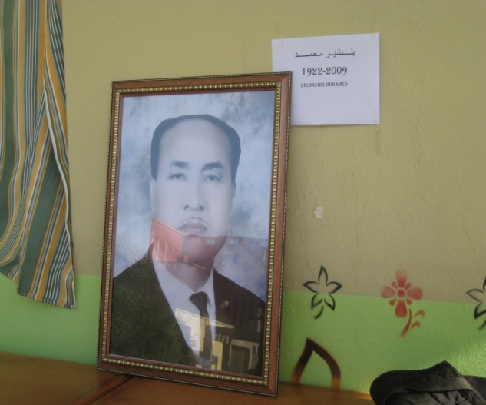
ولد الشيخ محمد بلبشير( المعروف بشيخ بوجمعة) في يوم 03 مارس 1922 بمدينة فيقيق بالمغرب الشقيق وتحصل على شهادة تعليم اللغة العربية سنة 1939 وفي سنة 1940 إنتقل من المغرب إلى الجزائر ليستقر في مدينة وهران وأصبح عضو هام في حركة الإصلاح والحركة الجزائرية الوطنية.
في سنة 1945 قد قامت فرنسا بنقله إلى بشار لإبعاده عن أعماله السرية ضد الاستعمار الفرنسي .
في سنة 1946 يعود المرحوم إلى وهران لإتمام نضاله ضد الاستعمار وفي 1947 نصبته جمعية العلماء المسلمين في مدرسة الشهاب أرزيو أستاذ للغة العربية والتربية الإسلامية ثم ترقى إلى مدير المدرسة .
في سنة 1953 نصب إمام أستاذ بمدرسة الفلاح بوهران وفي ديسمبر 1962 عمل كأستاذ اللغة العربية بمدرسة باستور وهران وفي سنة 1963 عاد إلى مدرسة الفلاح كإمام بعد إغلاقها سنة 1956 من طرف الاستعمار الفرنسي (1956/1962) .
في سنة 1970 تولى منصب مفتش للشؤون الدينية لناحية الجنوب الغربي وقد أنهى مهمة التدريس بمدرسة الفلاح ليلتحق في سنة 1975 بسلك الإمامة حيث كان إماما بعديد من المساجد بمدينة وهران نذكر منها مسجد الفلاح وخالد بن الوليد ومالك بن أنس وقد أسديت له رحمه الله يوم 23 ماي 2001 ميدالية مناضل إبان حرب التحرير من قبل رئيس الجمهورية .
توفي يوم 02 نوفمبر 2009 فرحم الله الفقيد وأحسن مثواه جوار النبيين والصدقيين والشهداء والصالحين .

Sheikh Belbachir Mohamed est né le 3 Mars 1922 à Figuig (Maroc). En 1939, il obtient son diplôme de l’enseignement de la langue Arabe. En 1940, il quitte le Maroc pour s’installer en Algérie, exactement dans la ville d’Oran. Il devient membre dans Harakat El Islah ‘Mouvement de Réforme.’ et El Haraka Aldjazairia AlWatania ‘Mouvement National Algérien’. En 1945, il est expulsé à Béchar avec d’autres militants Algériens par les colonialistes car ils travaillaient secrètement afin de libérer l’Algérie du colonialisme Français.
Il retourne à Oran en 1946 afin de continuer sa lutte contre le colonialisme Français.
En 1947 il est désigné par l’Association des Oulémas Algériens enseignant de la langue Arabe et de l’Education Civique à l’école Chihab Arzew , puis promu Directeur de la même école.
En 1953, il obtient le poste d’Imam Oustad à Madrasat El Falah à Oran. En Décembre 1962 il enseigne la langue Arabe à l’école Pasteur d’Oran puis retourne en 1963 à Madrasat El Falah d’Oran après sa fermeture en 1956 par les autorités Françaises (1956/1962).
En 1970, il est nommé Inspecteur des Affaires Réligieuses dans le Sud Algérien.
En 1975, il est affecté en tant qu’Imam dans plusieurs mosquées à travers la ville d’Oran : La Mosquée El Falah, Khalid Ibn oulwalid, et Malik Ibn Anès.
Le 23 Mai 2001, il reçoit, de la part du Président de la République Algérienne, La Médaille De Militant ‘Médaille du Moukawim’ durant la Guerre de libération (Algérie-France 1954-1962)
Sheikh décède le 2 Novembre 2009. Que Dieu l’accueille en Son Vaste Paradis

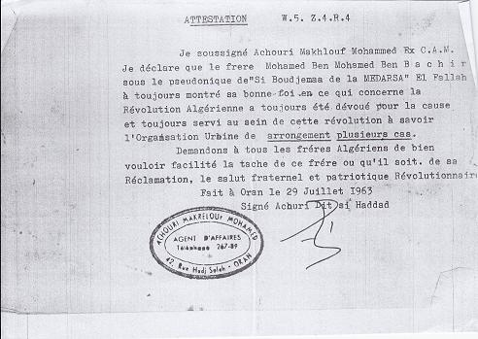

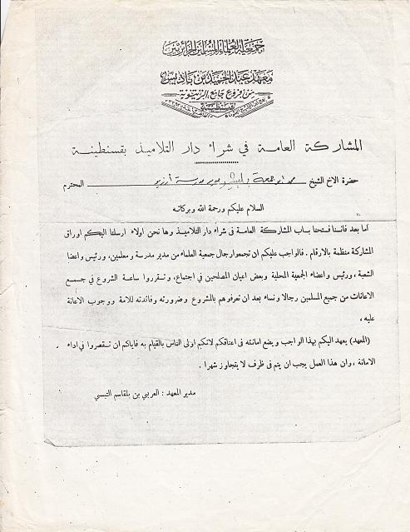
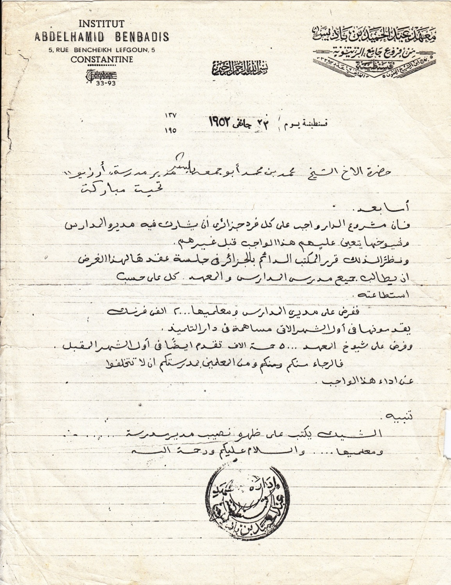
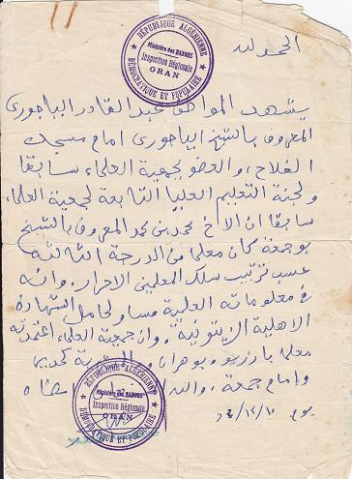
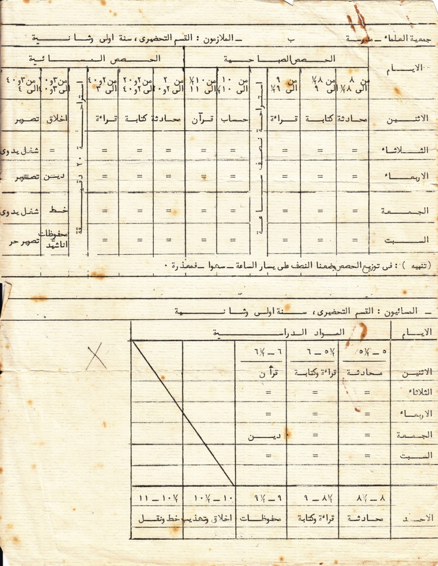

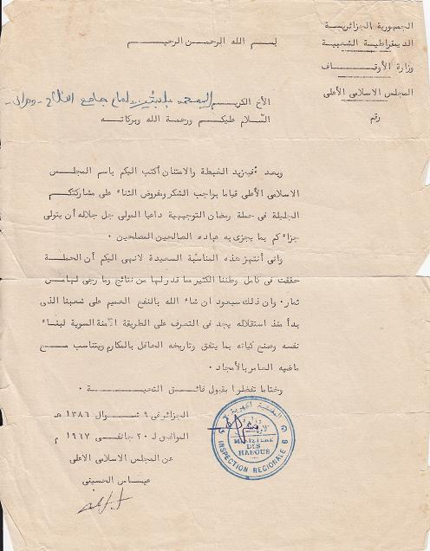

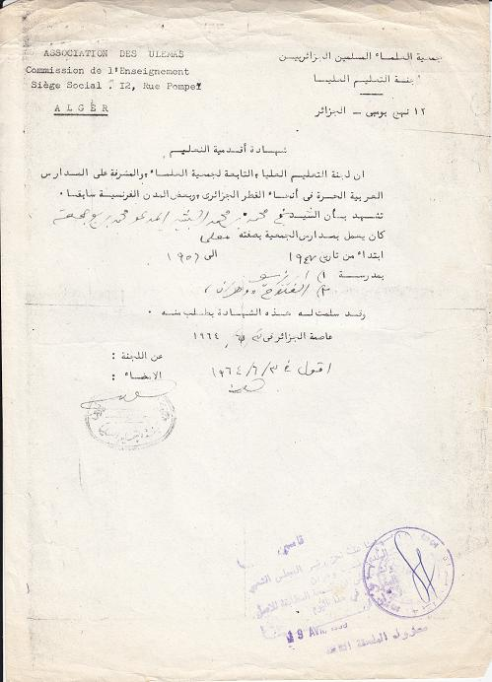

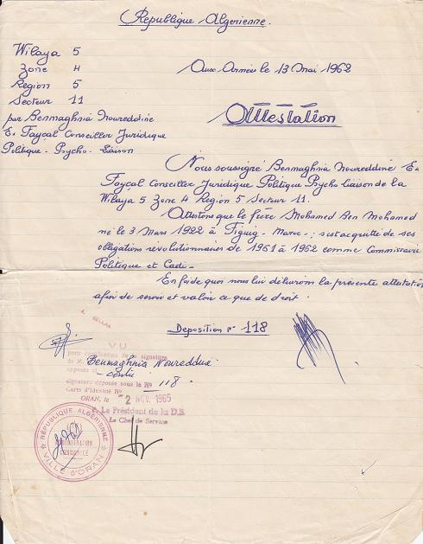
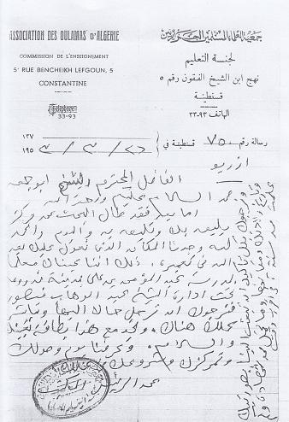
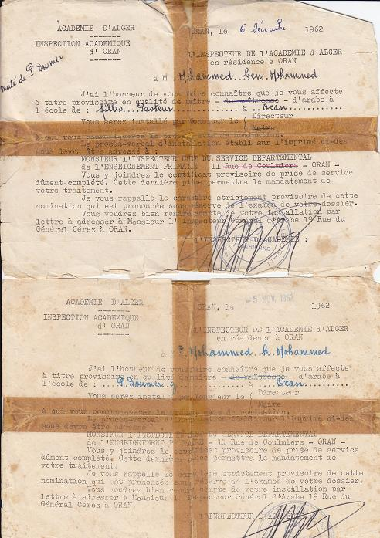

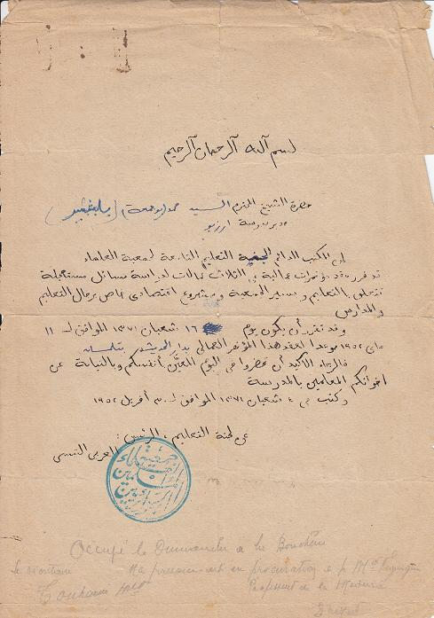
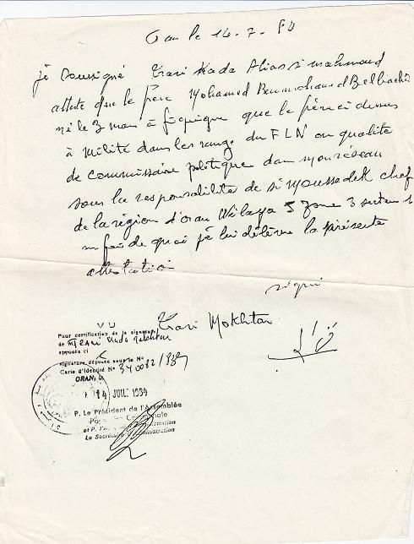
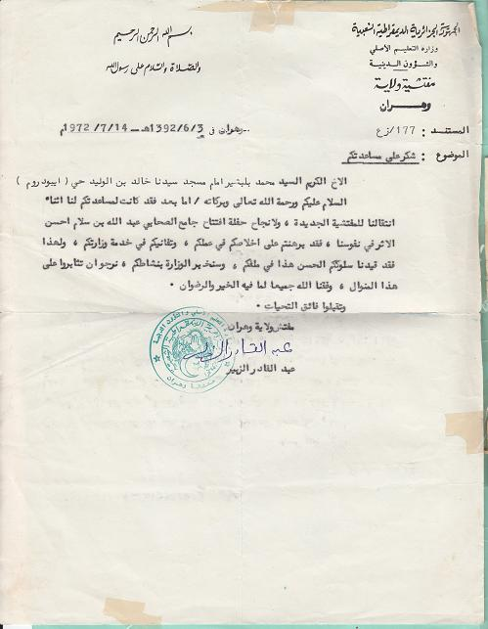
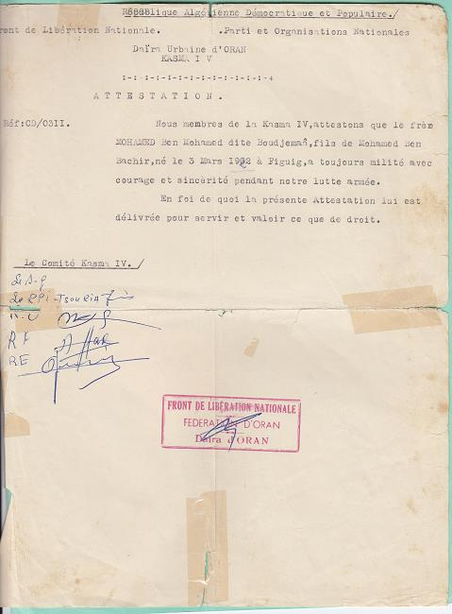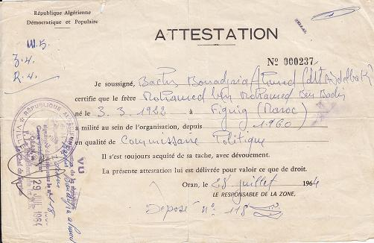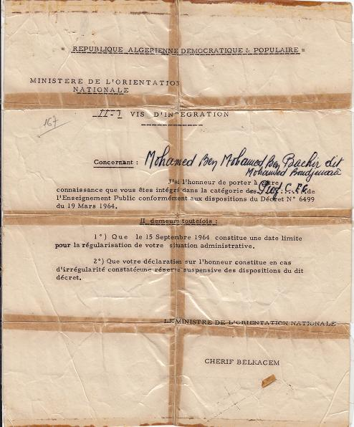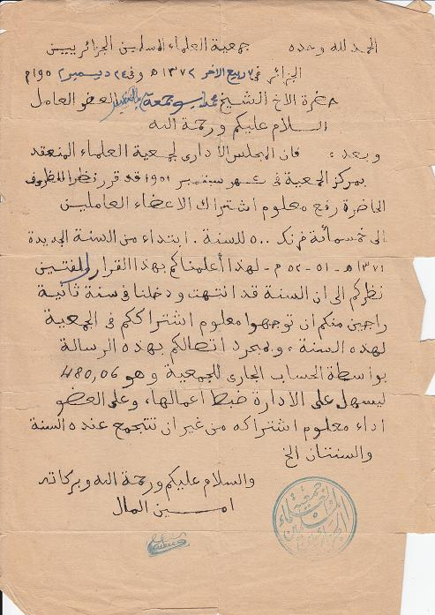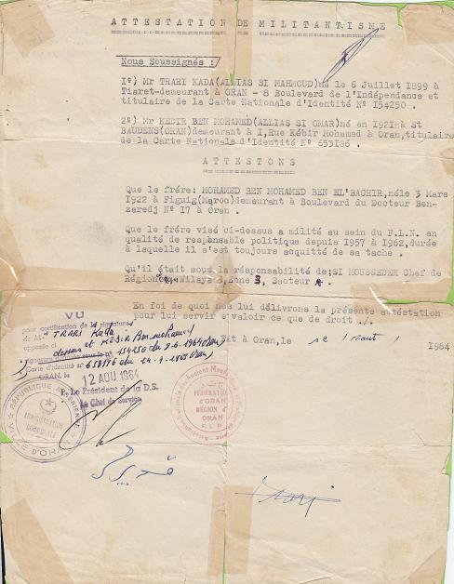

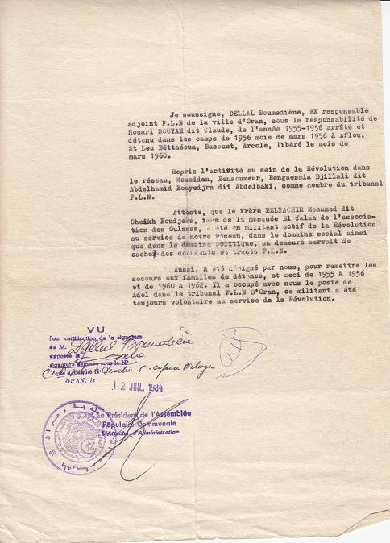
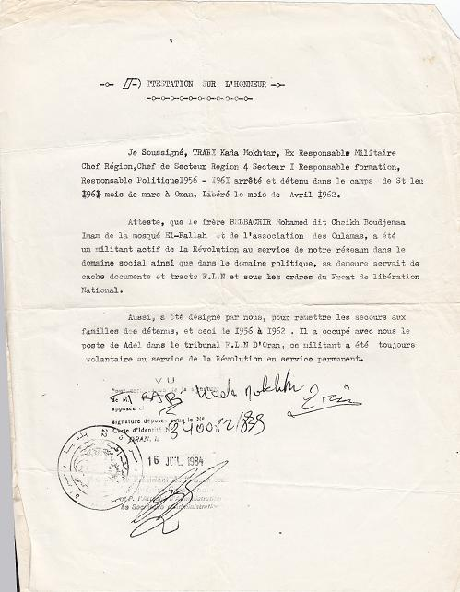

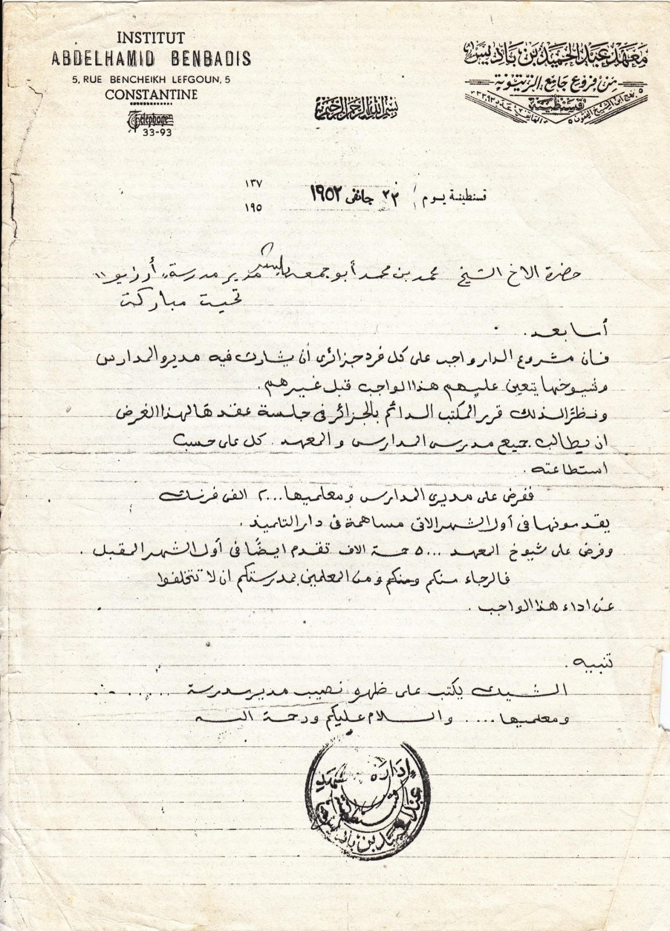

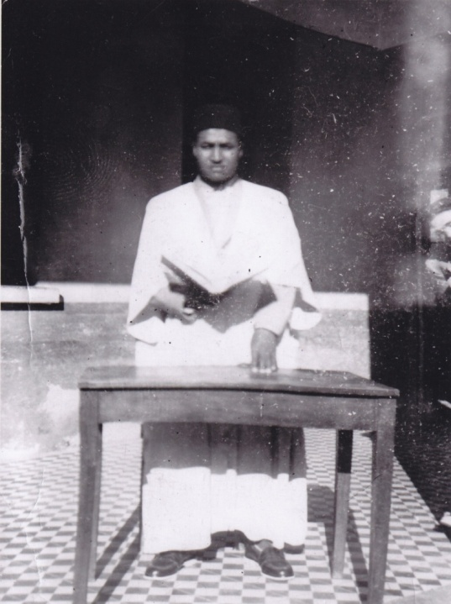
Sheikh Belbachir Mohamed in the School of Success (Madrasat El Falah) 1963.

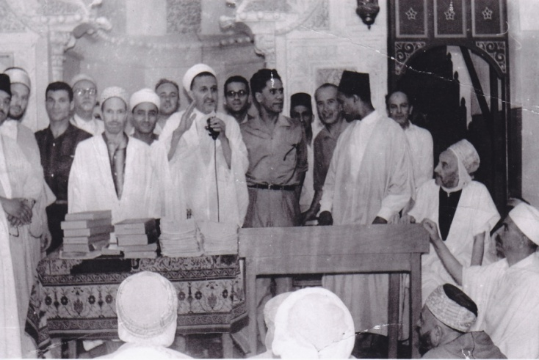

August 1964: Big Mosque. (Tlemcen)
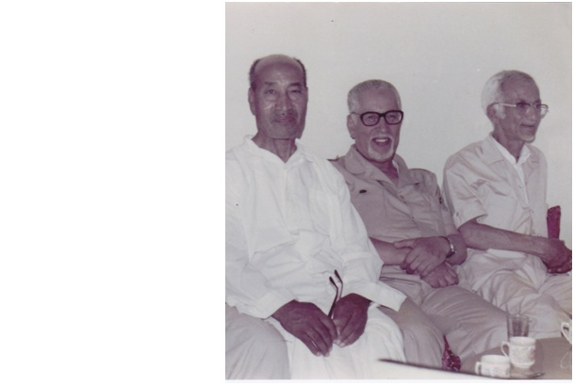

Sheikh with Souiah Lahouari and Dellal Ghaouti Boumediène in his home.(1983)

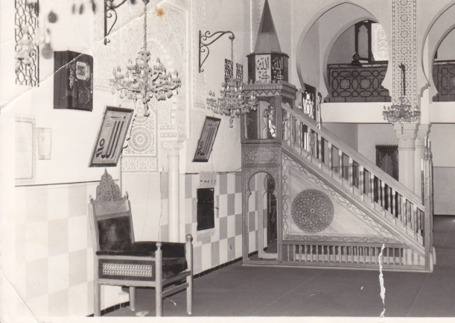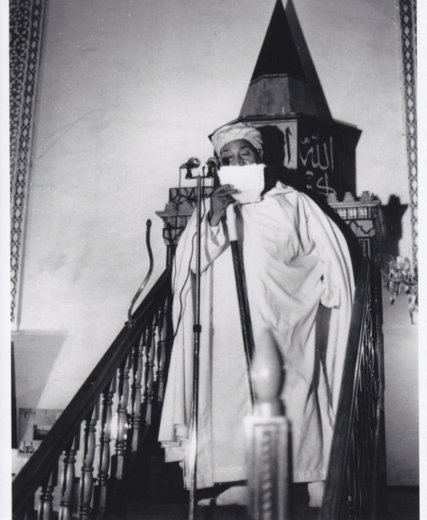
Imam Malek Ibn Anes Mosque
ESheikh

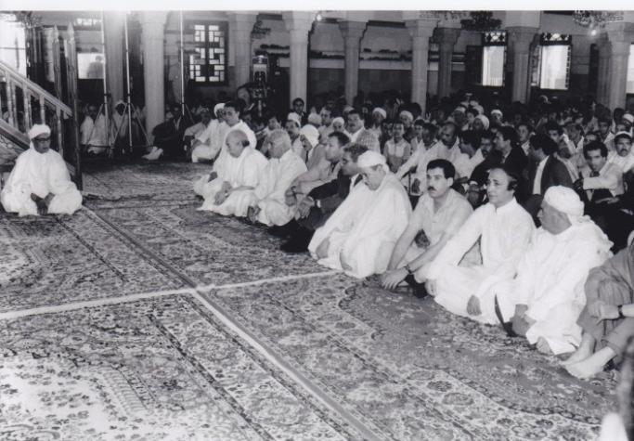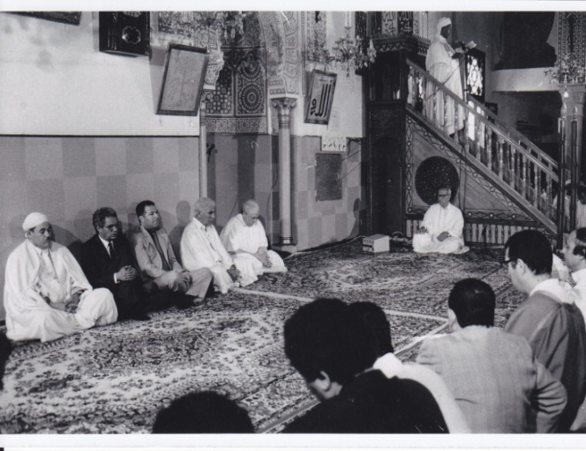
August 1986 Aid el Adha Prayer (Sheikh and President Chadli Benjedid)

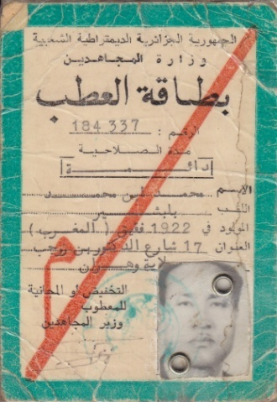

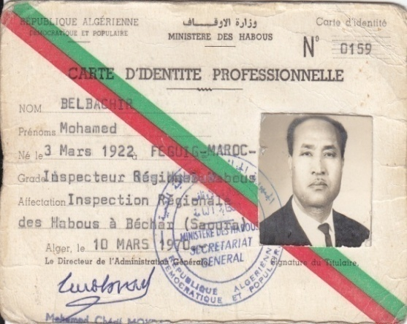
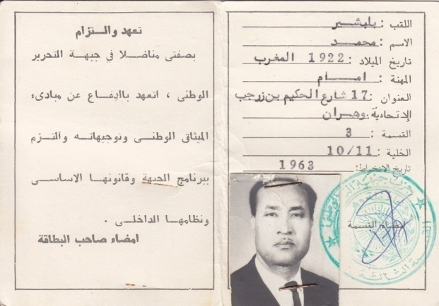

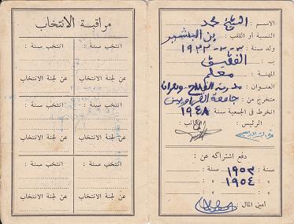

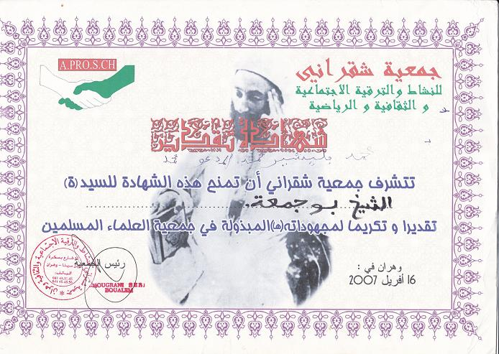

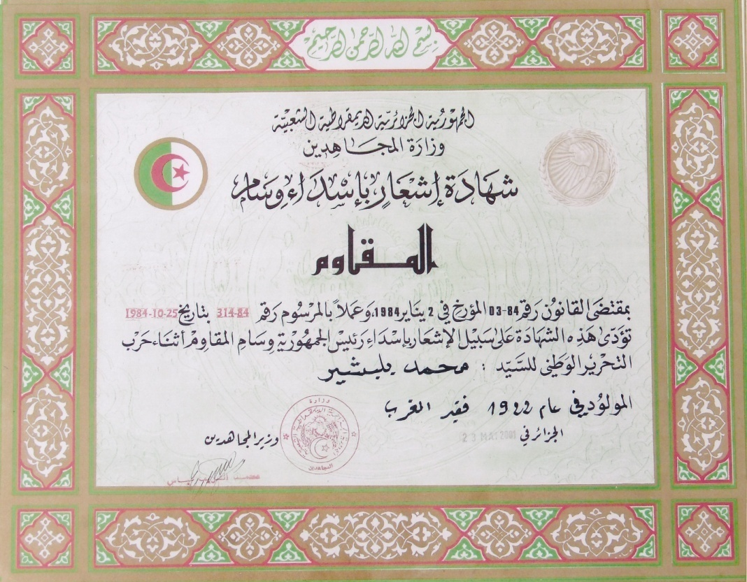
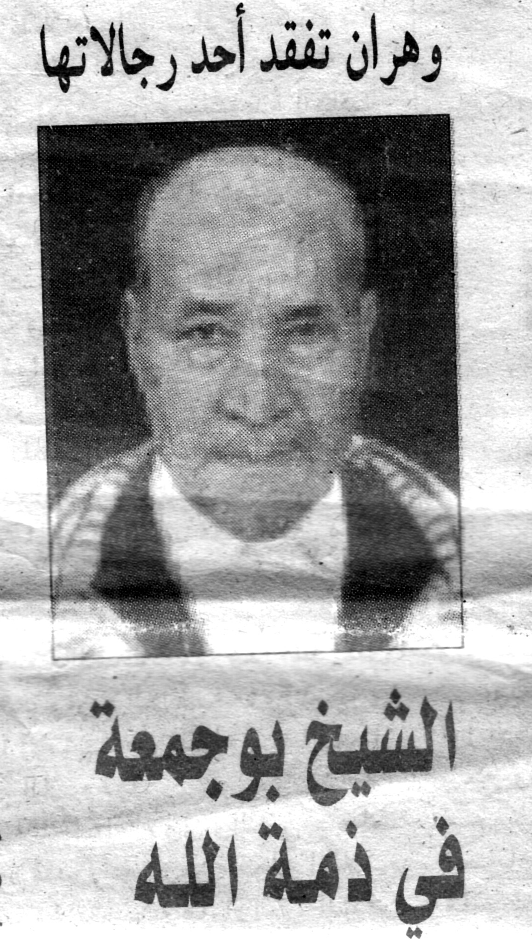
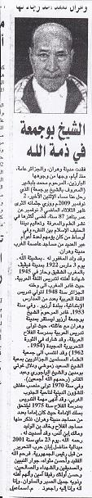

9th NOVEMBER 2009
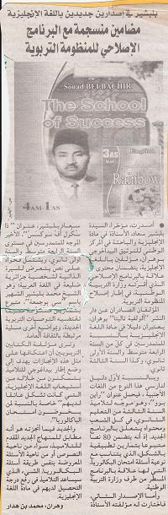

22nd DECEMBER 2009

Eljoumhouria Newspaper 22-12-2010
يومية 22-12-2010 من جريدة الجمهورية
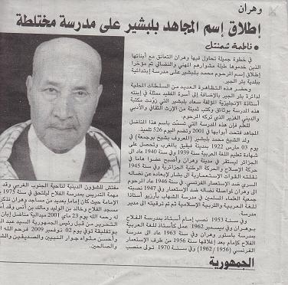

Dépôt Légal 2012-5111

9789961 549728

