UNIT 5 BACK TO NATURE
Book 1 At the Cross roads
Class: 1AS SEQUENCE 1: LISTENING AND SPEAKING
PRESENTED BY SOUAD BELBACHIR 2010

INCHALLAH

- Sequence 1: Listening and Speaking
- Aim (s): Raising awareness about the dangers of pollution, developing a sense of good citizenship by finding ways to protect nature and animals and preserve the earth in a healthy state .
- Skills : playing a game, listening to a song , writing an SOS about pollution.
- Functions: Expressing feelings, opinions and suppositions
- Language forms: Conditional type 1 if the earth gets warmer, we will suffer from droughts.
- Phonology: Mark stress in word ending in ‘tion’ and ‘ssion’- Intonation in yes/no questions and complex sentences.

- Time: 1h30
- Material needed: Data show, CDs, handouts ………..
- Lesson1( or rubric ): Anticipate / Listen and check
- Lesson 2 ( or rubric ): Say it clear

- Lesson 3 ( or rubric ): Your turn

Unit 5: BACK TO NATURE

Listening and speaking
Time: 1H30
Aim: Listen and respond to a game then a song
Listen and fill in the gap
Express feelings, opinions……….

Mark stress in words ending in ‘-tion and –ssion’
Language outcomes:
Grammar | Vocabulary | pronunciation
Conditional type 1 if the earth gets warmer, we will suffer from droughts. | Words related to the topic: pollution, deforestation, degrade………….. | Mark stress in words ending in ‘-tion and –ssion’  Intonation in yes/no questions and complex sentences.

SEQUENCE 1: LISTENING AND SPEAKING
- ANTICIPATE General Culture Game
-Which country has the biggest number of forests ? -Canada- China- Australia- Brazil
-Which animal is the symbol of the World Wide Fund ? (protection of nature) the Panda – the bear- the dolphin – the seal
-What is ecology ? The study of the environment.
- Which syllable is stressed in ecology? 2nd syllable
-Which adjective can be derived from e’cology’?ecological
-Which syllable is stressed in eco’logical?
- What does the word Sonatrach stand for? Société Nationale de transport des produits chimiques

- Name the non-profit organization which works to protect nature Greenpeace
- When was the United Nations Climate Conference held? 6-18 December 2009
- Where? Copenhagen
- What is its objective? To prevent global warming and climate changes.
- During the conference a president said, “I came here to act.” Who is it? Obama.
- Another president said, “Failure in Copenhagen would be a catastrophy.”- Sarkozy
-What does UNFCCC stand for? United Nations Framework Convention on Climate Change.
- Which noun can be derived from the verb to po’llute? Po’llution/Pollutant
-Add a suffix to the verb de’grade to form a noun. Degra’dation
-How many syllables are there in the word pre’serve? which syllable is stressed? 2. 2nd syllable
-How many syllables are there in the word preser’vation? which syllable is stressed?4. 3rd syllble
- What is the Etna ? a volcano
- Who said, “God made the country, man made the town.’ W. Cowper 1751-1800 romant.early part of 19thC
- Which country launched the 1st Artificial satellite Sputnik 1 in 1957? The Soviet Union
-Which big town registered more than 20 000 dead in 1985 after an earthquake ?
San Francisco- Mexico- Pekin- Lima. Mexico-
Who discovered the DYNAMITE ? Alfred Nobel.
- Why did he come up with the Nobel Prize ? because what he invented resulted in the loss of lives and great damages. A feeling of regret.

-What did Pasteur invent ? A vaccine against rabies
- Who invented a vaccine against smallpox ? Edward Jenner 1796
- When did Alexander Fleming discover Penicillin? 1928
- When did he win the Nobel Prize for medicine? 1945
-Who invented the drug Aspirin in March 1899 ? Felix Hoffman
- Who invented the radio in 1901? Marconi
- Name the 2 Americans who made the 1st jeans in 1873. Levi Strauss and Jacob Davis

-Who invented the 1st phonograph in 1877? Thomas Edison

-Who invented the telescope in 1600’s? Galileo
- Woman Nobel Prize Winner for Peace in 2003 Shirin ebadi
- Name the physicist born in Germany, awarded the Nobel Prize in Physics in 1921. Albert Einstein.

-Who discovered Radium ? Pierre & Marie Curie.Marie Curie..
-Who invented the Braille System ? Louis Braille
-Who discovered Penicillin ? Alexander Fleming

DESCRIPTION OF PICTURES USING DATA SHOW. STUDENTS TALK
The teacher guides through questions

1.
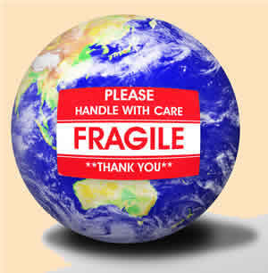

2. 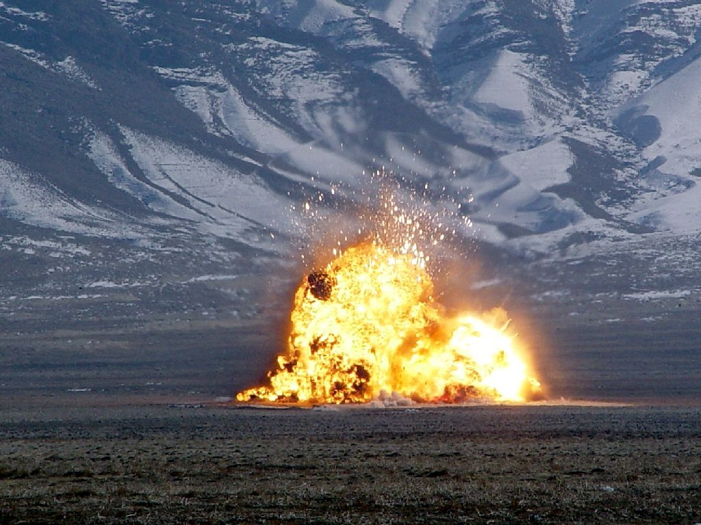

3.
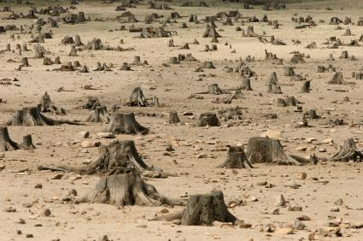

4.

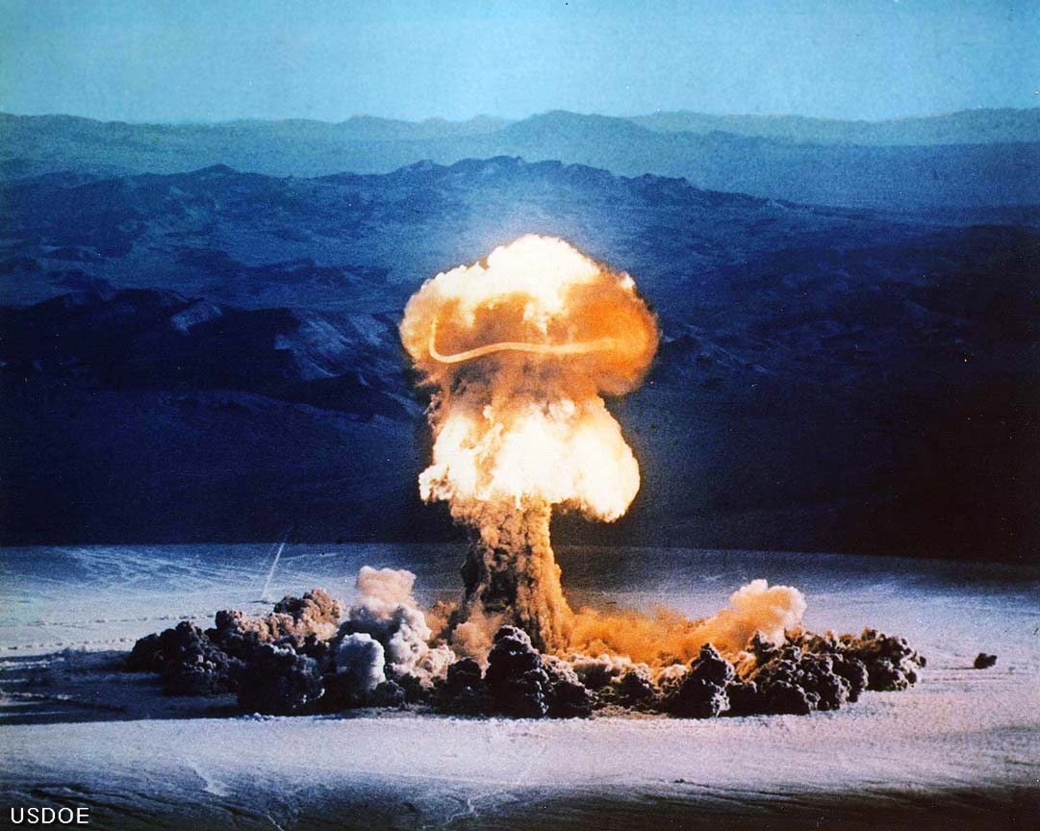

5.
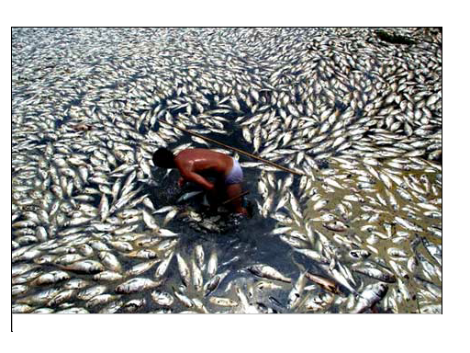

6.
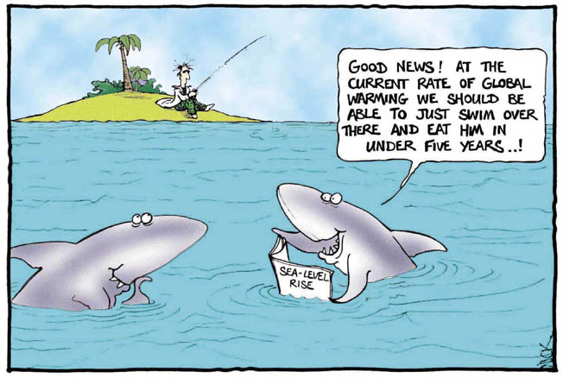

7.
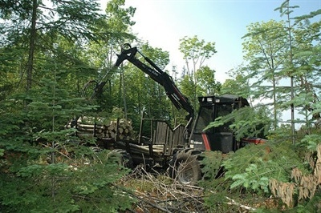

8.
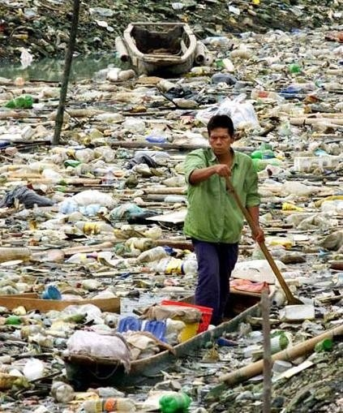

9.
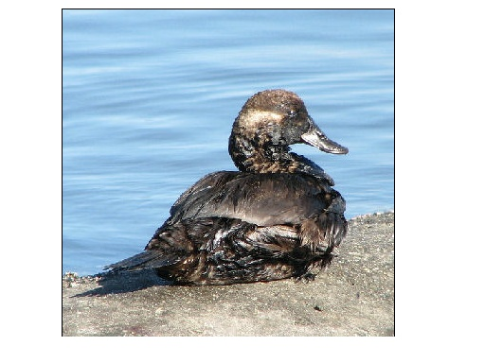

10.
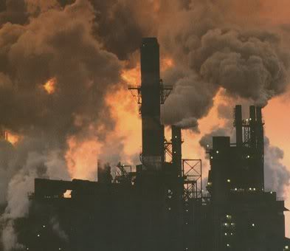

11.
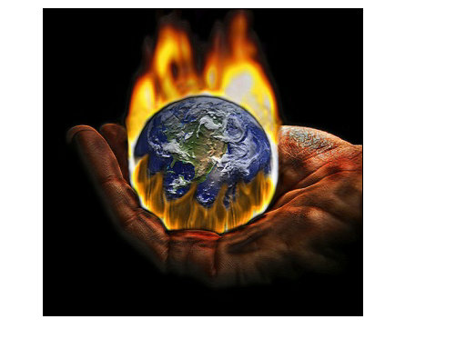

12.
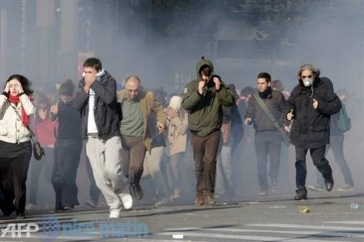

13.
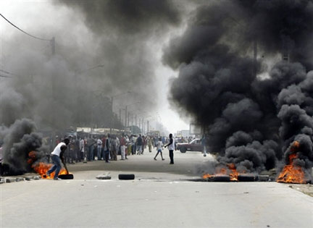

14. 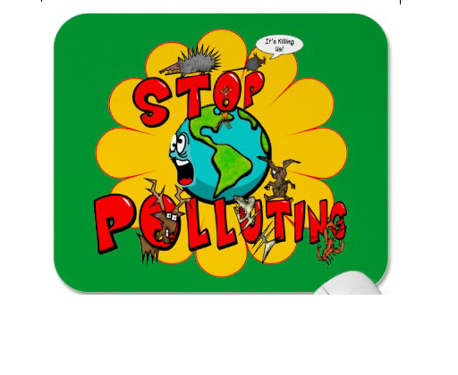

15.

16.

AFTER HAVING DESCRIBED THE PICTURES AND TALKED , THE TEACHER ASKS:
WHAT DO YOU THINK THE TEXT WILL BE ABOUT?
POSSIBLE ANSWERS: NATURE/ MAN AND NATURE /POLLUTION/…………………….

- LISTEN AND CHECK. Listen to the song and fill in each gap:
Time to Love (Stevie Wonder)
We have time for racism
We have time for criticism
Held bondage by our -ism's
When will there be a time to ……….1……
We make time to debate religion
Passing bills and building prisons
For building fortunes and passing judgements
When will there be a time to love
At this point in history we have a choice to make
To either walk a path of love
Or be crippled by our hate
We have time to cause ……..2…….
We have time to cause confusion
All wrapped up in our own illusions
When will there be a time to love
We make time to conquer nations
Time for oil ……..3………
Hatred, violence and terrorism
When will there be a time to love
At this moment in time
We have a choice to make
God is watching
While we cause ……..4…… ………5……..so much pain
It's such a shame
Not enough ……….6……..for
The young, the old and the poor
But for war there is always more
When will there be a time to love
We make time for paying taxes
Or paying bills and buying status
But we ……….7……..pay the ………8………
………9…….we don't make the time to love
Now's the time to pay attention
Yes now is the time - to love
A time love – love please please won’t you tell me when will there be a time to love.

Time to Love (Stevie Wonder)
We have time for racism
We have time for criticism
Held bondage by our -ism's
When will there be a time to love
We make time to debate religion
Passing bills and building prisons
For building fortunes and passing judgements
When will there be a time to love
At this point in history we have a choice to make
To either walk a path of love Or be crippled by our hate
We have time to cause pollution
We have time to cause confusion
All wrapped up in our own illusions
When will there be a time to love
We make time to conquer nations
Time for oil excavation
Hatred, violence and terrorism
When will there be a time to love
At this moment in time
We have a choice to make
God is watching
While we cause mother earth so much pain
It's such a shame
Not enough money for
The young, the old and the poor
But for war there is always more
When will there be a time to love
We make time for paying taxes
Or paying bills and buying status
But we will pay the consequences
If we don't make the time to love
Now's the time to pay attention
Yes now is the time - to love
A time love - love
A time to love
Please please won't you tell me
When will there be a time to love

C. SAY IT CLEAR (SEE GAME) phonology
D. YOUR TURN.
What will happen if we don’t stop pollution?
Earth/to become/ desert
Species / plants disappear/…………………

E. SAY IT IN WRITING (see p131) Book: At the Crossroads SE1
Write an SOS message (save our souls)=urgent call for help.
Environmental threat!
If you don’t stop spilling oil into the sea now……..
Environmental threat!
Do you know what will happen if…..?

