…………………………Middle School School year : 2016/ 2017

Level : 4MS Full name :……………………………………………………….

Teacher : Date :…………………………………………………………………



***Comparative and Superlative***

1/ Most one syllable adjectives :

**Comparative : adjective + er+ than**

Eg : tall………….…..tall**er** than

**Superlative : the+ adjective+ est**

Eg : tall……………….the tall**est**

3/ Adjectives ending in **‘er’ :**

**Comparative : adjective+ er than**

**Superative : the + adjective+ est**

*Adj comparative superlative*

*Clev****er*** *clev****erer*** *than the clev****erest***

**5/ Two or more syllables adjectives :**

**Comparative : more+adjective+than**

Eg : interesting…….more interesting than

**Superlative : the most+ adjective**

Eg : interesting …..the most interesting

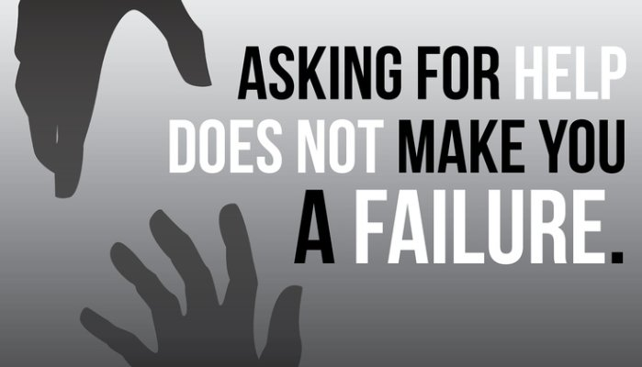

2/ One syllable adjectives ending in **CVC : we double the last consonant** **before adding ‘er’ and ‘est’.**

Adj Comparative  Superlative

Hot ho**tter** than the ho**ttest**

**CVC adjs: hot, big, fat, thin, sad, wet**

**Irregular adjectives :**

|  |  |  |
| --- | --- | --- |
| Adj | comp | super |
| **good** | Better than | The best |
| **bad** | Worse than | The worst |
| **Much/many** | More than | The most |
| **Little/few** | Less than | The least |
| **old** | Older/elder than | The oldest/ eldest |
| **far** | Farther/ further than | The farthest/the furthest |

4/ Adjectives ending in **‘ y ’** :

Comp Super

**Y i +er Y  i +est**

Busy bu**sier** than the bu**siest**