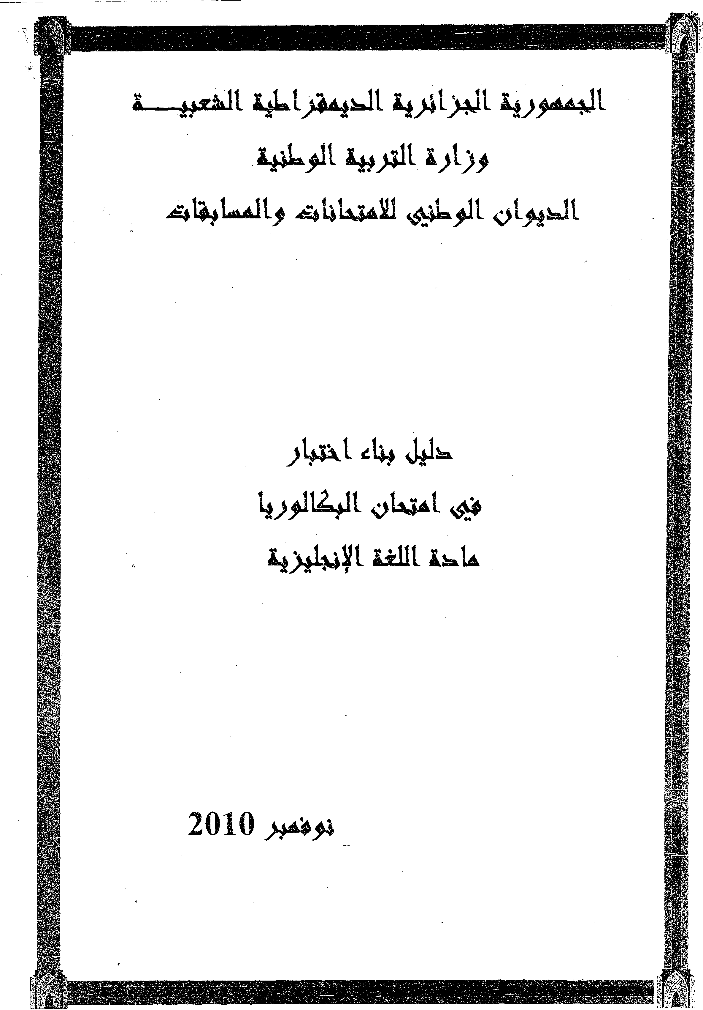

This document aims at supplying the teachers with some information and recommendations to help them prepare their pupils for the Baccalauréat English papers it also provides useful guidelines for building Baccalauréat tests. The various types of tasks are introduced, explained, and wherever necessary, illustrated with examples.

Moreover, as far as **the Competency Based Approach** is concerned, it provides practitioners with a framework containing the disciplinary (target) competencies, namely interacting. (dialogue completion is a form of interaction), interpreting , and producing

Users are invited, before setting a test, to consider the criteria listed in the preamble (Arabic version )

|  |  |  |
| --- | --- | --- |
| Streams | Coefficient | DURATION |
| LANGUES ETRANGERES | 05 | 03 |
| LETTRES ET PHILC'SOPHIE | 03 | 02 |
| Sc . Exp./ Math/ TM/ GE | 02 02 | |

EXAMINERS GUIDE

INTRODUCTION

**DURATION AND COEFFICIENT**

RECOMMENDATIONS

**Test the examinees only en what they have actually learnt during the academic year.**

**a-Congruencywith**

* official syllabus regarding topic, content and cognitive and learning objectives
* officiai instructions ( types of activities, number of activities, timing , length)
* formulation of instructions : it is more convenient for the examinees if they are instructed in the same way they are used to iPHILOSOPHIEnd testing during the academic year.

2

***b- Test Elaboration***

* **Secrecy**: Nobody should be informed of what text has been selected
* **Originality**:-It should not have been given previously in any form
* **Correctness**: It should be mistake-free

- **Acceptance by all:** The text should not deliberately hurt or insult anyone

* **Meaning**: In spite of its size, the text should still be meaningful and coherent
* **Sources**: Full sources ( author, title, publishing house, place , year) should be *given*
* **model answers**, including all sections
* **scoring scale** detailed and global
* It is recommended that:
* model answers and scoring scale be prepared beforehand by a different team , not necessarily the test setters, primarily to test the feasibility of the paper
* the activities should be graded from simple to complex

**II) Objectives of the examination paper**

***The English examination paper aims to evaluate:***

1- The candidates’ ability to understand and do tasks in connection with a reading passage, either adapted or authentic, based on a topic selected from the syllabus, and to make good use of the language components.

2-The candidates 'ability to mobilize the appropriate resources to express themselves reasonably and correctly in a given situation (in a written form).

**III) Organization of the examination paper.**

**IMPORTANT: It is advisable that the paper should revolve around the same theme, to be *in* accordance with the philosophy of the competency-based approach,i.e, tests provide examinees with opportunities to learn and re- use even while taking the test.**

The examination paper is made up of the two following parts:

-Part One : Reading . This part consists of:

A. interpretation and tnterpretation.

This sub-art focuses on the global and detailed understanding of a reading passage through a number of a comprehension-type tasks (see table 4).

3

**B .Text Exploration**

This subpart, through activities related to the reading passage or a similar topic, deals with the knowledge and use of the languages pages 5,6,7,8).

It contains tasks bearing on: 1. Vocabulary and morphology,

1. grammar,
2. sound system,
3. discourse.

**Part two: Written Expression**

This part consists of setting the testees to produce a piece of writing in a topic related to the text theme.

4

|  |  |  |  |  |  |  |
| --- | --- | --- | --- | --- | --- | --- |
| PARTS OF BAC PAPER | TYPOLOGY OF TASKS | TYPICAL  INSTRUCTIONS | OBSERVATIONS | TEXT LENGTH & NUMBER OF TASKS | | |
| **PART ONE**  Reading  **A.**  **Comprehension/**  **InterpretationLE-LP 07 points Sc-Exp-M-TM-GE**  **08 points** |  | Read the text carefully and do the activities. | This instruction is to be put above the text. | L.E | L & philo | Sc.exp /M/ TM/G.E |
| .choosing/giving  the general idea | .Choose/give the general idea of the text. | Giving(for LE only) | Text of  200-250 words  5t06 different activities | Text of  180-200 Words  4 to5 different activities | Text of  120-180 Words  4 to5 different activities |
| .answering MCQ | .Write the letter which corresponds to the right answer. |  |
| .T/F statements | .are these statements true or false? write T or F next to the letter corresponding to the statement |  |
| .locating the right paragraph | in which paragraph is it mentioned that...? |  |
| .Filling a table with information from the text. | .Fill in the following table. |  |
| .putting ideas in the right order according to their occurrence in the text. | .read the text and put the following sentences in the order they appear in the text. |  |
| .answering comprehension questions. | .Answer the following questions according to the text. |  |
| .-choosing /giving a title to the text. | .Copy the title you think is the most appropriate/give a title to the text. | Giving(for L.E only) |
| .identifying type of discourse. | Circle the letter that corresponds to the right answer. The text is: a) descriptive, b) narrative… |  |
| .identifying type of text. | Circle the letter that l corresponds to the right answer. the text is : a(a letter, a conversation)... |  |
| .Cohesive | .Who/ what do the the underlined words refer to in the text. |  |

|  |  |  |  |  |  |  |
| --- | --- | --- | --- | --- | --- | --- |
| **B. Text** | .Matching words  from the text with their definitions. | match words and definitions. | **Lexicalitems essential fortheunderstanding of the textlikely to be used in written expression should be included in the activities.** | 05  Activities  1 from each:  - voc  -morphol1  -gram1  - sound sy1  - Discour1 | 05  Activities  1 from each:  - voc  -morphol1  - gram1  - sound sy1  - Discour1 | 05  Activities  1 from each:  - voc  -morphol1  - gram1  - sound sy1  - Discour1 |
| E**xploration** |
| **LE- 07 points  LP- 0807oints  5c-Exp_M_TM_**  **GE : 07points**  1  **.Vocabulary and**  **Morphology** |
| .Finding words in the text whose definitions are given | .find in the text words whose definitions follow. |
| .Matching words and their  synonyms/opposites. | .Match words and their  synonyms/opposites. |
| .Finding  **s**ynonyms/opposites in the passage. | .Find in the text words that are synonyms/opposites to the following. |
| .Deriving nouns/adjectives/ verbs from words in text. | .Complete the chart as shown in the example. |
| .Giving opposites to words in the text keeping the same root. | .Give the opposites of the following words keeping the same |
| .Dividing words into roots and affixes. | .classify the following words in the table. |

6

|  |  |  |  |  |  |  |
| --- | --- | --- | --- | --- | --- | --- |
| 2.Grammar | Combining  statements with connectorsprovided.  Asking questions to the underlined words.  Paraphrasing withprompts given.  Supplying the  correct form(s) of  the verbs in a  given passage. | .Connect each pair of sentences with one of the words given. Makechanges where necessary.  Ask the questions which the underlined words answer.  Rewrite sentence B sothat it means the same as sentence A.  Give the correctform(s)of the verbs inbrackets. |  |  |  |  |
| The activities must cover a variety of grammar points and should notbe limited to reportedspeech, conditionals or active/ passive voice.  Give a short  passage, not unrelated  sentences. |

7

|  |  |  |  |  |  |  |  |  |
| --- | --- | --- | --- | --- | --- | --- | --- | --- |
| i  3.Sound system | Matching pairs  that rhyme.  Classifying words according to final 'ed’ or 's’  Underlining he  silent letter in a word.  Stress pattern.  Number of  Syllables | | Match pairs that rhyme.  Classify the following words according to the pronunciation of thefinal'ed' or 's'  .Underline or write the silent letter in each ofthe following words  Classify the words according to their stressed syllables  Classify the words  according to the number  Of their syllables  .. | 1    . | I  I  1  Î |  | |  |
|  |  | |
|  | |  |
|  | |  |

|  |  |  |  |  |  |  |
| --- | --- | --- | --- | --- | --- | --- |
| **4.Discourse** | Filling gaps with a number of words.  Matching statements from column A with statements from column B.  Re-ordering scrambled sentences into a passage.  Dialogue completion. | Fill in the gaps with words from the list.  Match statements from column A with statements from column B.  Re-order the following sentences to make a coherent passage.  Imagine what A/B says and complete the following dialogue. | **The activities suggested in Discourse should be conducive tothe writtenexpression.** |  |  |  |

|  |  |  |  |  |  |  |  |
| --- | --- | --- | --- | --- | --- | --- | --- |
| PART  TWO  **Written**  **Expression**  **LE-O6points**  **L.P-O5points Sc-Exp-M-**  **TM-GE**  **05 points** | Choose ONE of thefollowing topics: | Topic one  Topic two |  | **One: Should be**  **thematically**  **related to the**  **topic of the**  **initial text**.  **TWO:**  **thematically related to other themes of the syllabus** |  |  |  |

|  |  |
| --- | --- |
| **CRITERIA** | **INDICATORS** |
| **1.RELEVANCE** | **Learner's/testee's production aligns with requirements of a situation:**  ***\*format:* a letter/ e-mail /invitation/instructions ...**  ***\*objective:* to inform/ to describe/to complain...**  ***\*targeted language:* functional language and**  **vocabulary** |
| **2.SEMANTIC COHERENCE** | **Meaningful**  **Logic in the information given**  **Originality and development of ideas**  **Organization : well-structured sentence &paragraph** |
| **3.SYNTACTIC COHERENCE AND CORRECT USE** OF **LINGUISTIC ELEMENTS** | **Correct use of grammar: tenses , word-order, subject-verb agreement**  **Spelling, capitalization and punctuation** |
| **4.EXCELLENCE ( creativity + vocabulary wealth)** | **New ideas, varied vocabulary items, absence of  repetitions and redundancy, legible handwriting,   neatness.** |

**ADDENDA**

**A- CRITERIA TO SET A SITUATION OF INTEGRATION**

1. **A situation of integration requires :**

**-authentic documents**

**-well-formulated, readable (comprehensible) instructions rather than questions**

1. **Asituation of integration should be:**

- meaningful and motivating

-close to the learner's /testee's level

-adapted **to the learner's/testee's level**

**-in accordance with the target competence( production)**

**-with in a situation of communication**

**-be supported by some hints /tips to guide the learner /testee**

1. **A target situation (a situation of integration) integrates linguistic resources to achieve a communicative**

**purpose .**

**B- ASSESSING A SITUATION OF INTEGRATION**

NB: 1. Learners must not be penalized twice for making the same mistake

2.lf only two of the first two criteria are met , the full mark is to be given,

3.refer to BAC guide 2003for further samples of tasks

11

12

13