


Teacher : Mrs. FB Kh
El Cheikh Moulay Bencherif Middle School Sidi Ali

File Two Plan



You Can Do It



P48 physique relizane www.physique48.org



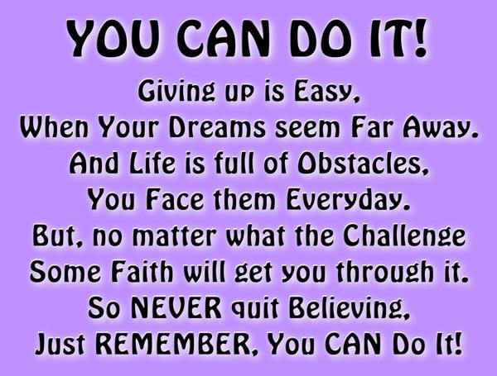

Nothing will work unless you do.
If you don't work for something, you will not cherish it. Life is a succession of events, and success is gradual.

File Two Plan

Skills Building

Ultimate Objective:
By the end of this file, students should be able to make a profile of changes in Man’s capabilities.

Functions and Notions
-Expressing ability
-Expressing possibility
-Asking for and giving permission
-Expressing certainty
-Making requests ( consolidation)
- Exressing agreement and disagreements
Language Learning
Grammar
-Modals : can, may, might and could
-Irregular forms of the modals can and could: am able / will be able / was able
-Agreement and disagreement patterns: so can I / Neither can I
-Modals: must / have to / need

Words and Sounds
-Vocabulary related to technology and animal life
-Equivalents of defective verbs (modals): allow to, permit to, capable of
-Prefixes of opposition: il, im, in, in, ir, un and dis
-Stress in words starting with prefixes
-Strong and weak forms of auxiliaries: was, were, can, do and have

Primary Skills

-Listening for functions (agreements and disagreements)
-Listening for intonation patterns
-Listening for gist
-Reading for details
-Predicting and checking prediction
-Transposing information to a graph
-Interpreting texts with the help of an illustration
-Writing a short news paper article/ school report
Social Skills

-Making a survey
-Managing through conversation
-Drawing rules for charter


Present to your students the theme of the file through the description of the pictures p42. Ask them as many questions as possible about the two illustrations.
Make your students deduce the message behind the pictures which is
SUCCESS or ACHIEVEMENT

Expain to your students that nothing of great value in this life comes easily. And strong and deeply rooted desire is the starting point of all achievements.

All what you must have to achieve your goal is to believe in yourself and have the courage to persue your dreams.


Self-doupt is the little voice in your head saying : » You Can Do It ». And the big voice saying: “I Wish You Would”. So, listen to the little voice!
Sean O Donnell



I don’t want to reach immortality through my work. I want to achieve it through not dying.

Listen and Consider
Learning Objectives :
By the end of this lesson, students should be able to
-Express their abilities
- Find specific information from a dialogue
- Distinguish between strong and weak forms of can

Step One : Review
Recycle the use of modal verb can

What is a modal verb?

All the auxiliary verbs except: be, do and have are called modals.
Unlike other auxiliary verbs, modals only exist in their helping form; they cannot act alone as the main verb in a sentence.

Be, Do and Have also differ from the other auxiliaries in that they can serve as ordinary verbs in a given sentence.
P48 physique relizane www.physique48.org

Could
Can
May

Would

Might
The modals are
Will

Must

Ought to
Shall
Should

Can
expresses

Present ability
General possibility
Give permission
Request something

Lyn can use the laptop

Susan and her friend can come to the party.

Our mother said that you can go to the woods

I left my bag at home. Can you lend me your book, please

Can’t

Absence of ability

Impossibility

Deny permission

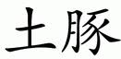

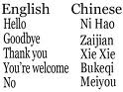

Chinese is very difficult. I can’t learn it.

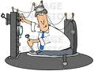

Time machine is not real. It can’t get you back to centuries ago.



You’ re messy. You can’t go to the party.

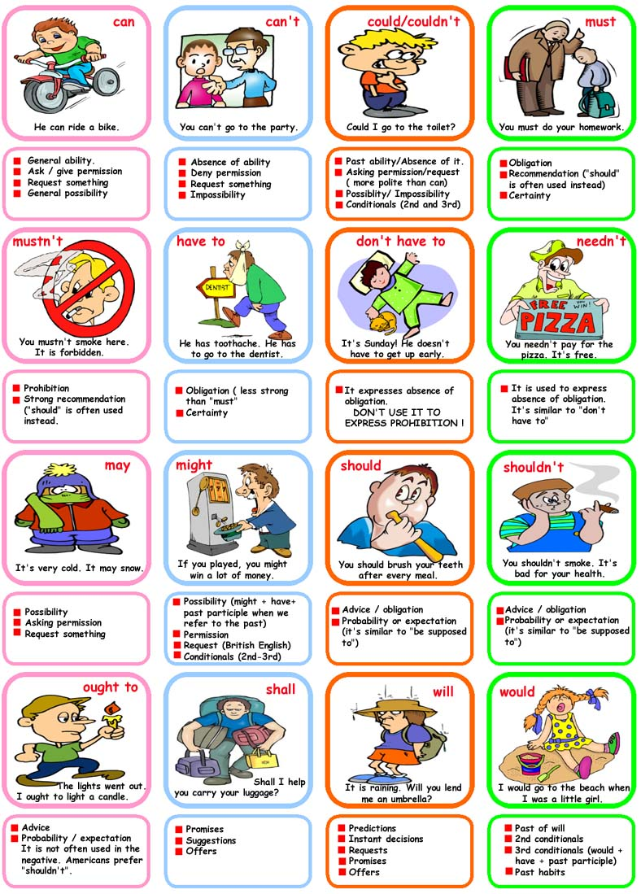

Step Two : listen and consider

Before you listen: Presentation of the theme
Draw your students’ attention to the magazine cover page and ask them
Possible questions
What is the cover page about? –It’s about a contest.
What kind of contests is it? -It’s talent show contest.



Ask your students to name some of the most famous talent shows.
Eg: Star Academy / America’s got Talent ………….

Make your students read about the contest then ask them about their talents. Activity 1 p 43

As you listen: Listen and Do

1-Read the questions carefully then listen to the teacher to answer the questions p44 P48 physique relizane www.physique48.org

2-Strong and Weak forms

What is a talent show?
Talent : a natural ability of a superior quality to do something.

Talented: Adj; a person who has talents

Talent show: a live performance or spectacle (sometimes on TV) where contestants perform acting, singing, dancing, acrobatics and other art forms

"I believe that every person is born with talent." - Maya Angelou

Some words not only verbs that are used in speaking, have one weak sound and one strong sound.
Weak forms are used in connected speech, that is when you are having a normal, everyday conversation or when they are in the middle of a sentence.

Strong forms are normally used when we say a word isolated from speech with an emphasis on the vowel. These forms are used by native speakers of English when talking to a foreigner, for example or in questions.

Modal verbs usually have these two forms. But negative forms of these verbs have only a strong pronunciation

Answers to questions p44

a-Bob politely requests Wendy to give him some of her time . He says : « Can you spare a moment to answer a few questions, please ?”

b-Wendy to offer help, she says: “Sure, what can I do for you?”

c-Yes, she can.

d-Yes, she can.

e-No, she couldn’t.

f-Her parents accepted to let her play music because she was able to convince them.



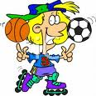

Grammar Window

Aim : To make students aware of the functions of the modals : can / could and be able to

Be able to

Although we look at be able to here, it is not a modal verb. It is simply the verb be plus an adjective (able) followed by the infinitive. We look at be able to here because we sometimes use it instead of can and could.
We use be able to: to talk about ability
The structure of be able to is:
subject + be + able + infinitive
 | subject | be  main verb | able  adjective | infinitive
+ | I | am | able | to drive.
- | She | is not | able | to drive.
- | She | isn't | able | to drive.
? | Are | you | able | to drive?
Notice that be able to is possible in all tenses, for example:
- I was able to drive...
- I will be able to drive...
- I have been able to drive...
Notice too that be able to has an infinitive form:
I would like to be able to speak Chinese.

Use of Be able to
Be able to is not a modal auxiliary verb. We include it here for convenience, because it is often used like "can" and "could", which are modal auxiliary verbs.

be able to: ability
We use be able to express ability. "Able" is an adjective meaning: having the power, skill or means to do something. If we say "I am able to swim", it is like saying "I can swim". We sometimes use "be able to" instead of "can" or "could" for ability. "Be able to" is possible in all tenses - but "can" is possible only in the present and "could" is possible only in the past for ability. In addition, "can" and "could" have no infinitive form. So we use "be able to" when we want to use other tenses or the infinitive.
- I have been able to swim since I was five. (present perfect)
- You will be able to speak perfect English very soon. (future simple)
- I would like to be able to fly an airplane. (infinitive)



Practice

Aim : students should be able to express Man’s past and present abilities

-find out what old travelers could achieve during their life

Neil Armstrong Marco Polo

Aim: students should be able to write a short school report about a student’s past and present performances then future expectations.

Aim: students should be able to predict and check predictions

Before you read: Presentation of the theme

Invite your students to see the picture p46 and guess why the pupil has stopped taking his test.

Make them try to give all the possibilities and probabilities that come to their mind using: perhaps or maybe


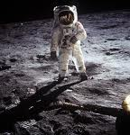

Write it Up



Read and Consider

You: Why has he stopped taking his test?

Your partner: I don’t know. Maybe / Perhaps he doesn’t know the answer.

Maybe / Perhaps he trying to remember the suitable answer.

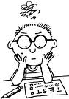

Maybe and Perhaps

In British English, both of these adverbs are still very commonly used and have the same meaning. We use them to say that something is possible or maybe true, but you are not certain. They can be used interchangeably but of the two:

Maybe
Perhaps

Is very appropriate for more informal contexts
Is used in more formal sitautions



There were perhaps as many as fifty badly wounded soldiers in the hospital.



How old is Jane?
I don’t really know. In her twenties certainly. Twenty-five maybe.

What do you think Professor Kane will say about exam preparation?

In my opinion, Professor Kane will talk about the importance of exam preparation and the advantages of group revision and its role in fighting stress and anxiety before exams’ period.

Aim: to make students aware of the functions of May and Might

Aim: to reinforce students’ mastery of the modals may and might and use them in contexts.
1-Students should be able to ask for permission
2-Give or refuse permissions using responses on the table p49

Aim: students should be able to write meaningful notes about what is most likely to happen at the end of the school year.

Grammar Window

Go back to file plan page 6

Practice

Write it Out




Words and Sounds

Aim: Students should be able to form new words (opposites): adjectives, nouns or verbs using the prefixes of opposition: il, im, in, ir, un and dis

Presentation

Try to make your students distinguish between the three words above (form and meaning).

Prefix Suffix

Unhappy
adj
Happiness
noun
Happy
adj

To feel joy
To be in a good mood
The feeling of satisfaction, pleasure or joy
Not happy

To feel mesirable

Unhappy
Happiness
Happy

Root
A root is a word in its basic simple form. Other word may be built up or have its meaning changes by an addition at the beginning “prefix” or at the end “suffix”



Prefix

A word or letter placed at the beginning of another word (root) to adjust or qualify its usage or meaning



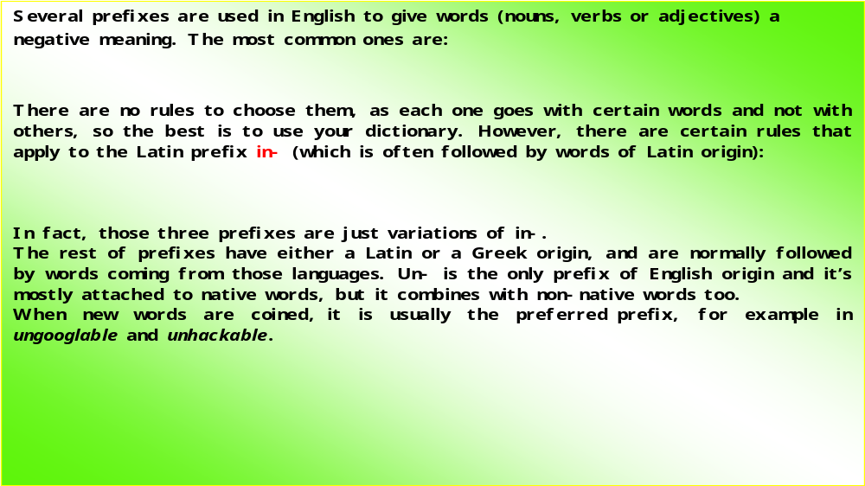

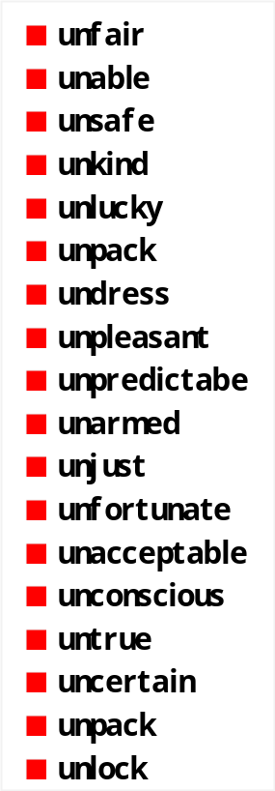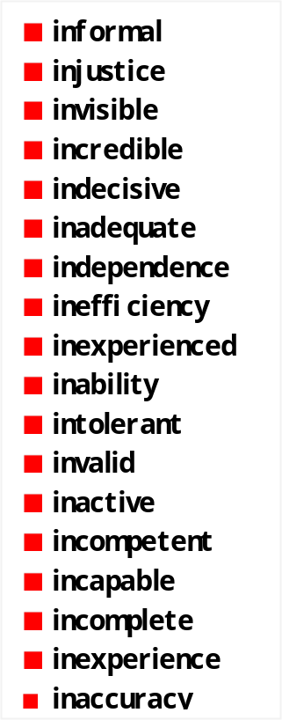


il / im / in / ir / un / dis

dis
im
ir
in
un

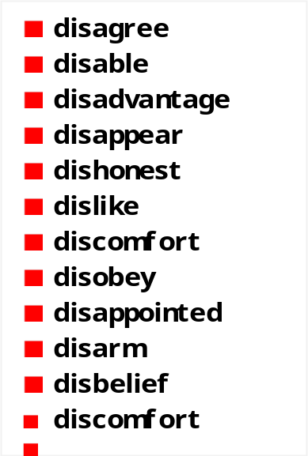
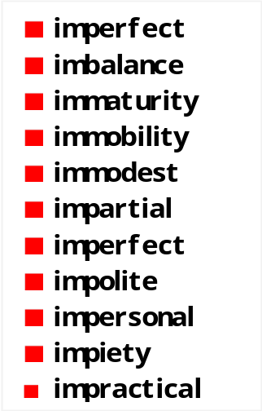
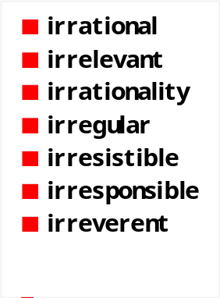

il

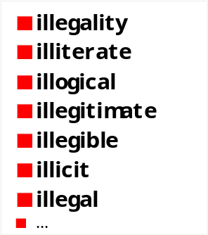


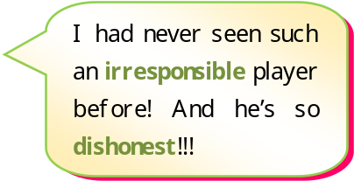

Key answers
Fill in the gaps with the appropriate prefix
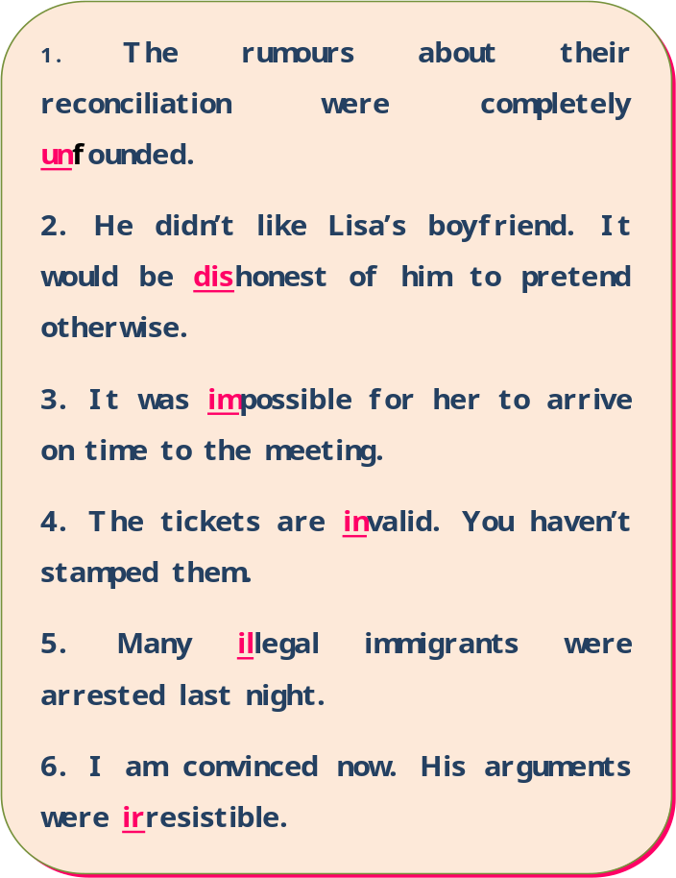
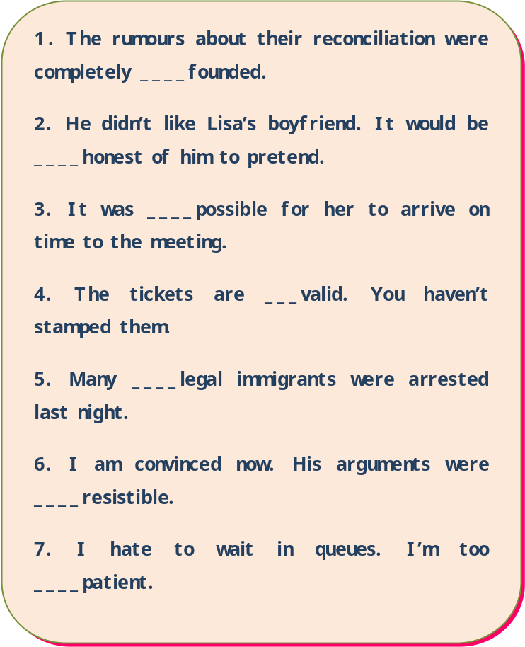

il | im | in | ir | un | dis | words
 |  |  | √ |  |  | regular
 |  |  |  | √ |  | capable
 | √ |  |  |  |  | possible
 |  |  | √ |  |  | responsible
√ |  |  |  |  |  | legal
 |  | √ |  |  |  | justice
 | √ |  |  |  |  | probable
 |  | √ |  |  |  | definite
 | √ |  |  |  |  | polite
 |  |  |  |  | √ | obey
 |  |  |  |  | √ | agree

Research and Report

Aim: to develop students’ desire to learn about endangered animals.

Students should be able to write a report about an animal in danger of extinction.

Present and explain the instruction p52
-What’s the graph about? -It’s about some animals’ life expectancy.
P48 physique relizane www.physique48.org
What is life expectancy?

SOS



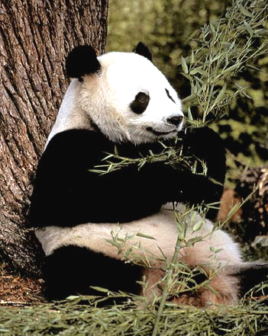

It is a statistical measure of the average length of survival of a living thing. It means the expected time
: how long an animal can live

The life spans of animals are either the average life or the most extreme age recorded or both.
Some animals live a very extreme life; others very short.
What determines the average life expectancy of a particular animal is dependent on many evolutionary pressures
1-Speed of metabolism
2-age of sexual maturity
3-body or brain size
4-Risk of predation





-Ask your students to list the animals on the graph.
-One of the most frequently asked questions is “how long are animals expected to live?”

Tortoise

Bat

Horse

Dolphin

Lioness

Cat

Giraffe

Elephant

5 10 12 15 22 24 38 100

Ask your students some questions about the graph
How long do these animals live on the average?

2-Discuss the maximum age to which people and each of the animals on the following table can live. Use the auxiliaries on the graph below to express degree of possibility

100
(higher possibility)
80 may well
60 might well

40 may (smaller possibility)
20 might
0 Can’t live to the age of 30

Life expectancy graph

Animals | Average age | Maximum age
Human  Elephant  Giraffe  Cat  Lion-lioness  Dolphin  Horse  Bat  Tortoise | 78  05  10  12  15  22  24  38  100 | 122  70  30  25  35  50  40  50  125

Example:

Humans live for78 years on the average, but they may live for up to 122 years.

Activity 4: Animals in danger of extinction

Presentation:
On planet Earth, live humans, animals and plants

How many species of animals are there? Species = kinds = sorts

There are more than 1.5 million species of animals.

Animals face a great danger. What is it?
-It is the danger of extinction.

Extinction (noun) / to become extinct( verb)

The above information is compiled from a number of sources: Encyclopedia Britannica and animal’ lifespans.com

Living things

Humans
Animals
Plants

Extinct species
Are plants or animals that once lived on Earth, but no longer live anywhere in the world. You’ll never see an extinct animal such as Dinosaurs, Dodo birds, Passenger pigeons because they are all extinct.

Extinction
The complete disappearance of a species

Extict species

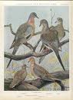

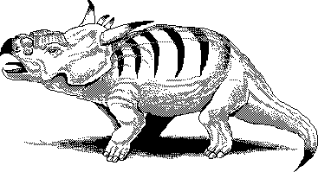
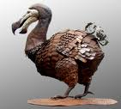

Pachyrhinosaurus (dinosaure)
Dodo bird
Passenger pigeon

Since 1600, about 500 species of animals have become extinct.
Dinosaures lived on Earth 200 million years ago and dominated it for almost 100 million years.

Endangered species
Are plants or animals whose number is so few that they are in danger of extinction, or becoming extinct.
Endangered species are most in danger of extinction; Even large populations of animals can be at risk
Threatened species
Are plants or animals whose total numbers are falling and they are on the way of becoming endangered.




White-Headed Langur

The Vaquita



Extinction has always happened naturally, but in modern times, people have pushed wildlife to the brink much more quickly than ever before. We are losing wildlife at a rapid rate.

What animals are in danger of extinction? -They are: African elephant, Tigers,

Koalas, Mexican crocodiles, Pandas, Polar bears, Brown bears, Mountain gorillas,

hippotamuses, Orangutans, River otters…

What causes their extinction? -Here are nine of the main reasons why animals become
Extinct:

1-Habitat loss 2-Illegal hunting 3-Introduction of a foreign species
4-Predation 5-Sport hunting 6-Folk medicine
7-Poaching 8-Fur trade 9-Pollution

Choose an animal which in danger of extinction and write a report about it:


Name of animal: Mountain Gorilla
Where does it live: Virunga volcanoes mountains Eastern Africa: Congo, Uganda
What does it look like: big, black fur, bounding chest, big bared teeth
What is special about it: vegetarian, peaceful
How long does it live: 20 years
What is the maximum age to which it can live: 55 years
What may cause its extinction: civil war, meat, trophies
What can we do to save it: set agreements to ban hunting gorillas, establish natural parks to protect them



The report :
An Animal in Danger of Extinction
One of the animals in danger of extinction is the Mountain Gorillas.
Mountain gorillas live in Virunga Volcanoes Mountains, some regions in Eastern Africa: Uganda, Rwanda and Congo. They are huge animals with black fur (hair), bounding chest and big bared teeth.
Mountain gorillas are gentle, peaceful and mainly vegetarian creatures. They live for 20 years in the average, but they may well live for up to 55 years.
Life for mountain gorillas is not at all peaceful. They are threatened by: civil war in some African regions. Hunters kill them for food and trophies. Their forests are chopped down for farm land, fuel and housing.
Here are some ideas that may help save the mountain gorillas: African authorities should sign international agreements to officially ban the hunting of this species and establish natural protected areas where mountain gorillas can live in peace.

WWF
5-Group work : Presentation

Aim: listening for functions (agreeing) and for intonation patterns

Students should be able to make agreements positively and negatively using so and neither

Presentation: So…………./ Neither…………

World Wildlife Foundation
World Wildlife Fund

World Wildlife Fund is an international organization founded in 1961 by the biologists: Sir Julian Huxley and Sir Peter Scott.
World Wildlife Foundation is another organization. It’s a name coincidence. The main point is that both the two organizations work for the same aim: a better planet, where all species live peacefully.
W. W. Fund has been doing a lot of strong, beautiful and committed actions related to the preservation of environment and its endangered species for nearly 50 years.
W.W. Foundation is much younger, but works for the same goals and strives to make a difference for the entire world to benefit from.

Listening and Speaking

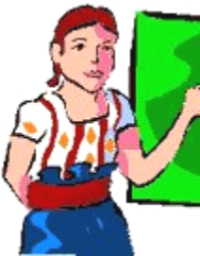
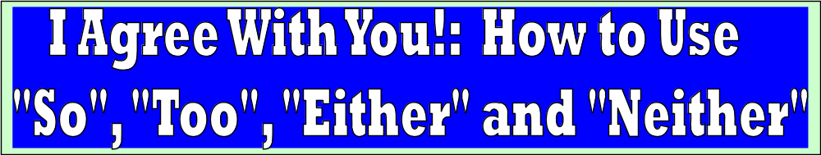

Positive agreement :
If you agree with someone about an opinion, you can simply say: “ I agree” or “ you are right.”
Eg: A- I think you need more time.
B-You are right / I agree OR

A-I am in a hurry./positive statement
B-Me, too. I am in a hurry, too OR So am I

A-I need to go to the bathroom./ps OR So do I
B-Me, too. Ineed to go ……,too.

Use: SO …..I IN A POSITIVE SENSE TO SHOW THAT WE FEEL THE SAME WAY AS ANOTHET PERSON? OR HAVE PERFORMED THE SAME ACTION.

CHANGE THE AUXILIARY VERB RELATED TO THE ORIGINAL STATEMENT. THE FORM IS USUALLY USED IN THE FIRST PERSON SINGULAR; HOWEVER, OTHER FORMS ARE ALSO POSSIBLE.

Find the suitable responses to the following statements:

A-I would like to visit Geneva some day.
B-……………………………………….
A-I could run 10 kms when I was young.
A-I am meeting a colleague tomorrow. B-……………………………………………
B- ……………………………………..
A-I work in a bank.
A-I went to the cinema last night. B- ………………………………
B-…………………………………..



Note that « too » usually comes at the end of the sentence and « so » at the beginning

To agree with a positive statement, we use :
So + auxiliary / modal + pronoun

A-I am cilmbing a ladder.
B-So am I

A-I love Maths.
B-So do I

A-Helen teaches Maths.
B-So does her husband.

Negative agreement

To agree with a negative statement, we use « NEITHER “in place of SO and EITHER in place of TOO

Examples Neither am I
A-I am not hungry. B-
I am not either
Neither do I.
A-I don’t have enough money. B-
I do not either.

These expressions can also be used in the 2nd or 3rd person
Example:
A-Tod does not want to quit smoking.
B-Neither does Louis. / Louis doesn’t either.

Aim: to provide further practice of: So and Neither

You can give your students different kinds of exercises such as:

*Add a response to the following statements
*Which of the following is a correct agreement?
*Which of the following is not correct?

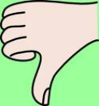

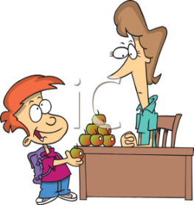



To agree with negative statements, we use
Neither + auxiliary or modal + pronoun

Note that NEITHER is used with positive verbs and EITHER with negative verbs

Practice Activities

Types of Activities

A variety of activities are available at:English-zone.com

Reading and Writing

Aim: Students should be able to interpret a passage with the help of an illustration
Pre-reading: presentation of the theme
The magazine’s cover page
The answers: P48 physique relizane www.physique48.org
1-The name of the magazine is: Popular Science
2-The title of this issue of the magazine is: Flash Forward Life in the future
3-The magazine deals with topics about: Science, Medicine, Technology,space
4-The illustration on the cover page represents: a robot holding a baby
5-I think the most important article will be about: Robots



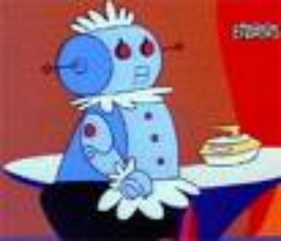


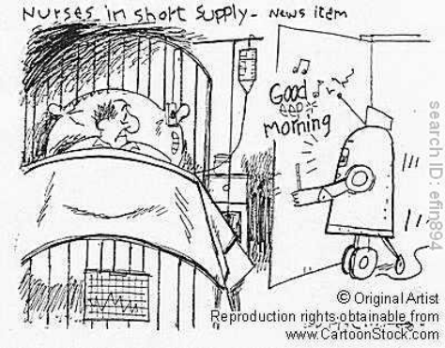

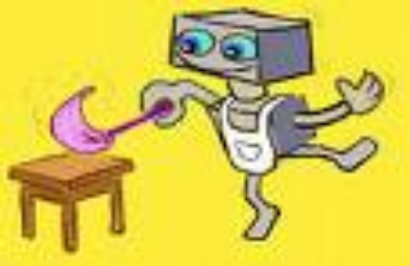
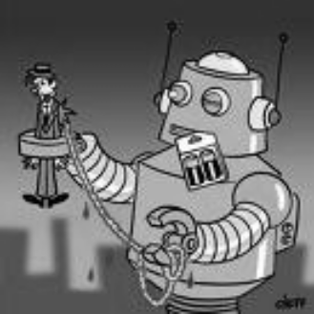

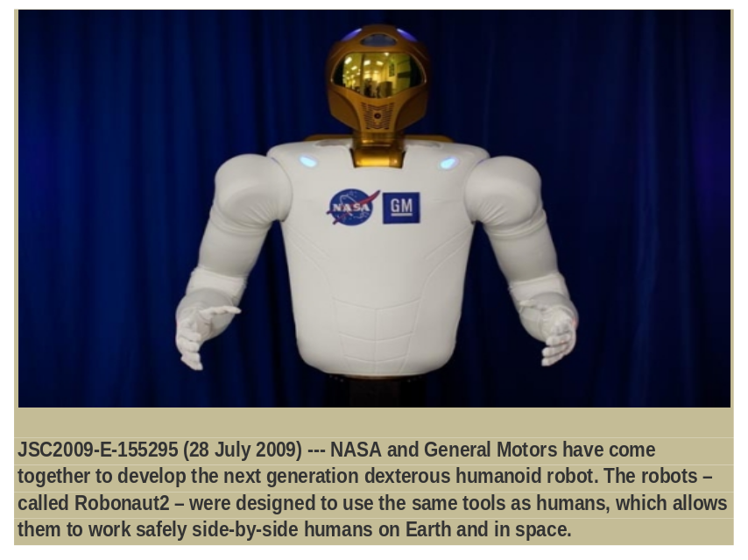

ROBOT
NASA

The talent of success is nothing more than doing what you can do, well.
Henry W. Longfellow

When you rehearse success in your mind, you experience it in your life.
Remez Sasson
P48 physique relizane www.physique48.org
After climbing a great hill, one only finds that there are many more hills to climb.

Nelson Mandela

