Teacher : Mrs. FB Kh
El Cheikh Moulay Bencherif Middle School (S/A)
p48 physique relizane www.physique48.org



Great Expectations

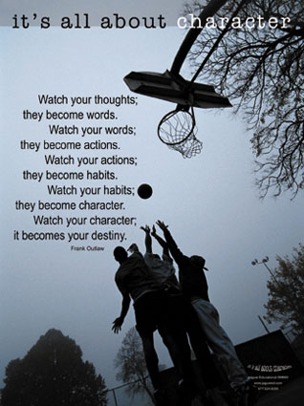


The ultimate objective:

By the end of this file, students will be able to arrange a conference

Functions and notions

-Giving instructions
-Expressing condition
-Expressing satisfaction and dissatisfaction
-Making suggestions, requests, offers, promises using “if”
-Locating places
Language learning

Grammar

-Time clauses with: when, while, as soon as, before, after, till and until
-Conditional type1
-Future with “will” (consolidation)

Words and Sounds
-Vocabulary related to hope and expectation
-Vocabulary related to the US educational system
-Suffixes: er, ist, ian and or
-Clusters
-Vowel sounds: /
/, /
:/, /a: / and /
/
-Intonation in WH questions (consolidation)

Skills Building

Primay Skills
-Listening for specific information
-Making a short class presentation
-Translating
-Transferring information (from oral script to map and from map to speech)
-Guessing meaning from context
-Recognizing features of song
-Summarizing

Social Skills

-Acting as a tourist guide
-Making contingency plans
-Making decisions for the future
-Planning an excursion
-Drawing a road map
-Making a fact file

Food for Thought


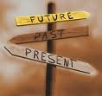

Live your own life, and live up to your own expectations

You were born to win, but to be a winner, you must plan to win, prepare to win, and expect to win.
Zig Zigla



Expectation, by definition, is the act of looking forward to something; and in case of uncertainty, expectation is what is considered the most likely to happen or what someone thinks is going to happen in the future.

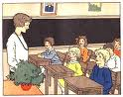

The first lesson about expectation is to expect much and look for much.
Don’t expect problems, but expect solutions to every problem. Don’t expect difficulties, but expect to grow stronger with every difficulty you overcome. Don’t expect hard times, but expect every need to be met, for it is in expecting that we look and in searching that we find.

If I enroll in a course, study hard and do my assignments, I’ll pass the course. If I skip classes, don’t study hard and don’t do my assignments, I will fail the course.
Why would you need a horoscope or oracle to learn what to expect in the future?
Each act you take, or fail to take, creates your future.

What can you expect from the future?
You can expect to reap the rewards for your right actions and suffer the consequences for your wrong actions.


Just for fun

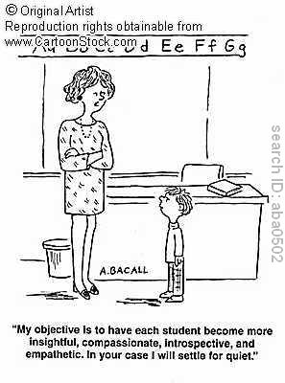
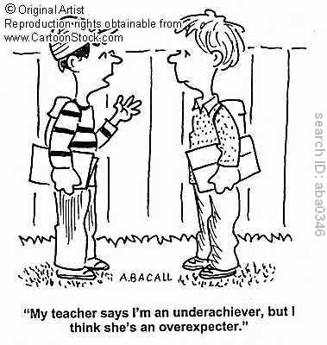

Go forward to the illustrations p66 and ask your students to guess what the two teens: Paul and Becky expect for the future.
p48 physique relizane www.physique48.org
Becky seems to be ambitious. In the second picture, she may have been graduated from college or university.

A bright future is not among Paul’s expectations: he may get married and start a new family life with a new born baby.

Listen and Consider

The Ultimate Objective :

Students should be able to predict or guess people’s activities and listen for specific information.

Before you listen:

Get your students’ books open on page: 67
Look at the pictures of Becky and Paul and answer the questions:

What are they like? Explain to your students that you expect Becky and Paul’s physical description

A Writing Guide

When describing someone you know well or see often, you should use the present tense. When describing someone who is no longer alive or someone you don’t see any more you should use the past tense.

Here are some ideas and guidelines that will help you write descriptions of people.

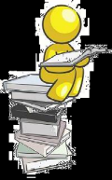





You can also describe personality through mannerism – saying how a person speaks, describing their gestures, mentioning particular habits.

To describe physical appearance you should give details of the person’s height, build, age, hair, facial features, and clothing
To describe character and behaviour you should support your description with examples.


My cousin Jim, is Italian but he lives in Germany. He`s of average height and medium build. He has got curly dark hair and a pale complexion. He usually wears smart clothes: suit or a shirt and trousers. He`s a very funny and polite person and he loves playing football and camping in the mountain.

Becky is a tall and slim girl and Paul is a tall boy with dark hair and black eyes.

What do they like? This question refers to their likes, hobbies and interests.

Both Paul and Becky are sporty: Paul likes American football whereas Becky is fond of soccer. (European football)

Where do they live? They live in USA.

As you listen
1-Students will check their predictions while the teacher reads the first listening script p 169
Becky loves football and singing. Paul loves American football and motor biking.

2-Students will listen to the second script p 169 to make notes about what will Paul and Becky do during the summer vacation

3-Listen to your teacher reading the questions below and mark the intonation at the end of each question with an arrow

a-What will you do when school finishes?

b-How will you spend your time when you are back?

c-Will you keep on training after the football season is over?

Aim:

Students should be able to differentiate between coordinating clauses and conjunctions and subordinating clauses and conjunctions



Vacation = Holiday

When school finishes,

Becky will visit her grand-parents in Spring Valley. She won’t do anything. She will simply stay in bed all day long listening to her favourite CDs, watch TV and eat popcorn.

Paul will camp with his team in Mount Palomar. He will keep training for the next football season.

Grammar Window



Presentation
Write on the board :

Sally is clever. Sally is reliable.

Statement1 statement 2

The above example contains two clauses or statements of the same idea.

In order to link the 2 separated clauses, we can use “and”

Sally is clever and reliable.

Or you can use “both …… and”

Sally is both clever and reliable.

Frank does not like Math. Louis does not like Math.

Statement 1 statement 2

The second example contains two clauses of the same idea. They are both in negative form

In order to link the 2 separated clauses, we can use “neither … nor……”

Neither Frank nor Louis like Math.

I like home made food. I don’t like fast food.

Statement1 statement2

The third example contains two clauses of different (opposite) ideas

In order to link the two separated clauses, we can use: “but”

I like home made food, but I don’t like fast food.

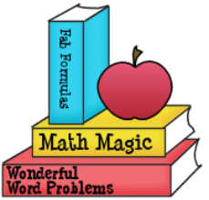



And, but, neither ……. Nor ….. etc are coordinating conjunctions



What are conjunctions ?

Some common coordinating some common correlative some common subordinating
conjunctions are conjunctions are conjunction are

and / or / but / for/ yet /nor both… and/ either…… or/ when / during / as soon as

so neither… nor/whether….or/ if / unless / while

not only….. but

Conjunctions are joining words.
They are used to fix together separate parts of a sentence.
There are three kinds of conjunctions

Correlative conjunctions
Pairs of conjunctions that connect words or group of words used in the same way.
These are conjunctions that are regularly used together, but they are not right next to each other in a sentence.
Coordinating conjunctions
Connect words or group of words used in the same way or contain similar ideas.

Subordinating conjunctions
Subordinating conjunctions also join two clauses together, but in doing so, they make one clause dependent "subordinate")

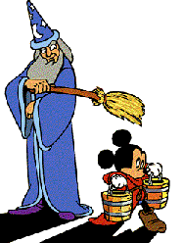

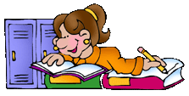
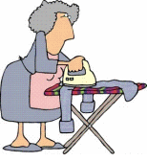

He watched over Mickey while he was working.
I want to do my homework, but I feel sleepy.
Jane has finished not only sweeping the floor, but also ironing.

When he arrives in town. Does this sentence convey any message?

Is the above sentence meaningful?

Is it correct to say it that way?
This sentence is incomplete. p48 physique relizane www.physique48.org

When he arrives in town. Subordinate clause

When he arrives, Paul will give me a call.

Subordinate C Main Clause
Dependent clause Independent clause

We should stop playing because we have a lot of school work.

Main clause subordinate clause

The clauses in the two previous examples are linked by: when and because

When what does it refer to? It refers to time

Subordinating conjunction of time

Because what does it refer to? It refers to cause

Subordinating conjunction of reason

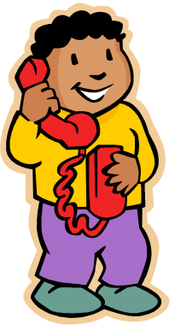

A subordinate clause is a clause that wouldn’t make sense without an accompanying main clause

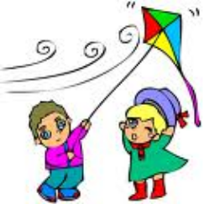

Subordinating conjunction introduces a subordinating clause, ie one that cannot stand alone without the support of a main clause.
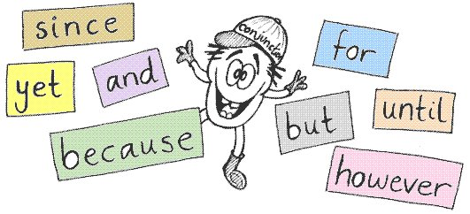

Time Conjunctions

Table of Conjunctions

Since | Whereas |  | Unless |  | Even though | In case | As soon as
Although | Though |  | Given That |  | In spite of | If | Or
While | Nevertheless |  |  | Therefore | Despite | As | Which
But | So that | As for |  |  | In order to | When | Whose
And | For | Furthermore |  |  | To | As if | However
Who | Because | Not with standing |  |  | So | Until | As long as
Before | After | In case |  |  | For instance | In other words | By the way
On the contrary | Talking of | After all |  |  | Anyway | On one hand | On the other hand

When
The first/ the next, last time
Before

After

Whenever
Every time

While / As

As soon as

By the time
Since
Until/ Till

We’ll go to lunch when you come to visit
When

Means “at that moment », « at that time ». Notice the different tenses used in relationship to the clause beginning with “when”.
It is important to remember that “when” takes either the simple past or the present- the dependent clause changes tense in relation to the “when” clause

I will finish before they arrive.

Before
Means « before that moment » ; It is important to remember that « before » takes either the simple past or the present .

We’ll go to sleep after my grand-ma finishes the tale.

After
Means « after that moment”. It is important to remember that « after” takes the present for future events and the past or past perfect for past events.

While / As
While and as mean « during that time » . “While and As” are both usually used with the past continuous because the meaning of “during that time” which indicates an action in progress.

As Sandy was washing the dishes, her mother called her

By the time they arrive, I will have finished dinner.
By the tome
“By the time” expresses the idea that one event has been completed before another. It is important to notice the use of the past perfect for past events and future perfect for future events in the main clause. This is because the idea of something happening up to another point in time.

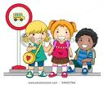
We will wait until they arrive
Until / Till
Until and Till express « up to that time ». We use either the simple present or simple past with until and till. Till is often used in spoken English

I have played tennis since I was a young boy.
Since
Since means «from that time». We use the present perfect (continuous) with “since”. Since can also be used with a specific point in the past.

James will tell us his wedding date as soon as he decides
As soon as
« as soon as” means “when something happens-immediately afterwards.
“As soon as” is very similar to “when”. It emphasizes that the event will occur immediately after the other. We usually use the simple present for future events, although present perfect can also be used.

Bill sneezes whenever he has flu.
Whenever / every time
« Whenever » and « Every time” mean each time something happens. We use the simple present (or the simple past in the past) because “whenever and every time” express habitual actions

The first, the second, the third, the fourth….
The next, the last time
The first, the second, the third, etc, next, last time means “that specific time” We can use these forms to be more specific about which time of a number of times something happened.

The last time I saw Jane, she cried a lot.

Practice

Aim :
Students should be able to
1-Identify and discriminate between a subordinate clause and a main clause.
2-To perform what they have learnt through a written activity
3-To recognize the different parts of a complex sentence then complete it
4-To transform the sentences in an exchange and give their own statements

Aim:
Students should be able
To correct words’ order in scrambled sentences and use the correct tenses to formulate coherent sentences.
To reorder the sentences in the previous activity to make a meaningful paragraph

Write it up

Task 1: Correct the words’ order and use the suitable tenses

-As soon as I pass my exams, I’ll go to the lycee.
-I’ll keep on travelling until I find a good place to live in.
-When I leave the lycee, I’ll travel around Algeria.
-I’ll work for some time before I go to university to train as an architect.
-After I get my diploma, I’ll build glass houses.

Task 2: Reorder the sentences to make a coherent paragraph

I have great expectations for the future. As soon as I pass my exams, I will go to the lycee. When I leave the lycee, I’ll travel around Algeria. I’ll keep on travelling until I find a good place to live in. Then, I’ll work for sometime before I go to university to train as an architect. After I get my diploma, I’ll build glass houses.



Read and Consider

Aim :
Students should be able to
-express conditions
-make notes about hopes

Before you read:
Ask your students on what they learnt about Paul and Becky. What they like or want to be in the future (from the listening passage heard before)
Then ask them to improvise what they will do in the future and who is most likely to succeed.

As you read

Students will have to take notes about what each of Paul and Becky hope to achieve in the future. (Students’ books open on page 70)

Paul’s expectations

-If Paul passes his final year exam, he will go to Lincoln Senior High School.
-If he gets his high school diploma, he will work in a drive-in restaurant.
-If he fails to take his high school diploma, he will start work full time right away.

Becky’s expectations

-Becky won’t go to junior high if she finishes primary school with high grades.
-If she gets her high school diploma with distinction, she will go to Grossmont College.
-She will keep on playing soccer if she has any spare time.

Paul is rather dreamy character whereas Becky looks more determined and self confident. Therefore, Becky is more likely to succeed.
Paul is fond of playing football and he does not take much care about his studies.
Becky is a smart student. She is always top of her class. She may well be brilliant in the future.



Grammar Window

Aim :
Students will be able to express conditions using the conditional “If” clause type1.



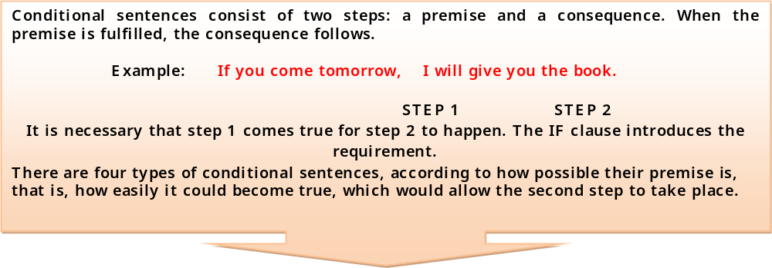






If I had seen her, I would have told you
If I saw her, I would tell you
If I see her, I will tell you
If I see her I tell you

Impossible/ too late
Impossible or Unlikely
Probable
Possible

When / If you cut your finger, it bleeds.


Refers to situations that happen normally in real life or for fixed facts.

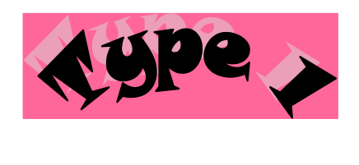
Refers to real situations that could happen in the future (promises, offers, etc……

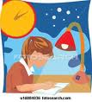If you study hard, you will pass the exam.

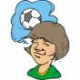If I were sporty, I would love to become a famous football star.

Refers to situations that could happen in the present or the future. It also refers to unreal or imaginary situation.

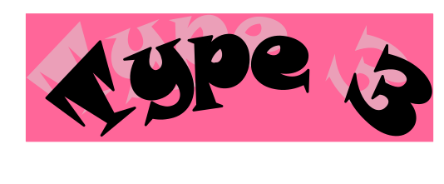
Refers to situations which are hypothetical or impossible often because the time has passed.
 If I had seen the thief, I would have arrested him.

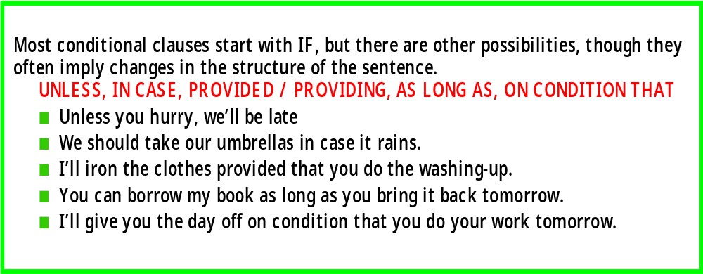

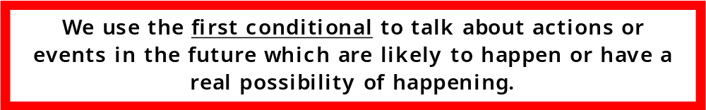

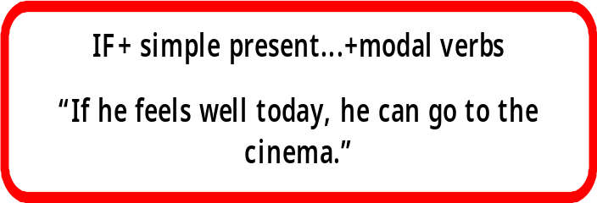
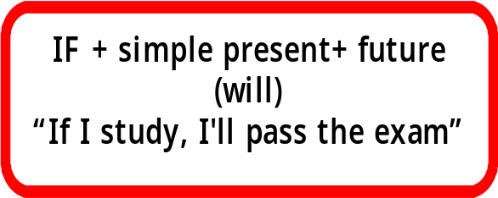

Choose the correct words in brackets

1. I (will go /go swimming) if you come with me.
2. If he (will lie / lies) again, I won’t trust / don’t trust him anymore.
3. She (cries / will cry) again if you (will shout / shout) at her.
4. A warden (gives / will give) you a fine if you smoke / will smoke here.
5. If it (doesn’t stop / won’t stop) raining, we won’t go / don’t go to the cinema.
6. If you (will have / have) a terrible headache, I (will give / give) you a painkiller.
7. If the shop (will be / is open), I (will buy / buy) you some sweets.
8. If you (are / will be) late, you (miss / will miss) the last train to Birmingham.
9. If the baby (doesn’t sleep / won’t sleep), they (will take / take) her for a walk.
10. I (help / will help) you if you (will need / need) help.
11. She (will make / makes) a snowman if it (will snow / snows) at night.
12. You (won’t go / don’t go) to the gym if you (don’t do / won’t do) your homework.
13. Your mum (is / will be) angry if you (don’t tidy / won’t tidy) your room.
14. We (will go / go) to the concert if we (get / will get) tickets.

Correct the words’ order to get coherent sentences

1. Kelly’s / him / will / brother / go / to the party / invite / if / you
…………………………………………………………………………………
2. you / ring / you / back / if / leave / a message / will
…………………………………………………………………………………
3. busy / disturb / I / you / are / won’t / if / you
…………………………………………………………………………………
4. She / be / will / if / hungry / take / doesn’t / a sandwich / with / she / her
…………………………………………………………………………………
5. They / a map / if / they / get lost / buy / won’t
……………………………………………………………………………

Aim :

Students should be able -to make sentences using “IF” by linking two clauses from a table.
-To build a dialogue using information from a table “What if ….?”

-Many teachers of English confuse between the use of “IF” and “What if….?

-Is it necessary to use the phrase “What if…?” and when is it used?

-Can we use other verb tenses with “What if…?
Finish the following conditionals in a proper way:
1.If you eat a lot of sweets, you……………..
2.Will they take you to the cinema if you?
3.They will waste water if they …………
4.Unless Peter behaves well, his parents
5.If I go to London, I ………………
6.If you heat metal, it ………………
7.If she doesn’t answer the phone, I ……
8.We won’t go to the beach…………………
9.Unless she studies hard, she ……………
10.If people eat too much, they ……………
11.If my boyfriend asks me to marry him,I
12.You won’t get any pocket money unless
13.If my friends move to another town, I
14.If Jenny doesn’t phone me I……
15.Peter will be late to work unless he…
16.We will miss the film if we………
17.If people cut down trees, they ……
18.Will you go to her party if she …?
19.Will you study English if you……?
20.You can drive a car if you…………

COMPLETE THE SENTENCES WITH THE CORRECT FORM OF THE VERBS IN BRACKETS.

1. If John…………………(visit) me, I……………………(thank) him for CDs.
2. If you…………………..(wear) these clothes, my friends……………………(laugh) at you.
3. If my parents……………………(agree), we ………………………(go) to the cinema.
4. Tom………………………(be) angry if you………………(take) his coat without permission.
5. If you…………………………(borrow) some money, you……………………..(have to) give it back.
6. If she……………………(have) free time, he……………………(call) her.
7. If it…………………..(rain), he……………………(stay) at home.

Practice

Exercise Two : What if…. ? You want to go camping in the forest. But your brother tries to prevent you from doing so by pointing up difficulties (column A). Answer him by completing the sentences in column B
We use "What if" to suppose something, to take something as an assumption.
Ex: What if I have an accident and die? Life is too short, we ought to enjoy it to its most.
What if he isn't there? Should I leave a messageWe use "What if" to suppose something, to take something as an assumption.
Ex: What if I have an accident and die? Life is too short, we ought to enjoy it to its most.
What if he isn't there? Should I leave a message?
We use "What if" to suppose something, to take something as an assumption.
Ex: What if I have an accident and die? Life is too short; we ought to enjoy it to its most.
What if he isn't there? Should I leave a message?

An IF sentence usually contains two halves: a possible/probable/theoretical condition (in the IF-half of the sentence), and then the other half of the IF sentence states a result of the condition being fulfilled.
A sentence that begins with "what if" basically presents a condition and asks what a (or the) result will be/would be/ would have been if that condition is/were/had been fulfilled. In other words, "what" basically asks for the other half of the IF-sentence. Here are some examples:
Q: What if he doesn't agree to do it?
A: Then we will just have to do it without him.
Q: What if you won a thousand dollars?
A: First I would treat myself to a gourmet dinner, and then I would spend the rest of the money on my kids.

There’s no problem using other verb tenses with “What if…?. Of course it sounds better with present or past,
since present gives an idea of future too and past refers to actions that have been concluded

Ex: What if she called but we were out?
What if he hasn't found the address?
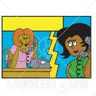



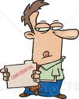

A-I’m going to camp in the forest.
B-What will you do if you don’t find where to sleep?
A-I’ll pitch a tent.

B-What if you don’t have a cleared-up space where to pitch your tent?
A-Don’t worry I’ll sleep under a tree.

B-But what if a jackal attacks you?
A-Well, I’ll climb up the tree and shout out for help.

B-What if you fall from the tree and you break your leg?
A-Don’t worry. I’ll call you up. I always carry my mobile with me.
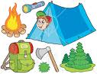

Aim :

Students should be able to write a short letter about what will they do if they pass their middle school Brevet.

Write it Up



What will you do if you pass your middle school brevet? Write a short letter to your friend to tell him/her what you have expected to do in the future.
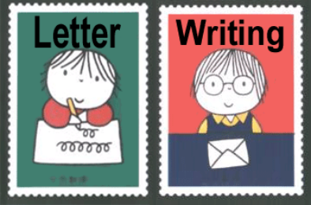

19, Liberty Avenue,
December 9th, 2010,
Dear Najwa,

Thanks for your last letter. I really enjoyed reading it. I think it would be a great idea if I share my future expectations with someone wonderful like you.

If I succeed in my brevet exam, I’ll go to secondary school. I’ll opt for the foreign languages stream. If I pass my Baccalaureate, I’ll go to university. I’ll train to become a translator. If I get my diploma, I’ll travel around the world to see other people and make friends.

However, I know that life is full of surprises. So, if I fail, I’ll go to vocational school. I’ll train to be a computer technician. If I manage to get my diploma, I’ll open a cybercafé and work on my own. Of course if I make a lot of money, I’ll build a house. I’ll get married and start a family.
Please, write back soon
Best wishes
From Manal



Words and Sounds

Aim :

Students should be able to form new words “nouns of professions” out of verbs and nouns using the suffixes:
er / or / ian / ist
RECYCLE:
Review with your students the use of the prefixes and suffixes learnt previously
Ex: il, im, in, un, dis, ir, ous, ful……

Presentation
Write on the board: to teach teacher
What kind of words are
verb noun

What does teacher refer to? Person who presents knowledge to stds

Teacher noun of profession derived from the verb “teach”
The word teacher is made out of the verb “teach” and the addition of ”er”

To sail sailor

Verb noun

Sailor person (someone) who explores the seas and oceans

Noun of profession derived from the verb to “sail”

The word sailor is made out of the verb (to sail) and the addition of “or”

Science scientist

Noun noun

Scientist noun of profession derived from the noun “science”

The word “scientist” is made out of the noun “science” and the addition of “ist”

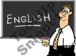

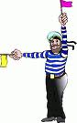



A person (someone) who is expert and skillful in the field of study.

Politics politician

Noun noun

Politician noun of profession derived from the noun « politics »

The word” politician” is made out of the noun “politics” and the addition of “ian”

The letters or combination of letters that are added at the end of each word are

The above suffixes are used to make nouns for jobs and professions out of verbs or nouns. p48 physique relizane www.physique48.org


A person (someone) who is a member in government or practises politics

Suffixes

er
or
ian
ist

There are no rules, I'm afraid, although a number of patterns emerge. Unskilled or semi-skilled job-holders are often denoted with …er, whilst those in scientific or medical professions are often designated with …ist. But there are many exceptions.
There are no rule although a number of patterns emerge. Unskilled or semi-skilled job-holders are often denoted with …er, whilst those in scientific or medical professions are often designated with …ist. But there are many exceptions.
The …er suffix is very common, but so is …or. The …ist ending is also quite common, but so is …an. We also have …ant (accountant, shop assistant, civil servant, flight attendant) …man (postman, fireman, dustman, barman, draughtsman, fisherman), …ess (waitress, hostess, Headmistress) …ee (trainee, employee) and …ive (representative, machine operative), etc.
It is really a matter of leaning them and knowing them. Learn them in word families, as in these examples below.

The …er suffix is very common, but so is …or. The …ist ending is also quite common, but so is …an. We also have …ant (accountant, shop assistant, civil servant, flight attendant) …man (postman, fireman, dustman, barman, draughtsman, fisherman), …ess (waitress, hostess, Headmistress) …ee (trainee, employee) and …ive (representative, machine operative), etc.
It is really a matter of leaning them and knowing them. Learn them in word families, as in these examples below.

er (but not only …er)
Bob is a well-known local builder who employs two plumbers, three carpenters, a roofer, four electricians and half a dozen unskilled labourers.
If teachers, education officers, child minders and social workers had worked together, none of these children would have suffered abuse.
- He's a writer - the author of four books about China, but he's also worked as a translator and interpreter, actor
and journalist.

or (but not only …or)
- The Managing Director delegated responsibility for the project to the supervisor, but he was a poor administrator and would never become a manager

Words | Nouns for occupations
Act  Paint  Music  Collect  Sculpt  Art  Guitar  Cartoon  Write  Direct  Physics  Library | Actor  Painter  Musician  Collector  Sculptor  Artist  Guitarist  Cartoonist  Writer  Director  Physist  Librarian

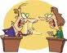
ist (but not only …ist)
The whole family are musicians: Ed's a percussionist and pianist, Viola's a flautist and cellist and Barry's a French horn player. Their parents are both singers.
He's a doctor - a general practitioner, but he wants to become a specialist - a gynaecologist and obstetrician.
His older sister's a chemist / pharmacist, his younger sister's a speech therapist and his mother works as his receptionist and telephonist.

an (both …ian and …man)
Did you say you were an optician? ~ No, I'm a politician. I'm spokesman for international affairs and chairman of the refugee committee. My older brother is the parliamentary librarian. My younger brother's a magician.

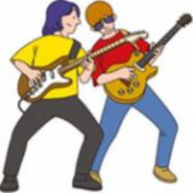
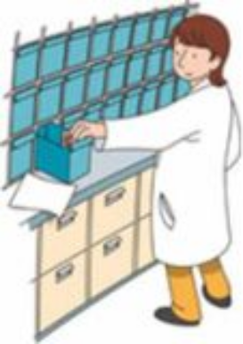

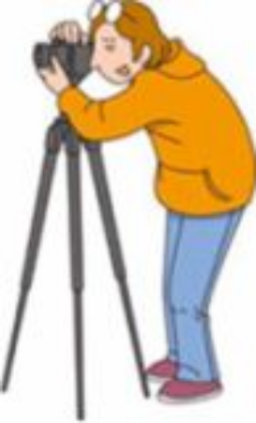


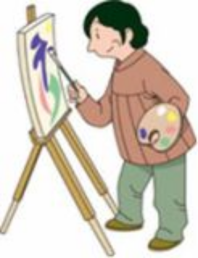

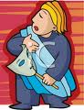

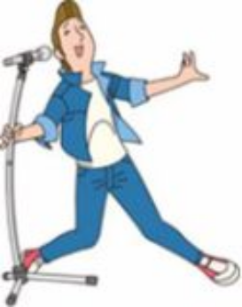

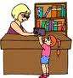
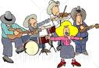

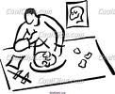

Aim:
Students will be able to complete a fact file about a famous city
To use the information on the file to write a report
To transfer information from a form or map into a speech
Presentation
Find information about California and complete the fact file below; then report to the class reading from your notes

Research and Report

California Facts, Population

2000 state resident census population :
33, 871,648

10 largest cities : (2000)

- Los Angeles 3,694,820
- San Diego 1,223,400
- San Jose 894,943
- San Francisco 776,733
- Long Beach 461,522
- Fresno 427,652
- Sacramento 407,018
- Oakland 399,484
- Santa Ana 337,977
- Anaheim 328,014

By gender
Male : 16,874,892 (49,8%)
Female : 16,996,756 (50,2%)

By age

18 and over : 18 and over: 72,7%
65 and over : 65 and over: 10,6%
Median age : Median age: 33,3

By Origin

White: 20,170,059 (59%)
Black: 2,263,882 (6,7%)
American Indian: 333,346 (1,0%)
Asian: 3,697,513 (10,9%)
Other races: 5,682,241 (16,8%)
Two or more races: 1,607,646 (4,7%)
Hispanic/ Latino: 10,966,556 (32,4%)

General California Facts

Name : California
Capital : Sacramento
Entered Union : Sept. 9th, 1850 (31st S)
Motto : Eureka “ I found it”
State colours: blue and gold
State song: I Love You California
Nickname: Golden State

California Facts, Government

Governor: Arnold Schwarzenegger
Scenators: Barbara Boxer “democrate”

State Symbols

Flower: Golden poppy
Tree: California redwood
Bird: California valley quail
Animal: California grizzly bear
Fish: California golden trout

California Facts, State Geography

Land area: 155,973 sq mi
Water area: 7,734mi
Coastline: 840mi
Shoreline: 3,427mi
Highest point: Mt Whitney-14,494 ft
Lowest point: Death valley-282ftbsl
Number of counties: 58
Largest county by population: los Angeles, 9,519,338 (2000)
Largest county by area: San Dernardino, 20,062 sq mi
National forests: 18
State parks and beaches: 264

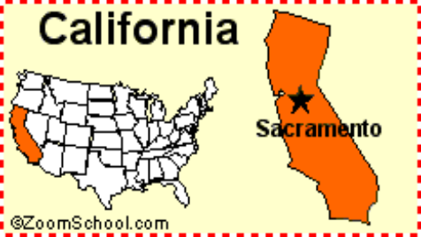



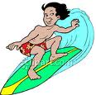
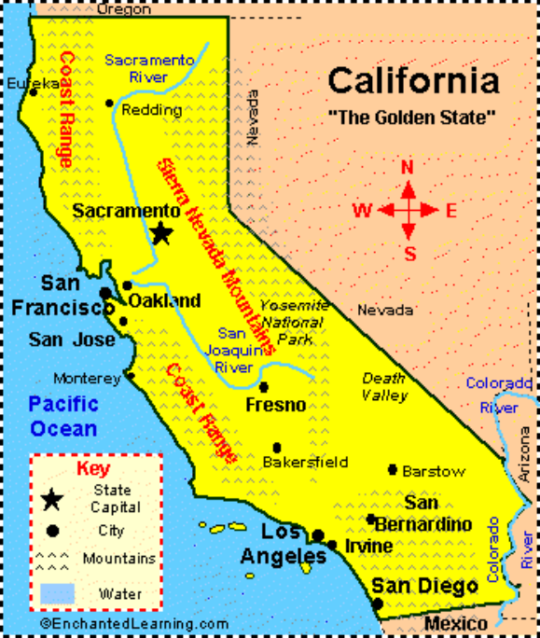
California is located on the West Coast of the USA, along the Pacific Ocean. The coast of California is 1,264 miles long. There are some wonderful beaches. Surfing is a popular activity.


California is the most populous state in the US and the third largest by area.

It is known for its varied climate and geography, as well as its diverse population.

It is known for its varied climate and geography, as well as its diverse population.

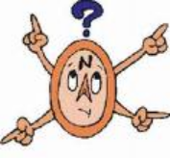
It is bordered by
Oregon to the north,
Nevada to the east,
Arizona to the southeast and the Mexican state to the south.

Its four largest cities are Los Angeles, San Diego, San Jose, and San Francisco. These are all Spanish names. That’s because the first Europeans in California were from Spain.



California has a coast, lakes, forests, deserts and mountains. There are three national parks in the Sierra Nevada Mountains. The most famous is Yosemite with its many waterfalls.

California has a coast, lakes, forests, deserts and mountains. There are three national parks in the Sierra Nevada Mountains. The most famous is Yosemite with its many waterfalls.
Everyone has heard of Hollywood in Los Angeles. Hollywood means movies

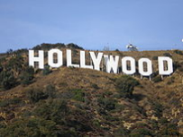
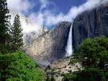

California has a coast, lakes, forests, deserts and mountains. There are three national parks in the Sierra Nevada Mountains. The most famous is Yosemite with its many waterfalls.

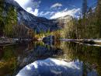

In the north of the state you can see huge redwood trees, the tallest in the world. Some are 110 meters high. You can drive a car through some of them.

The Golden Gate Bridge in San Francisco is one of the great sights of America. The famous cable cars go up and down the steep hills.

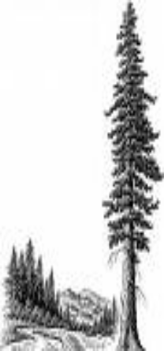


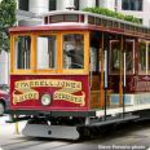

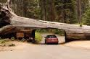


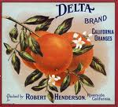

California’s valleys are famous for their oranges and wine. But Silicon Valley is famous for its computers!

The United States has 50 states. The most famous state is that of California. Its area is 411,100 sq km/ 155,973sq mi. Its capital is Sacramento.

California is situated in the west, bordering the state of Oregon to the north, those on Nevada and Arizona to the east, Mexico to the south, and the Pacific Ocean to the west. Arnold Schwarzenegger is currently its governor.

California is the most populous state in the United States with a population of 33,871,684 (census of 2000). Its important cities are: Los Angeles, San Diego, San Francisco, San Jose, Fresno and Santa Barbara.

California has important features. Yosemite Falls (with its 739m/2,425 ft) is the highest waterfalls in North America. It has the tallest type of trees in the world, the sequoia. These features have made California famous, but it’s best known for its cinema city, Hollywood, with its Universal studios, Sun Strip and Beverly Hills. Computer fans know it for the Silicon Valley where chips started to be made for the first time in the 1980’s. The most famous bridge is the Golden Gate Bridge in San Francisco and California’s most famous observatory is situated on Mount Palomar.

You: What does the abbreviation NY stand for?
p48 physique relizane www.physique48.org
Your partner: It stands for New York.

Montana, Helena (MT)
Nebraska, Lincoln (NE)
Nevada, Carson City (NV)
New Hampshire, Concord (NH)
New Jersey, Trenton (NJ)
New Mexico, Santa Fe (NM)
New York, Albany (NY)
North Carolina, Raleigh (NC)
North Dakota, Bismarck (ND)
Ohio, Columbus (OH)
Oklahoma, Oklahoma City (OK)
Oregon, Salem (OR)
Pennsylvania, Harrisburg (PA)
Rhode Island, Providence (RI)
South Carolina, Columbia (SC)
South Dakota, Pierre (SD)
Tennessee, Nashville (TN)
Texas, Austin (TX)
Utah, Salt Lake City (UT)
Vermont, Montpelier (VT)
Virginia, Richmond (VA)
Washington, Olympia (WA)
West Virginia, Charleston (WV)
Wisconsin, Madison (WI)
Wyoming, Cheyenne (WY)

Alabama Montgomery (AL)
Alaska, Juneau (AK)
Arizona, Phoenix (AZ)
Arkansas, Little Rock (AR)
California, Sacramento (CA)
Colorado, Denver (CO)
Connecticut, Hartford (CT)
Delaware, Dover (DE)
Florida, Tallahassee (FL)
Georgia, Atlanta (GA)
Hawaii, Honolulu (HI)
Idaho, Boise (ID)
Illinois, Springfield (IL)
Indiana, Indianapolis (IN)
Iowa, Des Moines (IA)
Kansas, Topeka (KS)
Kentucky, Frankfort (KY)
Louisiana, Baton Rouge (LA)
Maine, Augusta (ME)
Maryland, Annapolis (MD)
Massachusetts, Boston (MA)
Michigan, Lansing (MI)
Minnesota, St. Paul (MN)
Mississippi, Jackson (MS)
Missouri, Jefferson City (MO)
Abbrv
State name
Capital
Abbrv
Capital
State name

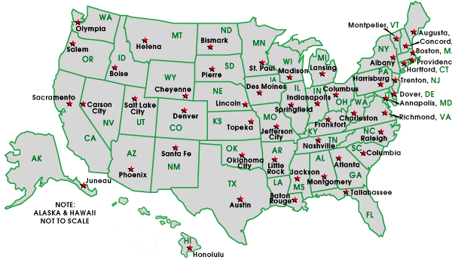

class | school |  | age
 | NURSERY SCHOOL (optional) |  | 3
 |  |  | 4
 | KINDERGARTEN |  | 5
first grade | ELEMENTARY SCHOOL |  | 6
second grade |  |  | 7
third grade |  |  | 8
fourth grade |  |  | 9
fifth grade |  |  | 10
sixth grade |  |  | 11
seventh grade | JUNIOR HIGH SCHOOL |  | 12
eighth grade |  |  | 13
ninth grade (freshman) | HIGH SCHOOL |  | 14
tenth grade (sophomore) | HIGH SCHOOL |  | 15
eleventh grade (junior) | HIGH SCHOOL |  | 16
eleventh grade (junior) | HIGH SCHOOL | PSAT | 16
twelfth grade (senior) | HIGH SCHOOL |  | 17
twelfth grade (senior) | HIGH SCHOOL | SAT | 17
freshman | COLLEGE |  | 18
sophomore |  |  | 19
junior |  |  | 20
senior |  |  | 21

Many Americans send their children to a nursery school
or to day care or pre-school at an early age. At 5 children go to kindergarten and begin their formal К—12 education. US schools are divided into elementary school, junior high school and high school.

Elementary schools teach children from kindergarten till the end of sixth grade. Grades seven and eight are taken at junior high school, and the ninth to twelfth grades at high school.

THE SCHOOL YEAR/DAY
The school year runs from early September to the following June. Students attend daily from Monday to Friday. The school day in elementary school usually lasts from about 8,30 a.m. to 3.30 p.m., though kindergarten children usually attend for only half the day.

TEACHER/HOMEWORK
Students spend most of the day with their class. The class is taught most of the time by the same teacher, except a gym class, music or art. Students rarely have homework until they reach the final grades of elementary school, and even then there is very little.

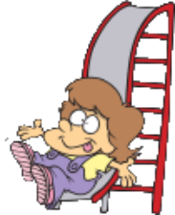
Elementary School


RECESS/LUNCH
The school day is divided into various sections and in the morning and the afternoon students have recess, a time when they can go outside and play, for about 15 minutes. In the middle of the day students eat lunch, either a meal prepared by their parents or a hot meal which they buy from the school. The rest of the lunch period is free and spent playing.

THREE Rs
The traditional subjects for elementary school students are called the three Rs: reading, writing, and arithmetic. In addition, the students study other subjects, such as history and geography and are given a chance to do creative activities and sports.

Dear Becky,

I’m happy to help you in your project on schools in other countries.

The pre-university educational system in Algeria consists of three important stages. First, pupils go to primary/elementary school at six. They study there for five years. At the age of eleven, they take a final primary school exam. If they succeed, they move to middle school. The middle school goes for four years, from 1MS TO 4 MS. If they manage to take a pass, they will go to the lycee. There are many streams in the lycee. Students at the end of the second year in the lycee can choose the stream which they like best if they meet the required standards. Studies in the lycee run for three years. In the third year, they take the Baccalaureate exam. The Baccalaureate is a diploma which allows its holders to register at university.

I hope this information will help you get a good score in your project.
Best wishes,
Meriem

Listening and Speaking

Aim: students will be able: To express satisfaction and dissatisfaction
To check predictions
To listen for specific information

Invite your students to describe the photo p79 throughout finding some information about
Place: the bus Time: in the morning People: tourists / tourist guide
Activities: tourists: listening tourist guide: speaking

Explain the instruction of activity 1: consider the situation and guess what you expect the speaker to say:

Aim: students should be able to play the role of the tourist guide



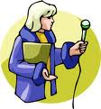
A-A tourist guide wants to express his dissatisfaction because one of the tourists keeps arriving late. He will say:
b- He is late again
B-The tourist guide expresses his satisfaction because the tourist has arrived at last. He will say:
- It’s quite alright now

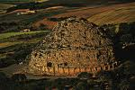

3-Listen again to your teacher and answer the questions

1-The first sight the tourists will visit is the Royal Mauritanian Mausoleum.
2-It will take them one hour and a half.
3-It is some six kilometers off the main road.
4-It’s situated on the top of a hill, some six kilometers off the Algiers-Tipaza main road just after Ain-Tagourait, on the left hand side, in the direction of Sidi Rached.
5-Thay’ll split into groups.
6-They’ll have lunch in the local cafeteria.
7-They’ll stop in Tipaza.

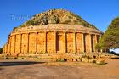

Write it Up

Imagine you are a Spanish tourist guide. Tell the tourist what they will do, what they will see and when in the city of Barcelona.

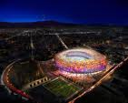

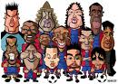

Ladies and gentlemen, good morning. I hope you enjoyed last night party in one of Spain’s most fabulous cities: Barcelona.

Today’s visit will be an awesome surprise. A destination to a five stars stadium, the largest in Europe, the second largest in the world. The home of the most successful club and whose players are the most popular worldwide. Guess what? Yes, “Nou Estadi Del Futbol Club Barcelona or “Camp Nou” or “The New Field”.

The stadium is located in the west of Barcelona about 5 kilometers from the city center.

Our ride will start as soon as we reach the metro station; luckily, Line3 metro is the nearest around the stadium. If we leave now, we’ll be there at 09:30. We‘ll take the diagonal exit and go down the road that has 2 big towers to the left. The stadium will be down that road in front of us.
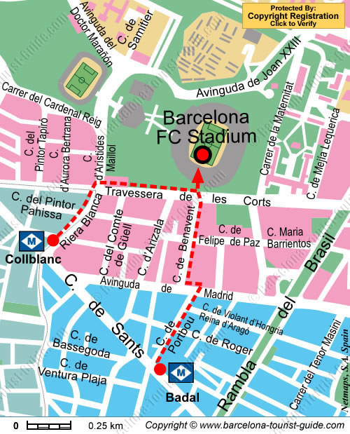

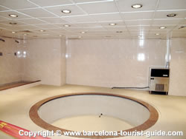

The Camp Nou complex is very extensive. Within it, there are several things to do. When we get there, we’ll split into groups. The first group will tour the club’s museum. Don’t worry; there are yellow bright barriers to ensure that you go to the right way. There you’ll have the opportunity to see trophies, cups, medals, photos of victory, statues of great old and currents players.
The second group will visit the FC botiga mega store. There you’ll be able to buy the club’s shirts, balls, wall papers as souvenirs.

The two groups will meet at the club’s café to have a break and if possible, we’ll stay there until we have our lunch.
We’ll spend the afternoon in the stadium. We’ll get to go into the dressing rooms, press box and through the tunnel onto the touch line but not to the pitch. We can sit in the stand on various bunches so that we get different views of the pitch.

Whether you are a football fan or not, you gotta see it. If you are all ready, let’s experience the Barca like never before.

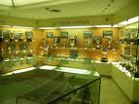

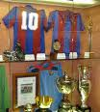

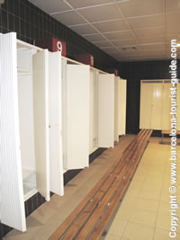

Reading and Writing

Aim: students will be able to identify features of a song
to find specific information
to recognize rhyming words
to transform prose into song
to answer comprehension questions

PRE-READING p48 physique relizane www.physique48.org
Show your students a CD and ask them:
-What is this? –It is a CD.
-By the way, what does the abbreviation CD stand for?
-It stands for Compact Disc.
-What are CDs used for?
-They are used for storing information: articles books …….etc and recording music, movies, games.

Show your students a CD’s jacket and ask them again:
This is a CD’s jacket. Is it about a movie, a game, or what?
No, it is not.
What is it about then? It is about songs’ album.
What do you often find in the CD’s jacket?
We find the singer’s photo and name, title of the album:
Best hit, all songs’ titles, name of the composer (musician) and the name of
The songwriter.

READ AND CHECK
Look at the CD jacket below (82) and find information about the following items:

Invite your students to have a look at the reading passage and ask them about Its type or format. a dialogue?
a letter?
a report? No, it is not.
Is the reading passage an e-mail?
An advert?
an article?
a poem
What type is the reading passage then? It is
a song




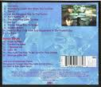

Singer’s name : Jimmy Spheens

The composer’s name : Robert Campbell

The title of the song: Song For a Rainy Sunday

The writer of the lyrics: Jonathan Dykes
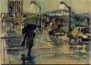

The song is the combination of

What is a song ?

What are the different parts of the song?

Are all songs of the same topic? Of course not.
What are the most common topic songs? Most of the songs are about love.
Romance (love)
Grief
Loneliness
Songs topics include Regret
Friendship
Racism
Life style
Sport

2-Read the lyrics below and underline the words that rhyme i.e., which have the same sound at the end of the verses in each stanza.



Melody (music)
Lyrics (words)



Title : every song must have a title.
The title indicates the theme of the song.



Introduction: appears at the start of the song. It pulls the listener and makes him want to hear the song.

Verse or Stanza: tells the story of the song. Every song has a story or a message to convey. Musically the melody of the verse is the same each time. Lyrically, it differs with its verse developing the story.
Verse of a song equals a paragraph of an essay.


Chorus : this is the most important part of the song. It is where the singer conveys the main message of the song.
It should be the same each time: lyrically and musically.

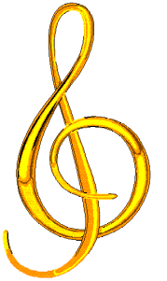

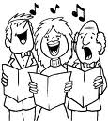
Rhyme: is the correspondence of two or more words with similar sounding final syllable placed so as to echo one another
It is the similarity in the sounds of words ending; especially, in poetry.

The rhyming words are

The prose passage below contains the rest of the lyrics of the song on the previous page. Find the words which rhyme, then transform the passage into song

Read the lyrics again to answer A and B questions

A-The word which comes closest to describing the singer’s feeling is

c-grief (extreme sadness)

B-The singer feels thus because his girl-friend has left him.

Stanza1
Do / you / new / flu
Stanza 2
Know / do / know / do
Stanza3
You / new / flu / atchoo

It’s nearly Sunday lunch time and I don’t know where to eat,
If I go to the fish and chips shop, I’ll only get wet feet,
If I stay at home for lunch, I’ll have to eat last week’s meat,
And if I get in my car and drive to the pub, I probably won’t get a seat.

Write it Out

Aim: Students should be able to write an e-mail to their friends about contingency plans (Alternative plans)

Imagine you’re going on an excursion with a friend of yours next Friday by coach.
You may come up against unexpected difficulties, but you have prepared alternative solutions.
Write an email to your friend telling him/ her of
What you have planned to do.
What you will do instead if a problem arises.



Your e-mail should be
SMART

Specific
Meaningful
Appropriate
Relevant
Thoughtful



E-mails Writing

NETIQUETTE
Never think you are talking to a computer
Ensure you follow the rules of good writing
Take off the caps lock. Don’t shout
Informality is OK in e-mails
Question your subject heading
Use short sentences and short paragraphs
Enumerate with numbers or bullets
Tidy up long sentences
Take a pride in your finished message
Ensure everything is right before you hit “Send”

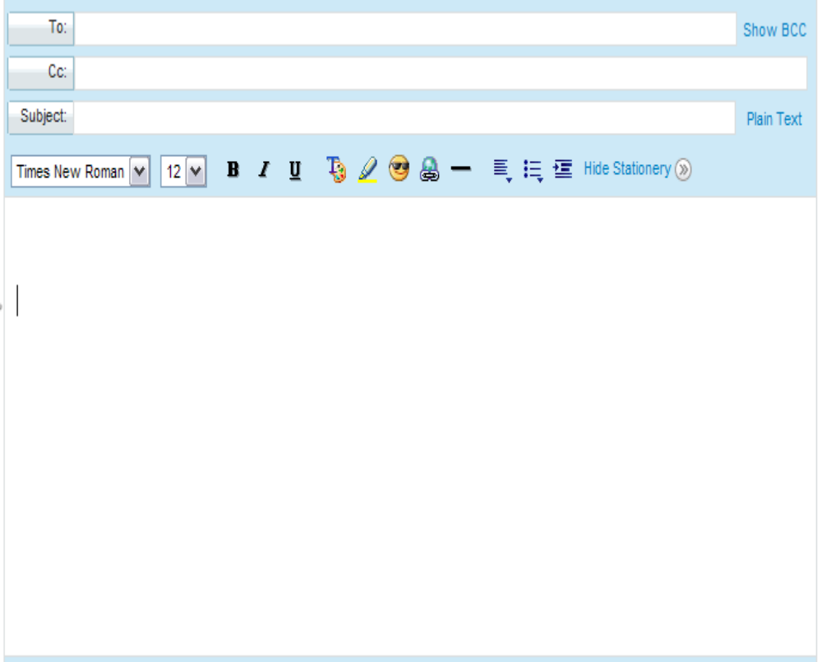
nihalbouda@gmail.fr

Karimluckynumb12@yahoo.fr

Friday’s Excursion

Dear Nihal,

Hi! How are you doing? I hope you’re fine.

I’m writing to inform you about the plans for next Friday’s excursion. The departure point will be our school, just at the front door. If everybody is punctual, we’ll start at 7 sharp. We’ll postpone the departure for another 15 minutes if there are late comers. p48 physique relizane www.physique48.org

The weather forecast announces a day with showers on Friday. Don’t worry, we have made a contingency plan just in case it rains while we are in excursion. Thus if it rains in the morning, we won’t go to the zoo. We’ll visit the Martyr’s Sanctuary/ Monument in El-Madania instead. That will keep us from getting wet and it will help a lot in revising our History lessons. Normally, we’ll have lunch at 12.30 by a riverside in Boushaoui. But the weather gets bad, we’ll get back into the coach and have our sandwiches inside.

Looking forward to seeing everybody on Friday morning.

Karim: excursion coordinator



Happy New Year
2011
May this New Year and every New Year burst out with showers of joy, laughter, success, health

Very prosperious
2011

and good luck

